What is the Weather?  © 2019. Pacific Education Institute. All rights reserved. |  |  | What is the WEATHER?  Written by Cherri Locke and Emily Hopple for the Pacific Education Institute.

What is the weather?
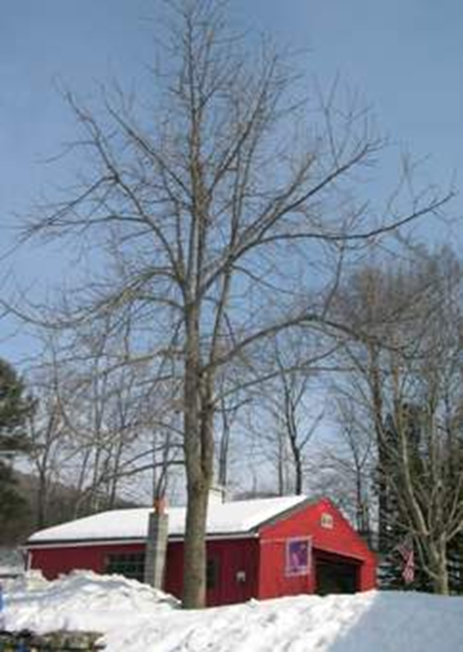

The weather is sunny and cold.
How can you tell?

1

What is the weather?

The weather is sunny and warm.
How can you tell?
2

What is the weather?  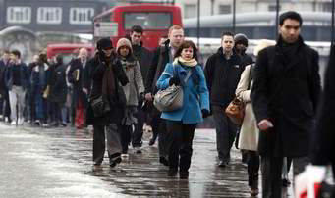  The weather is cold and rainy.  How can you tell? |  |  | How would you describe the weather today?
3 8

What is the weather?
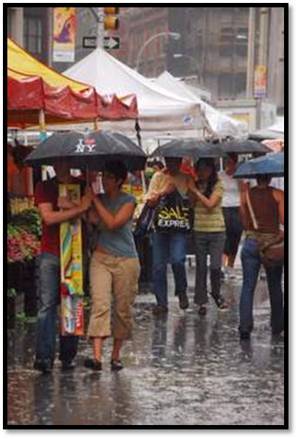

The weather is warm and rainy.
How can you tell?
4

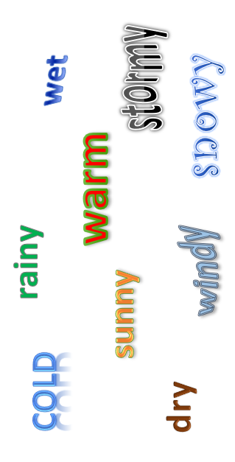

People can use many words to describe the weather.

7

What is the weather?

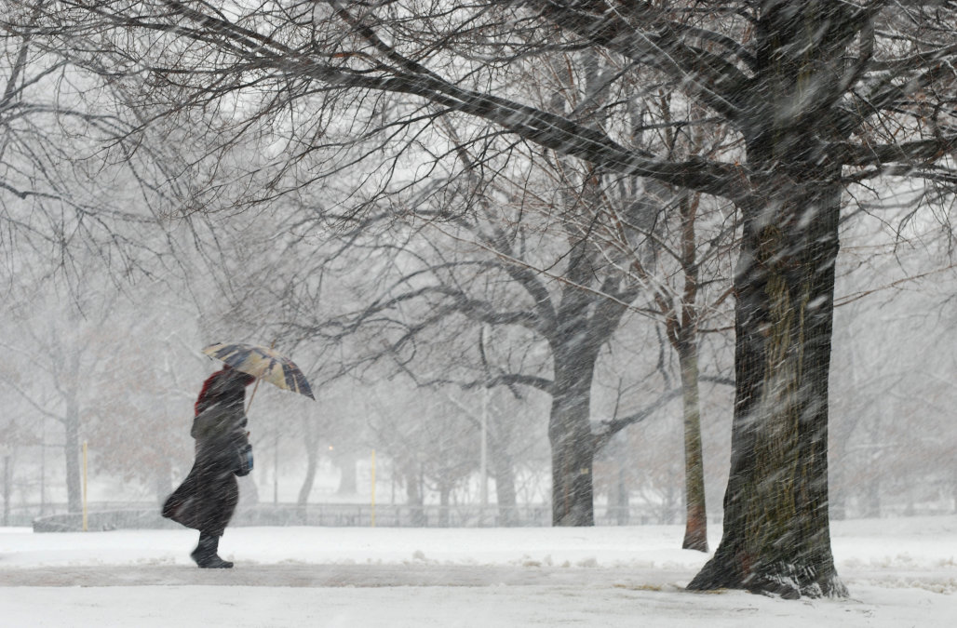

The weather is cold and windy.
How can you tell?

5

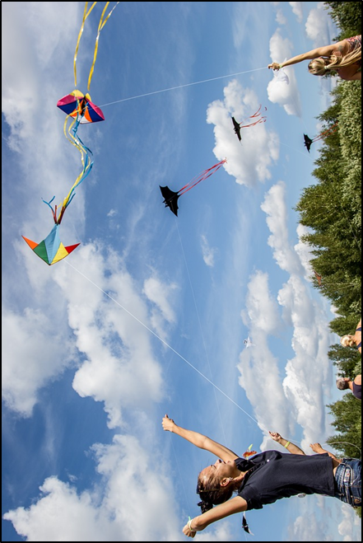
What is the weather?

The weather is warm and windy.
How can you tell?

6

