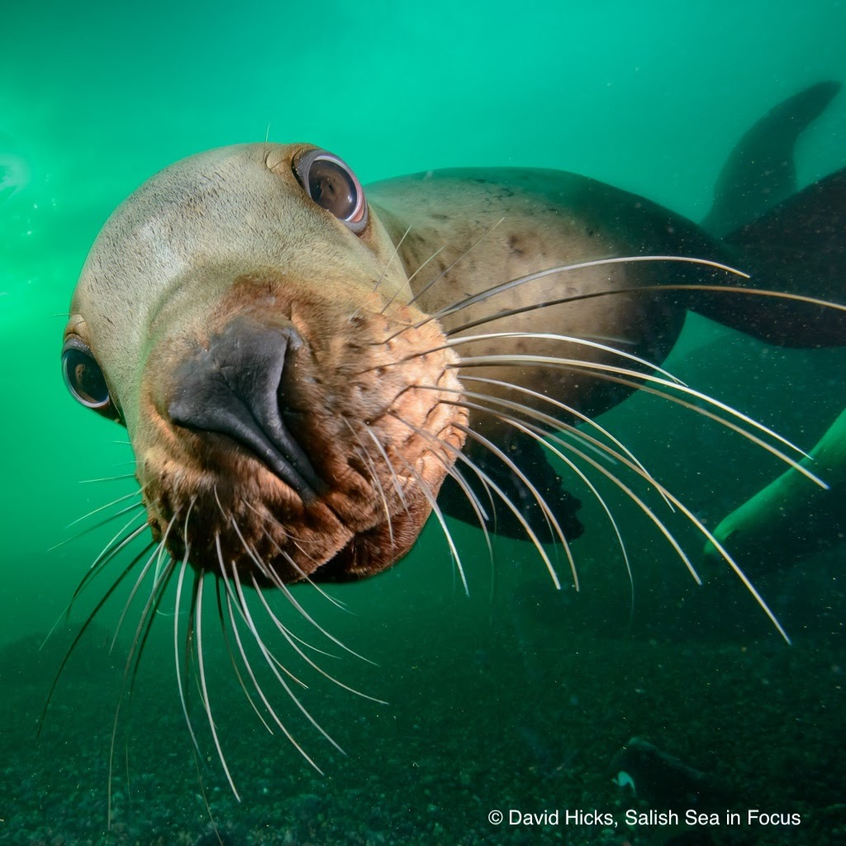

Dive
Grade Level: 4^{th –} 6th
Explore Chapter: Life Between Two Worlds
Time Required: 9 50-minute sessions
LEARNING TARGETS LESSON 1:  Understand that pressure, temperature, and light change with water depth.  Know that marine birds and mammals have physical, behavioral, and physiological adaptations that help them survive diving in deep waters.  Know that humans have a dive reflex where our bodies react physiologically to being submerged in water.  PERFORMANCE TASKS LESSON 1:  - Model what it is like to search for prey in the dark while playing a game that simulates a porpoise hunting for herring.  - Observe pressure changing at different water depths by submerging objects in water and having them compress at the different depths and pressures.  - Read a graph and determine that light, temperature, and pressure changes at different water depths.  - Research a diving animal in the Salish Sea and draw its place in a Salish Sea food web  - Research adaptations that diving animals have that make them capable of surviving deep dives under water by reading scientific articles.  - Test humans (classmates) to determine if we have a dive reflex by using the process of science and measuring one physiological variable with our noses in water vs. in air. | TEACHER PREP LESSON 1 CONTINUED  Team Read: What Happens During a Dive  Provide poster papers with the Team Read template drawn on them. Print the How Diving Mammals Stay Underwater So Long article  Human Dive Reflex Research  Provide a paper cup (or reusable cup) for each student. Review how to take a pulse (instructions on journal p13)  Provide a stopwatch (or cell phones) for each pair of students.  Select and prepare a 5 minute formative assessment to assess the performance tasks from this lesson.  TERMS FOR THE TEACHER  Explore Teams - teams of 3-6 students contributing different roles and strengths to nature detective mystery-solving. Scientific roles are described in student journals, p.2 and in the slideshows.  Pearls of Wisdom- Inspirational quotes, cut into individual strips, folded, and placed in a large shell for a student to draw and read at the beginning of each lesson or each unit.    Background research- includes articles, videos, the Explore the Salish Sea book and others.    Wonder – a phenomenon, problem, or discrepant event that sparks curiosity in students and initiates the themed exploration for the unit.  Team Talk – Explore Team members share with one another. Each student has 1 min to share to ensure equitable opportunity to speak, and to allow even the quiet students to be heard, where they may not share in a full-class discussion. The Science Communicator shares Team ideas with the class at the end.    Essential question – The overarching question that drives the background research, games, activities, and authentic inquiry for each unit.  Team Read – The equitable division of a large piece of literature or several types of background information, including articles, videos, webpages, and more, among teammates, each getting summarized individually, and then synthesized into an overall summary. This allows each student to feel that they have contributed an important piece of background research, while accommodating individual ability levels.  Tribal Knowledge - Work with your district’s Tribal or First Nations Liaison, if you have one, to invite a cultural outreach or natural resources employee from a local tribe or First Nation to visit your class and share what they deem appropriate on the topic of their family history in this place and specifically, how they used traditional eco- logical knowledge to ensure the return of the salmon.
NGSS PERFORMANCE EXPECTATIONS
Three Dimensions of NGSS
blue=Practice orange=DCI green= Crosscutting Concept
GRADE 4
4-LS1-1 Construct an argument that plants and animals have internal and external structures that function to support survival, growth, behavior, and reproduction.
4-LS1-2 Use a model to describe that animals receive different types of information through their senses, process the information in their brain, and respond to the information in different ways.
GRADE 6-8
MS-LS1D Information Processing.
TEACHER PREP LESSON 1

Read through the unit plan along with the slideshow and student journal after printing 1 journal per student.
Gather/procure materials listed at the end of each lesson.
Print and cut into strips Pearls of Wisdom. Fold and place individual strips into a large abalone or clam shell
Print pre-assessments, 1 per student

Hungry Hungry Porpoise game
Plan for using an open space. Supply a porpoise that will cover the eyes.

Speed Diving Tournament
Print the tournament bracket
Supply an equal amount (about a 2” cube) of waterproof clay for each student

TIME | Teacher Guide Lesson 1, Adaptations for Diving
Session 1  1 min  2 min  15 min  20 min  5 min  7 min | - Have a student select and read a ‘Pearl of Wisdom’ (nature-related inspirational quotes) from a large shell.  - Direct the formation of Explore Teams using roles on journal p3, slide 6.    - Administer Ch 6 Dive! pre-assessment, slide 7.  - Distribute Dive! student journals and have students read Explore the Salish Sea Ch.6 Between Two Worlds, slide 8 then free-write on journal p4.  - Direct them to highlight or circle then define unfamiliar vocab words on journal p5.  - Ask students if they are diving mammals! Show The Truth About Mermaids by clicking the image in slide 9 of the Dive! slideshow. Encourage them to share wonderings and their own diving experiences with the class.
Session 2  25 min  10 min  5 min  10 min |   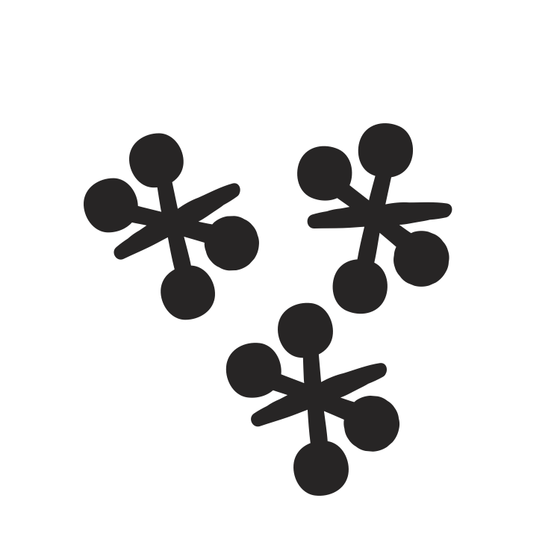  - Wonder : Show the Da Vinci quote in slide 9 and have students contemplate it for a moment. Turn and talk in Explore Teams:  - Play the Hungry Hungry Porpoise game , slide 10 in a large, open space, journal p6. Do have some of the student “islands” turn to ships and make ship noise in the third or fourth round for an added challenge. Leave time to reflect on its challenges at the end.    - Guide the formation of an Essential Question as a class, slide 11, using what students wondered and consider challenges associated with diving for prey in a noisy sea. Have students write the question on journal p7.    - Show slide 12 (sea lions) and ask students to look for diving adaptations (structures and behaviors) in the videos in each of slides 12-16. Compare and contrast then consider which behaviors and shapes contribute to fast diving. Ask the class what all diving animals have to do while diving.  - Ask students if they can hold their breath for 30 seconds (barring preventative medical conditions). Show slide 17-18 to consider how long diving animals can hold their breath. Introduce the term physiology – the functions of body systems, such as respiration, heart rate, blood flow, metabolism, heat-generation. Finally, have students consider behaviors, shapes, and physiological adaptations that enable them to hold their breath for so long, journal p8.
Session 3  30 min  20 min | - Have students review their ideas for adaptations that enable efficient diving, journal p8. Have Techs retrieve waterproof clay for each Explorer then conduct the Hydrodynamics model diving animal speed tournament with available materials, journal p9, slides 19-20. Record results in the tournament bracket. Have students reflect on effects of form on function, journal p10.  - Show the gray seals video, slide 21. Ask students to conduct a Team Read journal p11, slide 21. Hand out the Nat. Geo. Article on diving mammals. Have Science Communicators share summaries.
Session 4  35 min  10 min  5 min  Total:  3.3 hrs | - Show The Truth About Mermaids SSW video in slide 22 and ask students, do you think humans have a dive reflex like the gray seals? Guide students through the Research it! Dive reflex investigation on journal pp12-14, and the extension, if time and resources allow.  - Show dive reflex video on slide 23 to initiate an informal Get CERIAs Forum. No notes needed.  - 13 Administer a formative assessment that suits your students’ learning to date.

MATERIALS LESSON 1:  - Internet connection  - Audio-Visual equip for slideshow/videos  - Student journals, printed with booklet fold on 8.5 x 14” paper, 2 center staples  - Slideshow  - Colored pencils, 1 pack per Team  Wonder  The Truth About Mermaids video  Hungry Hungry Porpoise game  - Balaclava, Buff, or other hat/object that simulates a porpoise head and/or serves as a vision blocker  - Open space with level ground where class can form a large circle  - Hats or other ways to identify prey (herring, surf smelt, or squid), islands, and ships (optional)  Speed Diving Tournament  Diving animal video clips (links in slideshow)  Test tanks (5 or 10 gal aquaria or rubber bins), 1/Team  Something to represent “prey” at the bottom of the tanks  Stop watches  Water-resistant modeling clay or other reusable, negatively buoyant, pliable material divided into equal proportions, 1/student  Speed-diving tournament brackets (on board, screen, or poster)  Team Read Activity  Poster paper with Team Read Template drawn on by students, using the example in the slideshow  Printed article, 1/student (Option: divide article ahead of time, with reading differentiation in mind. You want all Team members to feel they contributed something valuable, regardless of their reading level)  Research it! Dive reflex investifation  Dixie cups filled with water, 1/student  Stopwatch, 1/pair of students  Other equipment, should you choose to expand the investigation-see link for Dive reflex investigation extension | WEBLINKS:  Dive! Slideshow  https://pacificeductioninstitute.sharepoint.com/:p:/s/Program/EcAv4ppnn6hAi0p25JJyWy0BcHo9ElGkXiXmUjTLsP0awQ?e=CRxSJF  Hungry Hungry Porpoise game  https://pacificeductioninstitute.sharepoint.com/:w:/s/Program/ERhLJg7RtHNLtwbZGm4m6XABMnyNbUOBauHXNKTYi4uwiQ?e=eC47Fu  Diving animal videos:  Sea lions  https://vimeo.com/90444190  Pacific white sided dolphins https://www.youtube.com/watch?v=mn_Pv4cVeuo  Rhinoceros auklet  https://www.youtube.com/watch?v=WJiMbNAEzaM  Murre  https://www.youtube.com/watch?v=cn6Gz-axetw Cormorant  https://www.youtube.com/watch?v=SfGeKYc-YXY  Speed diving tournament bracket  https://pacificeductioninstitute.sharepoint.com/:w:/s/Program/EcNOl_CWME9Kt9Ghl3ZchKYBJeGwzkALPo8uiNwFgJTV6Q?e=i6RaMT  BBC gray seal diving video  https://www.youtube.com/watch?v=UYkiRbgiwx0 The  Truth About Mermaids video:  The Truth About Mermaids-shorter.mp4  Team Read Template  06 - Team Read Template and Instructions.pdf  National Geographic article, How Diving Mammals Stay Underwater So Long, by Jane Lee  Natl. Geog. article-How Diving Mammals Stay Underwater for So Long.docx  Dive reflex investigation extension  Dive Reflex Investigation extension.docx  Dive reflex video for after investigations  https://www.youtube.com/watch?v=00RKh6NRMqc

LEARNING TARGETS LESSON 2:  Know that sound is pulses of energy that compress air particles, water molecules, and even particles in solid matter, causing objects (bone, ear drums, feathers) to vibrate, sending a message to our brains.  Understand that ocean waves have similarities to and differences from sound waves.  Understand that diving animals have sensory structures to sense sound waves in the water  PERFORMANCE TASKS LESSON 2:  - I can see that sound moves objects by observing rice bouncing on cellophane stretched over a bowl after a drum is struck across the room.  - Draw a diagram of longitudinal (sound) waves after modeling them using a Slinky and watching a video capturing sound waves with a special camera.  - Study a diagram of echolocation organs in an orca and listen to orca calls picked up on a hydrophone. | TEACHER PREP LESSON 2  Air has mass demo (only necessary if you did not implement the Explore Stations in Unit 5, Ocean Tech)  Bring in 1 empty balloon and a balance or scale. You will have students record its empty mass and then its mass when filled with air.  Sound as Vibrations Demo  Bring in a stringed instrument, cellophane, a large bowl with a smooth rim and a handful of rice grains  Sound through a gas, liquid, and solid investigation  Provide 2-3 zip-top, plastic baggies, a source of water, and 2-3 wood blocks in a tray for each Explore Team  Sketching Sound Activity  Preview the NPR video on sound  Provide at least 1 Slinky-type coiled metal or plastic toy for each Explore Team  Human Sound in the Sea Model  If available (not essential, but fun): provide one orca toy and one salmon toy
NGSS ADDRESSED IN LESSON 2

4-PS4-1 Develop a model of waves to describe patterns in terms of amplitude and wavelength and that waves can cause objects to move.

4-LS1-2 Use a model to describe that animals receive different types of information through their senses, process the information in their brain, and respond to the information in different ways.

MS-LS1-8. Gather and synthesize information that sensory receptors respond to stimuli by sending messages to the brain for immediate behavior or storage as memories.

TIME | TEACHER GUIDE LESSON 2: SENSING SOUND
Session 1  5 min  7 min  5-20 min  23 min  5 min  5 min | - Show slide 25 to introduce Lesson 2.Remind class about the definition of matter (any substance that takes up space and has mass). Ask if air is matter and for evidence either way. Remind them of station activities in Unit 5, Ocean Tech where they discovered air has mass by weighing an empty vs. a full balloon (demo this now if you did not implement unit 5).  - Run demos for thinking of sound as waves:  - Pluck a guitar (or other instrument) string. Ask class what they observed about the string. What causes the sound?  - Place about 10 rice grains on a sheet of cellophane stretched over a large bowl. Strike a drum and have students observe the rice.  Ask students to have a Team Talk about their observations: What caused the rice to jump?  - Hold a new Team Talk to discuss: Does sound act the same in matter with different densities? Here you may need to review what they learned about density in Unit 1, Ocean Motion, or do a quick demonstration and/or game to understand the concept of density if you have not implemented that unit.    - Show students where to find materials to test out how sound acts through materials of different densities, air, water, and wood, journal p15. Let them know that, unless they use a sound meter, this will be qualitative data (not numerical). Take a few minutes to clean up.  - Ask students if they know what is happening in their own ears when their partner is tapping. Show the Sense of Hearing video by Mocomi Kids (1 min 41 sec)    - Use the conclusions and responses on journal p16 as a formative assessment.
Session 2  10 min  2 min  20 min  10 min  8 min  Total:  up to  1hr 40 min | - Show NPR video on sound, slide 26 then direct students to draw a diagram of the air particles near their favorite marine mammal after it makes a sound on journal p16.  - Show slide 27. Ask why the crest of the wave aligns with the areas of high-density air particles. Hold a “popcorn” discussion (students pop in to contribute thoughts, free-form) about them.  - Direct students to stretch the Slinky the length of their lab tables. Have one student at a time/Team make the sound of their favorite diving animal as they send pulses of energy through the Slinky to model the collisions of air or water particles that are compressed by sound, journal p17. Ask if the diagram’s arrangement of dots is similar to their own drawings. Ask why the line drawing has peaks at the highest densities of air particles. Ask if they’d like to amend their diagrams at the top of journal p17.  - Connect wave characteristics to students’ experience of sound using slides 28-29. Introduce some other types of waves, using slides 30-34, showing the video on deep ocean waves in slide 34. Show slide 35 and describe wave terms. Have students label their own diagrams on journal p18, using terms from the Wave Word Bank.  - Show slide 36, showing how echolocation works in killer whales. Then make a Human Sound in the Sea Model: Ask students to become human water particles and create a line across the room, standing 1ft/30cm apart. Have the student make orca echolocation clicks at the start of the line, which causes the first water particle (student) to vibrate, bumping into the next, which starts vibrating and bumps into the next, and so on. Students should stop vibrating when the student 3 people ahead of them in line starts vibrating. If you have an orca toy and a salmon toy, have the orca ‘make the call’ at the beginning and have the salmon jump when the sound wave hits it at the end, then have the sound wave return to the orca.

MATERIALS LESSON 2:  - Slide show  - A/V system  - internet connection  - NPR Skunk Bear Video: What Does Sound Look Like?  Demos  - Guitar or other stringed instrument for observing vibration  - Drum or other loud noise-maker, large bowl, plastic wrap  Sketching Sound Activity  - Slinky toy (coiled metal) 1 per Explore Team | ONLINE RESOURCES LESSON 2:  What Does Sound Look Like Video, by Skunk Bear on NPR  https://www.youtube.com/watch?v=px3oVGXr4mo&feature=youtu.be  Sense of hearing video by Mocomi Kids https://www.youtube.com/watch?v=g_US0Qn_SZA
RISK MANAGEMENT:  - Play games in a safe area where vision-blocked students or those in the obstacle course will avoid tripping hazards or a hard fall. | Extensions:  Build a piezoelectric hydrophone using University of Connecticut’s COSEE TEK Simple Hydrophone Design: https://www.nurtec.uconn.edu/wp-content/uploads/sites/287/2016/08/COSEE-TEK-Simple-Hydrophone-Material-List-Fabrication-Instructions-V4.2-7-7-2016.pdf  Add these hydrophones to the students’ ROVs built in unit 5, connect them to speakers or smartphones, and head to a nearby dock to hear sound in the sea!  Learn more on killer whale echolocation by SeaWorld at:  https://seaworld.org/animals/all-about/killer-whale/communication/

LEARNING TARGETS LESSON 3:  Understand that the Southern Resident Killer Whales (SRKW’s) and many other diving mammals are having a difficult time finding prey due to excessive vessel noise in the Salish Sea.  Understand that science and engineering can be used to develop solution(s) to a problem.  - Know that science can’t help solve problems until it is communicated. | NGSS ADDRESSED PERFORMANCE  EXPECTATIONS LESSON 3:  Three Dimensions of NGSS  blue=Practice orange=DCI green= Crosscutting Concept  Grade 5  5-ESS3-1 Obtain and combine information about ways individual communities use science ideas to protect Earth’s resources and environment.  Grades 6-8  MS-LS2-4 Construct an argument supported by empirical evidence that changes to physical or biological components of an ecosystem affect populations.
PERFORMANCE TASKS LESSON 3:  - Conduct a literature search to learn about impacts of vessel noise in the sea and how it can be mitigated  - Suggest ways of decreasing human-made sound in the sound and use the engineering design process to design a prototype ship that decreases radiated noise in the sea.  - Conduct a scientific experiment to determine factors in quiet ship design and communicate results, implications, and applications through a Get CERIAs forum | TEACHER PREP LESSON 3  Can you hear the orcas calling?  Preview the Orca Sound website at www.orcasound.net Listen to each of the sample orca calls in the “Listen” tab and distinguish the clicks from a boat motor noise in the second sample.  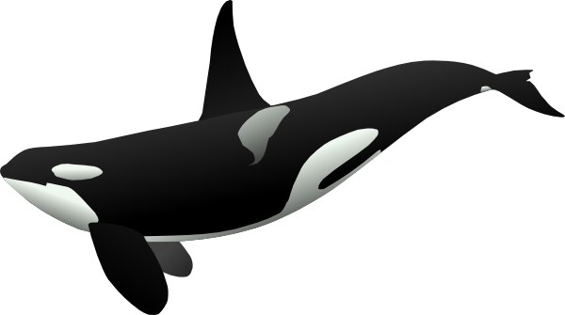  Listen to the live hydrophones to hear if orcas are going by.  Lowering Sound in the Sound  If possible, invite a Naval Architect, ship builder or engineer from a local shipyard or Navy base to talk with your students about designing ships to reduce radiated noise.  Review principles of quiet ship design in the following document: The Science of Quiet Ship Design  Provide ship-building and propeller materials:  - aluminum foil, 5 12x12” (30cm) sheets per Team  - recycled materials (spoons, popsicle sticks, etc.) to build the propeller  - ‘motor’ shaft (wooden dowel)  - Rubber band to power ‘motors’  - glue guns  - paper plates (to go under glue guns)  Procure a sound meter or upload a sound meter app to your smartphone to use during prototype trials.

TIME | TEACHER GUIDE LESSON 3: ENGINEERING A QUIETER SEA
Session 1  5 min  5 min  25 min  10 min | - Review the Hungry Hungry Porpoise game again. Debrief- what were the challenges? Was it harder while holding your breath? Harder with ship noise? How did the porpoises adapt their behavior in a noisy sea?  - Share the example orca calls from the Orca Sound link in slide 37. The “clicks” link has the high-pitched clicking sounds with boat motor noise in the background. Clicks are the sounds used in echolocation to find salmon. Ask the class if they can hear the throbbing of the boat propeller and the high-pitched clicks. Ask what the orcas might do to hear the echo of their clicks over the boat noise.  - Ask the class if they think the orcas can hear when a small boat is passing by then play this video clip by Orca Sound and Beam Reach to share what a small boat sounds like underwater. Suggest they return to thinking like an engineer, this time about boats. Ask for suggestions to decrease human-made sound in the sound. They’ll likely suggest, “We’re gonna need a bigger quieter boat.”  - Tell students it sounds like they are going to need some background on how to engineer quieter ships. Show the video in this Hakai article on ocean noise (2 min), then have Explore Teams conduct a Team Read of 1 of the articles in the Ocean Noise article folder, slide 39. Invite Teams to share out their take-aways with the class.  *Replace this activity with a visit from a ship-builder or Navy engineer, if possible. Have students prepare ahead with questions about reducing radiated noise in ships.  - Show slide 40 and and propose the quietest ship design challenge to address the question in the slide. Review the engineering process, slide 41, show students the available materials, and invite students to fill in the green and lavender circles (Identify the Problem and Design) on journal p20.
Session 2  Total: | - Ask engineers if they are ready to build their prototypes. Let them know that each Explore Team may entire their final prototype out of 3 they’ve tested into the quiet ship design comparison. Show slides 42 – 44, showing videos in slide 42. Invite Lab Techs to gather materials and begin to Explore, building ship hulls from aluminum foil and propellers from recycled plastic or wood to create the quietest ship.  - Build a frame for the hull, cover with aluminum foil  - Build a propeller and attach it to a propeller shaft  - Connect a rubberband to spin the propeller shaft  - Test your prototype

MATERIALS LESSON 3:  - Slide show  - A/V system  - internet connection  Ship-building and propeller materials:  - aluminum foil, 5 12x12” (30cm) sheets per Team  - recycled materials (spoons, popsicle sticks, etc.) to build the propeller  - ‘motor’ shaft (wooden dowel)  - Rubber band to power ‘motors’  - glue guns  - paper plates (to go under glue guns)  1 or 2 10-gallon tanks or Rubbermaid-style bin with water | ONLINE RESOURCES LESSON 3:  Orca Sound sample orca calls  https://www.orcasound.net/listen/  Boat noise underwater by Orca Sound and Beam Reach  https://www.youtube.com/watch?v=4We7pz0A8fI&t=1s  Ocean Noise Article Folder  Student Research References  The Science of Quiet Ship Design  https://pacificeductioninstitute.sharepoint.com/:w:/s/Program/ETxEjbrlWD5OgvHP1dQeeK4BzggbdiDHyCaWaHCqlcGRdA?e=jM7dHf  Cavitation video  https://www.youtube.com/watch?v=IKwQX31Mans  How to reduce cavitation video by Nick the Naval Architect  https://www.youtube.com/watch?v=MyZzhwYMytc
RISK MANAGEMENT: | EXTENSION  Shouting Whales  A wonderful curriculum to extend the study of sound in the ocean, Shouting Whales, can be found at: https://www.openschool.bc.ca/shouting_whales/

