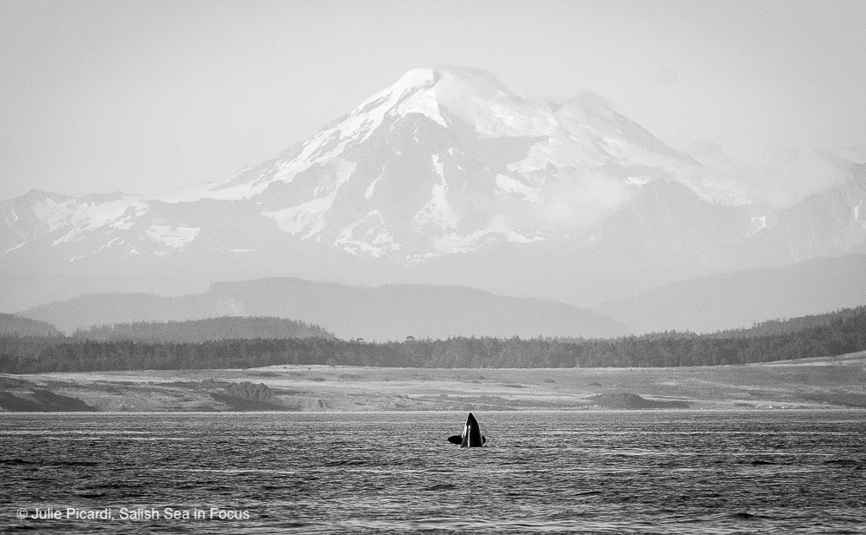

Salish Sea Heroes

Grade Level: 4-5th
Explore Chapter: 8: Be a Salish Sea Hero
Time Required: 4 50-minute sessions plus project time

LEARNING TARGETS LESSON 1:  Understand that when the environment is healthy, the economy and people are also healthy.  Know that communities are currently coming together to restore habitats with expert help from tribes, First Nations, state, county, and federal government agencies, universities, non-profit organizations, and citizen science groups and there are many examples of success.  Know that students can be an important part of environmental improvement projects and even initiate and help lead them.  Understand that a successful project requires planning, organization, funding, time, cooperation between many types of experts, and the right tools and materials for the job.  - Understand that communicating science and action helps to educate the community, invite input for improvement, encourage others to help improve the environment, and build hope for a better world. | NGSS ADDRESSED PERFORMANCE  EXPECTATIONS  Three Dimensions of NGSS  blue=Practice orange=DCI green= Crosscutting Concept  Grade 5  5-ESS3-1 Obtain and combine information about ways individual communities use science ideas to protect the Earth’s resources and environment.  Grades 6-8  MS-ESS3-3 Apply scientific principles to design a method for monitoring and minimizing a human impact on the environment.
TEACHER PREP  Review unit plan, student journal, and slideshow. Revise each (delete, add, or change components to suit your needs). Delete pages at the end of the student journal which you will not use.  Communicate with community partner/s to identify potential projects and create a skeletal project plan that your students will fill in with details of their choosing.  Create a timeline that works for your schedule for student project managers to plan within.  Familiarize yourself with a project management tool that your student project managers will use, such as | TERMS FOR THE TEACHERS  Essential question – The overarching question that drives the background research, games, activities, and authentic inquiry for each unit.  Team Read – The equitable division of a large piece of literature or several types of back- ground information, including articles, videos, webpages, and more, among teammates, each getting summarized individually, and then syn- the sized in one overall summary. This allows each student to feel that s/he has contributed an important piece of background research, while accommodating individual ability levels.    Wonder – a phenomenon, problem, or discrep- ant event that sparks curiosity in students and initiates the themed exploration for the unit.  Team Talk – Explore Team members share with one another. Each student has 1 min to share to ensure equitable opportunity to speak, and to allow even the quiet students to be heard, where they may not share in a full-class discussion. The Science Communicator shares Team ideas with the class at the end.

TIME | TEACHER GUIDE LESSON 1: PROJECT DESIGN
1 min  9 min  10 min  30 min | - Keep the same Explore Teams from the previous unit for now. These will change in session 2. Provide final pearls of wisdom in a large shell.  - Distribute Salish Sea Heroes student journals and have students read Explore the Salish Sea Ch.8 Be A Salish Sea Hero, slide 4, then free-write on journal. p3.  - Direct them to circle or highlight unfamiliar vocab words on journal p4 and add any more they are unsure of from the chapter. Return to define them opportunistically after you’ve used them a few times.  - Wonder: Introduce and show films in the Salish Sea Wild Film Fest!, slide 5  Review films in the online resources box below. Select a few to make up your film fest that add up to about 30 min. Provide popcorn and make it festive. These films are selected to inspire hope by showcasing existing Salish Sea Heroes and their success stories. Guide students to write thoughts on journal p5, turn and talk about the environmental improvement success stories, then share out to the class.
Session 2  10 min  25 min  10 min  5 min | - Ask students about their favorite films. Guide them to write their choice and what they liked about it on journal p5. Then ask, what action would you take to help heal the sea?  - Ask what their overall goal for improving something in their community would be, slide 6. It’s called “Essential Goal” to be consistent with the previous “Essential Question” that normally goes here, journal p5.  Provide students with all of their Explore the Salish Sea student journals to date. Ask students to look back at the “Applications” box of their Get CERIAs forms in each of their journals and create a list of the 3 most important science- and traditional knowledge-based actions they recommended on journal p6.  - Next they should have a Team Talk (1 minute per team member) about their options and narrow it down to one top choice for the team, journal p6. They are still in their teams from the Migration unit here.  - Now they will form teams, but for this unit it is a little different, slide 7 (feel free to replace the photo with one of your own students). Explore Teams evolve into Restore Teams to take on a community project. The whole team takes on the role described. Modify and add roles, as you deem fit and describe the roles, journal p7, slide 8.
Session 3  10 min  30 min  10 min | - Have class choose an ecosystem they’d like to work on, slides 10-20. Allow students to look over the journal page with the full description of their tasks. Page numbers are listed with Restore Team titles and tasks on journal p7. Have students write their chosen ecosystem, ie. “Fraser River delta salt marsh” or “Orcas School raingarden”  - Let students know it’s planning time! Invite their community partner and fill in journal p8 together.  - Start a project planning document or online planning tool, such as https://coggle.it/. This should then be handed off to the Project Managers, once they get the hang of how it works. There is an example in the slideshow Presenter Notes, slide 9. This should be shared with all or posted in the room.
Session 4  50 min | - Orient Explore Teams to their respective tasks as chosen in Session 2. Invite students to fill in the details of the plans on their respective journal pages (9-12), slides, How Science Works tracker (journal p13), etc., slide 21

MATERIALS LESSON 1:  - Internet connection  - Audio-Visual equip for slideshow/videos  - Printed student journals  - Migration slideshow  Team Read  Team Read template, poster paper, one different colored marker for each group member, Team Read article: Ocean Conveyor Belt  Salish Sea Heroes Project  Salish Sea Wild film fest  Community expert visit for planning | WEBLINKS:  Salish Sea Heroes Slideshow  02 - Salish Sea Heros Slideshow_ML.pptx  Salish Sea Heroes Student journals  https://pacificeductioninstitute.sharepoint.com/:w:/s/Program/Ee3s9OGEnGFItR_S84Wzf4MBG3S-ysLmddJSCQMqXNrWag?e=LqXWgG  Lifeblood film by WDFW  https://www.youtube.com/watch?v=AWjkgVJ2s0s&t=715s&fbclid=IwAR0FCKZwWcws90FTplA_XLRcxNRKeXHGLYQ4o8TMvv8oNWREINV4XV8o46Q  Bowker Creek (Victoria, BC) 100 Year Blueprint, restoration of an urban creek, video 5 min  https://www.youtube.com/watch?time_continue=296&v=H1arxeMQXqo&feature=emb_logo  Family Forest Fish Passage video by WDNR  https://www.youtube.com/watch?v=0m0DqpZzBU4  A River Reborn video by NOAA  https://response.restoration.noaa.gov/multimedia/videos/river-reborn-restoring-salmon-habitat-along-duwamish-river-seattle-washington.html  Puget Sound Restoration Fund Olympia Oyster Restoration video  https://vimeo.com/53984430  Society for Ecological Restoration’s links to success stories in BC. Short articles.  https://chapter.ser.org/westerncanada/restoration-showcase/restoration-showcase-bc/  Team Read template (to draw onto poster paper)  https://pacificeductioninstitute.sharepoint.com/:w:/s/Program/EY71vuJZCWNLsqxMR5e9uPYBci9QbBWhQHsPqvO50WGPdw?e=odIpwB

LEARNING TARGETS LESSON 2:  Understand that rolling up our sleeves and getting to work with peers and community leaders, we can fix past mistakes and accomplish the impossible.  - Know that improving habitats for wildlife is good for the plants and animals, good for people, and good for the economy. Everyone wins.  - Understand that communicating science and action helps to educate the community, invite input for improvement, encourage others to help improve the environment, and build hope for a better world. | NGSS ADDRESSED PERFORMANCE  EXPECTATIONS  Three Dimensions of NGSS  blue=Practice orange=DCI green= Crosscutting Concept  Grade 5  5-ESS3-1 Obtain and combine information about ways individual communities use science ideas to protect the Earth’s resources and environment.  Grades 6-8  MS-ESS3-3 Apply scientific principles to design a method for monitoring and minimizing a human impact on the environment.
TEACHER PREP  Communicate with community partner/s to arrange for the field day and necessary materials, ie tools, gloves, plants, soil, garbage bags, etc.  Communicate with administrators and chaperones to arrange for your field day on or off campus.  Have the student project managers oversee the gathering of all materials that your class will provide for the project. | TERMS FOR THE TEACHERS  Essential question – The overarching question that drives the background research, games, activities, and authentic inquiry for each unit.  Team Read – The equitable division of a large piece of literature or several types of back- ground information, including articles, videos, webpages, and more, among teammates, each getting summarized individually, and then syn- the sized in one overall summary. This allows each student to feel that s/he has contributed an important piece of background research, while accommodating individual ability levels.  Wonder – a phenomenon, problem, or discrep- ant event that sparks curiosity in students and initiates the themed exploration for the unit.  Team Talk – Explore Team members share with one another. Each student has 1 min to share to ensure equitable opportunity to speak, and to allow even the quiet students to be heard, where they may not share in a full-class discussion. The Science Communicator shares Team ideas with the class at the end.

TIME | TEACHER GUIDE LESSON 2: IMPLEMENTATION AND COMMUNICATION
Time for each step will vary depending on project details and location | - Make appropriate field trip arrangements, even if it is on school grounds, to comply with your school safety guidelines.  - Oversee student project managers as they review the project plan with the class and community partners, if possible, journal p14. Review outdoor classroom and safety rules with students.  - Transport to project site.  - Conduct your Salish Sea Heroes project! Build a rain garden, pull invasive weeds, clean the beach, remove a seawall, add sand and gravel to a beach, monitor an existing restoration site for plants, forage fish spawning, salmon spawning, plant eelgrass or salt marsh plants, restore oyster reefs, … The possibilities are wide open and your choice will reflect your community’s particular needs, partners, and resources. Enjoy!
Session 2 | - Plan and prepare a way to communicate your research and Salish Sea Heroes projects with your community. Some options are described on journal pp15-23, however, don’t let these suggestions limit student creativity. They may want to include a song, play, puppet show, art installation, … the options are wide open!
Session 3 Present | - Communicate your project in a community symposium, art installation, performance, or? Your/student choice.  - Give stamps, journal p20, and celebrate with your community expert partners in a festive way!

MATERIALS LESSON 2:  RISK MANAGEMENT:  Enforce “outdoor classroom” rules for safe behavior, including staying with the team and chaperones.  Instruct students in safe tool use during project.  Have at least 2 adults per student group at project site.  Provide first aid supplies, student meds, epi-pens, etc. and a parent or volunteer with emergency response training. | ONLINE RESOURCES LESSON 2:  Post-Explore the Salish Sea Student Survey weblink  https://ucdavis.co1.qualtrics.com/jfe/form/SV_8q6y69UokgwIl4q  Post-Explore the Salish Sea Student Survey download for printing:  https://pacificeductioninstitute.sharepoint.com/:b:/s/Program/EUCn091oestOo3Uhe1mgImoBXJu_uiHQF-WlC0GASZrs2w?e=HhIqka

