Chapter 1. Where is the Salish Sea?

Ocean Motion

Oceanographer:

______________________________

ORGANIZE YOUR EXPLORE TEAM

Salish Sea Explorers use teamwork to solve mysteries and save the day for sealife. Thank your last Teammates for their support and good ideas. Form a team and select one of these equally valuable roles, then start to explore!

Team Name: _________________________________________________

|  |  |
| --- | --- |
| **Chief Scientist**  Research manager  -suggests research projects  -ensures proper scientific protocol  Project manager  -ensures each team member has a job and stays on-task, motivates team with positive encouragement  -Ensures project completion  Assists all other positions as needed | **Research Associate**  Conducts background research online, in books, interviews, videos, or magazines  Methods manager  -ensures research procedures are legit.  Recorder  -records and enters data in data tables  -records summaries of team’s work  Assists all other positions as needed |
| **Field/Lab Technician**  Materials manager  -gets supplies and makes sure they are in working order  -Keeps workstation organized  Infographic artist  -creates graphs from data table content  Assists all other positions as needed | **Science Communicator**  Reporter  Graphic artist  Presentation manager  -slideshow, poster, video, etc.  Translates complex science into words the general public can understand  Assists all other positions as needed |
| **Cultural Liaison** (for 5 person groups)  Researches and records input and perspectives of members of the local Coast Salish Tribe (US) and/or First Nations (Canada). Finds Indigenous stories, songs, art, or knowledge keepers who can teach us about keeping Salish Sea ecosystems balanced. | For long-term projects, switch roles every 4 weeks  **GO TEAM!** |

# Seashore Stewardship Pledge

I, _____________________________________________, do hereby solemnly pledge to be a good steward of the marine environment. This means that I will:

1. Listen to the instructors both in the classroom and in the field
2. Walk on the shore and docks with care to avoid hurting myself, others, and the sea life
3. Treat all life forms with care and respect
4. Use only wet hands to touch gently animals that I find
5. Leave creatures attached to rocks and docks because attempting to remove them can hurt them
6. Not hold any marine life out of the water for more than one minute
7. Leave no boulder overturned; I will carefully replace all rocks that I look under and I will only turn over rocks that are smaller than my head.
8. Return all organisms to their homes or where I found them

Signed: ___________________________________________________

Date: ____________________

# Chapter 1: Where is the Salish Sea – inspired thoughts

What did this Explore chapter bring to mind? Use this space to free-write and/or draw your thoughts, ideas, imaginings, and questions.

# Ocean Motion Vocabulary

Circle or highlight unfamiliar words and add your own. Return to write or draw their definitions as you figure them out through use.

|  |  |
| --- | --- |
| Vocabulary | Definition |
| Coast Salish  Canoe Journey  Density  Circulation  Evaporation  Condensation  Precipitation  Oceanographer    Tide  Current  Plankton  Buoyancy |  |

# Mapping the Salish Sea

A map is geographic information through art! Cartographers map our world on paper and on computers. Could a map help us solve mysteries to help killer whales?

What would you use to map the Salish Sea? Pen and paper? Computer cartography? What information would your map show? Brainstorm here then add your suggestions to a mind map.

|  |  |
| --- | --- |
| Items to include | Map Design |
|  |  |

# What did you wonder?

Consider the journeys of the “Friendly Floaties” in the ocean, the boat sailing on a bi-colored sea, and the turquoise water in Hood Canal, part of Puget Sound. What do all these things make you wonder about ocean water? Write and/or draw your wonderings.

______________________________________________________________

______________________________________________________________

______________________________________________________________



Write our Essential Question Here:

____________________________________________________________________

____________________________________________________________________

____________________________________________________________________

***Model it!*** Can wind cause ocean currents?

|  |
| --- |
| Design a way to model the effect of wind on ocean currents.   1. Send your Lab Tech to acquire materials: plastic bin, food dye, hair dryer, water 2. Determine how you could model wind-driven ocean currents with your materials. 3. Try out your model. Record results below with a diagram or notes. Find out what other teams tried. Try it again. 4. Share your observations and conclusions in the class discussion |

***Model it!*** Can density cause ocean currents?

|  |  |
| --- | --- |
| Did you know: | What to do: |
| * Density is the amount of stuff (matter) that takes up a set amount of space (volume).   Marine Math! Density (D) equals mass (m) divided by volume (V).  The equation for this is: $D= \frac{m}{V}$    * Water may have matter dissolved in it, such as salts. Would salts change the density of water? How?   =   * Water may get warm from the sun, causing water molecules to spread out. Would heat change the density of water? How? | 1. Place the note card on the jar containing blue water all the way to the top. 2. Turn this jar upside down and set it onto the jar containing green water, or vice versa. 3. Pull out the note card carefully, keeping the jars exactly aligned. 4. Observe. Draw what you observed in the jars below. 5. Repeat with jar with blue water on the bottom and jar with red water on top, or vice versa. Then experiment!   Related imageRelated imageRelated image  Related imageRelated imageRelated image  Color and label the jars to show how the water in your jars looked before and after removing the note card. Use the next page to add more jar diagrams, if necessary. |

Document your observations of the effects of density on water movement

NOTES:

Explain your Density and Motion activity observations using what you experienced in the You are my Density game.

NOTES:

Density Differences and Ocean Circulation

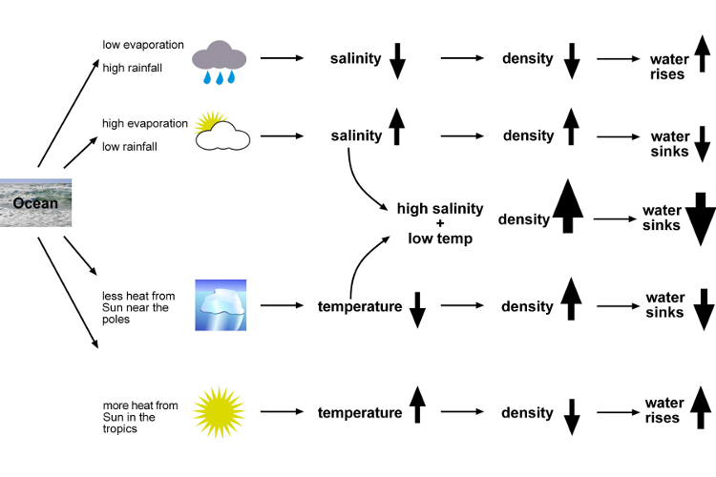

Image by Science Learning Hub – Pokapū Akoranga Pūtaiao, University of Waikato, [www.sciencelearn.org.nz](http://www.sciencelearn.org.nz)

## *Model it!* A black background with a black square Description automatically generated with medium confidence Why is the sea two colors?

Using what you observed in the density and motion explorations, how would you explain the phenomenon in the photo on the cover of this journal? Write and/or sketch and label a diagram to model your understanding.

***Paddle to Tsawout

1. Draw your route on the map below from your nearest beach to Tsawout First Nation Reserve on the Saanich Peninsula, Vancouver Island, BC.

1. Study your tide guide or app to find the safest and easiest date and time to paddle your route (in late July).

Date ____________________ Time _______________________ AM / PM

***Model it!*** Ocean Motion Model

|  |  |
| --- | --- |
| Did you know: | What to do: |
| *If you made a cube-shaped swimming pool 1 mile long by 1 mile wide by 1 mile high, that would hold 1 cubic mile of water to swim in! (Same goes for kilometers).  *It would take over 332,519,000 of these swimming pools to equal the amount of water in the ocean.  That’s 1,386,000,000 giant swimming pools if you’re using kilometers.  *That’s about 352 quintillion gallon jugs of water in the ocean!  *Could someone make a current in their swimming pool using density differences? | Make this tray of water a model of the whole world ocean:   1. Fill your dish halfway with water, add 2-3 drops blue dye 2. Add continents and sea life 3. Add ice to the north and south poles, where the ocean is cold. Add 3-4 drops of blue dye at each pole. 4. Point a heat source to represent the sun hitting the equator. Add red dye there. 5. Draw your observations here: |

 Ocean Motion Model Evaluation

Pros Cons Improvements

Looking Ahead

What types of marine life that might be affected by all this ocean motion?

## *A close up of a sign Description automatically generatedActivity:* Friend a Plankter!

My Favorite Plankter #1 My Favorite Plankter #2

Type of plankton: ________________ Type of plankton: ______________

Circle: Phytoplankton or Zooplankton? Phytoplankton or Zooplankton?

Holoplankton or Meroplankton? Holoplankton or Meroplankton?

Look into the meaning of the root word phyte.

Turn and Talk Based on what you learned, where in the water do you think phytoplankton need to live? _____________________________

How can these tiny organisms stay at the right depth to survive?

Can you engineer a model plankter to learn how?

*Engineer It!*

Did you know ***planktos*** is a Greek word meaning drifters? Plankton (with an n) are organisms, both large and microscopic, that swim too weakly to move against currents. They are moved not only by ocean currents, but gravity, too.

If they don’t swim strongly enough, how can they avoid both sinking into the dark and getting sunburned at the surface to get just the right amount of sunlight for photosynthesis?

What to do: Follow the Engineering Design Process to build a plankter that achieves neutral buoyancy just below the surface of the water. Write and/or sketch diagrams in the circles below. When finished, enter your contestant in the Great Plankton Race. **The slowest plankter to the bottom of the tank wins!**

IDENTIFY THE PROBLEM

DESIGN

EXPLORE

CREATE (build your model then sketch it here)

TRY IT OUT

MAKE IT BETTER

NOTES:

The Great Plankton Race Results

|  |  |
| --- | --- |
| Our plankter’s name |  |
| Sinking time |  |
| Sinking distance |  |
| Sinking speed  (*distance /time*) |  |

Brief and concise description of results:

_____________________________________________________________ _____________________________________________________________ _____________________________________________________________ _____________________________________________________________

Explanation: Write possible reasons your race results turned out the way they did. Use engineering principles and ideas to explain your findings.

_____________________________________________________________ _____________________________________________________________ _____________________________________________________________ _____________________________________________________________

NOTES:

*

Map from Tsawout Marine Use used with permission from Tsawout First Nation

Map from Tsawout Marine Use used with permission from Tsawout First Nation

# How would ocean currents move oil spilled in the central Salish Sea?

# *KNOW WANT TO KNOW LEARNED*

|  |  |  |
| --- | --- | --- |
|  |  |  |

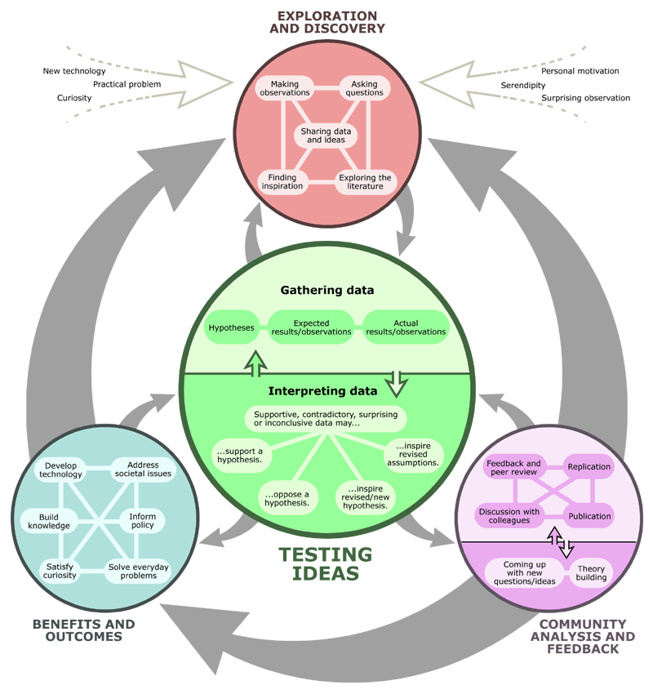

# *Icon Description automatically generated Put Science to Work:* Get your Oceanographer On!

Research Title: _________________________________________________

Choosing Variables: ____________ **location of spill** _______

one changed (manipulated/independent variable)

____ **distance oil spreads** _________

one measured (responding/dependent variable)

Research Question: 1. **Will an oil spill along tanker routes spread to important indigenous fishing and gathering sites of the Tsawout First Nation?**

**2. Where should a spill response tugboat be positioned to protect these First Foods?**

Hypothesis/Prediction:

We predict that if __**an oil spill occurred at** _______________________________ _____________________________________________________________(fill in location)

then_**it will / will not** (circle one) **reach Tsawout First Foods sites.**

because (explain using what you know about density and buoyancy and water circulation in the Salish Sea) _____________________________________________________________

____________________________________________________________

____________________________________________________________

____________________________________________________________

Procedure: Number step- by-step directions for how to do the experiment.

* 1. **Find the Coast Salish First Foods sites on the maps on pp21 and 22.**
  2. **Simulate an oil spill in the Trans Mountain pipeline shipping lanes using the Salish Sea Model. (See instructions)**
  3. **Observe the spill’s progress to see if it reaches the First Foods sites.**
  4. **Repeat the simulation at least three times for a spill in your selected location.**
  5. **Record data below.**

Results: (*Tables, graphs, maps, and/or pictures with a brief description of the outcomes of the oil spill simulation trials*)

**Model Trial 1**

Fuel type ____________________________ (bitumen is the most common shipped in these routes)

Date started __________ Total time elapsed ________________

First Foods sites contaminated? ***Yes / No*** (circle one)

**Model Trial 2**

Fuel type ____________________________ (bitumen is the most common shipped in these routes)

Date started __________ Total time elapsed ________________

First Foods sites contaminated? ***Yes / No*** (circle one)

**Model Trial 3**

Fuel type ____________________________ (bitumen is the most common shipped in these routes)

Date started __________ Total time elapsed ________________

First Foods sites contaminated? ***Yes / No*** (circle one)

NOTES

Brief and concise description of results:

Get CERIAs Forum Notes

|  |  |
| --- | --- |
| Claim  answer your research question | Evidence  What did the simulations show us? |
| Reasoning  Explanation of why you think your results turned out the way they did (including potential errors). | Implications  How does this new information impact the world or change the way we think? |
| Applications  How could this information be applied to the way we manage our watershed? | Science-based recommendations  What do you advise your community leaders based on your results? |

These stamps certify achievement of the following:

Friend to Plankton

Density Dynamo

Ocean Engineer

First Foods Protector

Ocean Model Master

