
Name_________________________Date_____________Period__________________

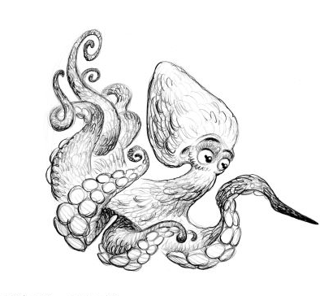
Explore the Salish Sea: Ch 6 Dive! Pre-assessment

Instructions: Read each question carefully. Write what you know; you will not be graded.

1. Circle or draw and label each of the changes you would experience as you dive deeper in the sea
a. visible colors (light) decrease
b. temperature gets colder
c. the pressure increases, squeezing you
d. all of the above

2. Circle or draw what will happen if you submerge an air-filled, plastic bottle in water. The bottle will:
a. expand – puff up
b. compress – press in
c. stay the same shape

3. Diving birds, mammals, and turtles can survive extreme changes in temperature and pressure thanks to: (circle all that apply or draw and label one example animal)

a. streamlined structure
b. wet suits
c. feathers and fat
d. physiology (heart rate, oxygen storage, blood circulation)

4. Do humans have adaptations for diving under water? If so, describe.

6. Do sound waves travel faster under water or in air? ________________

7. How does echolocation help diving animals locate prey in the dark sea? Explain or draw and label a diagram.

