
Name_________________________Date_____________Period__________________

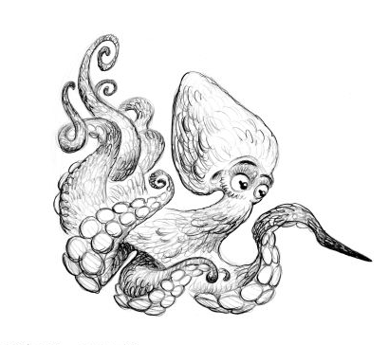
Explore the Salish Sea: Ch 3 Salish Sea Rocks Pre-assessment

Instructions: Read each question carefully. Write what you know; you will not be graded.
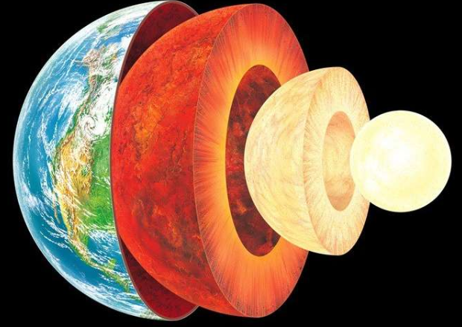
1. The outer crust of the Earth is made from ______________________ that is
floating on a squishy, moving layer called the mantle.

2. Describe 1 way rocks can form _________________________________________________________
___________________________________________________________________________________
___________________________________________________________________________________

3. What characteristics help us tell different types of rocks apart? Circle all that apply:
a. texture d. minerals
b. size e. personality
c. color

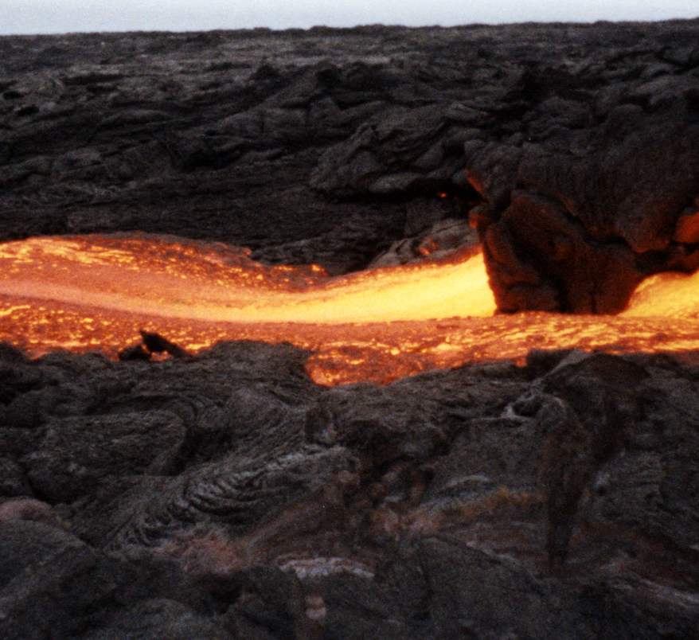
4. Any kind of rock can melt to form magma
a. True
b. False

5. What type of rock is forming in this picture?
a. igneous
b. sedimentary
c. metamorphic

6. What mysteries of Earth’s past can a rock reveal? ______________________________________
_______________________________________________________________________________
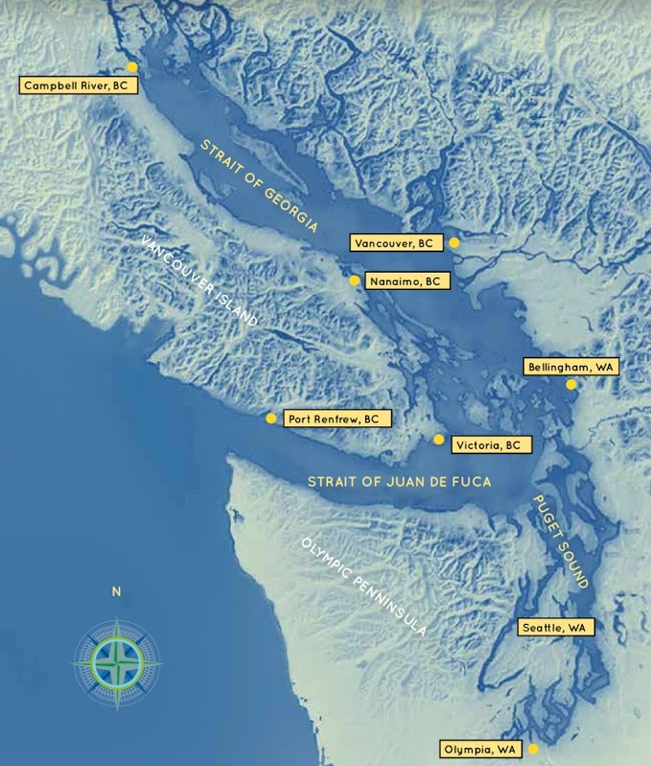

7. What Earth process carved out the basins of the Salish Sea?
a. volcanoes
b. earthquakes
c. moving ice, called glaciers
d. giants with big shovels

Bonus: If I had my own pet rock, I would name it ____________________________________ 😊

