Name_________________________Date_____________Period__________________

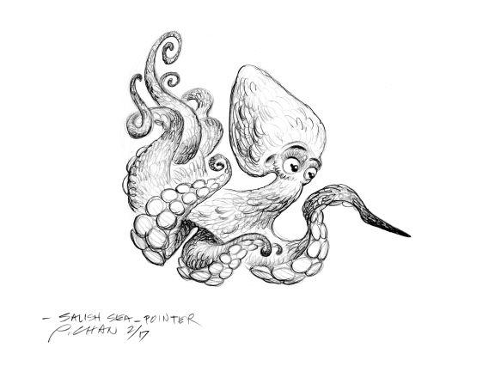

Explore the Salish Sea: **Stormwater** **Pre-assessment**

Instructions: Read each question carefully. Do your best; you will not be graded.

1. Fill in the missing step of the water cycle:

**A-_______________________________**

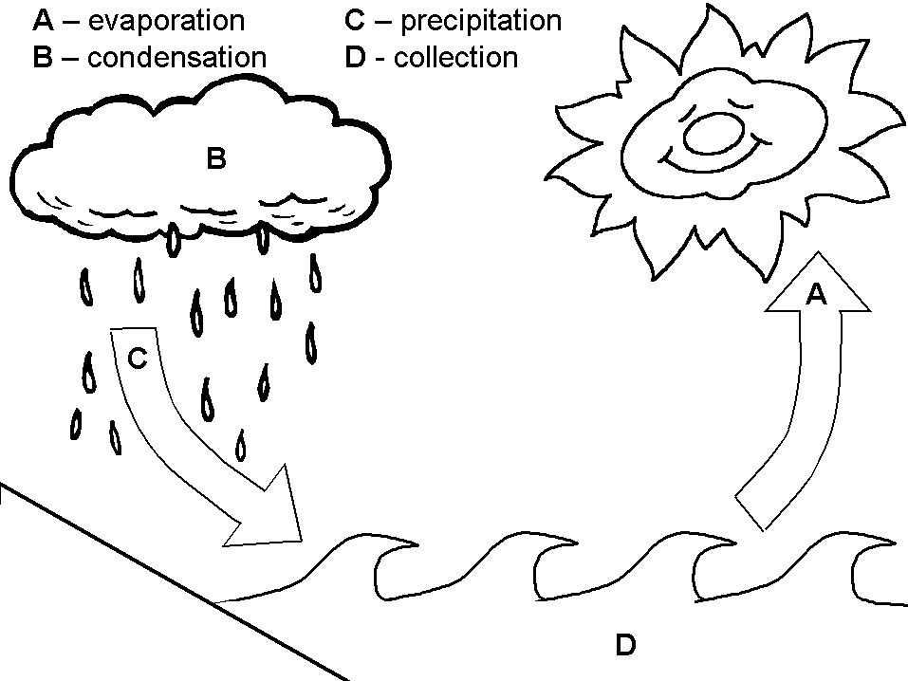

2. Label the watershed boundary in the watershed diagram:

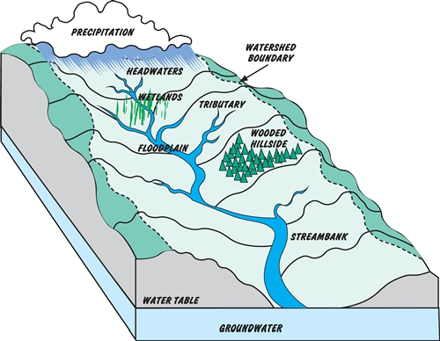



3. Where does the water that you drink come from and where does it go afterward? Write or draw a labeled diagram.

4. List at least 3 substances that this water might carry with it through your community.

5. Identify the manipulated (independent) and responding (dependent) variables in the following question:

“Does the river contain more pollutants after it passes through the city than before?”

Manipulated variable______________________ Responding variable __________________________

6. Write your hypothesis to the question in number 5 above.

7. What actions would you recommend to improve the water quality in your watershed?