Name_________________________Date_____________Period__________________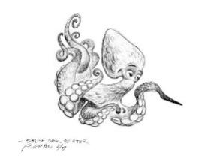

Explore the Salish Sea: Ch 4 Tide Out Table Set **Pre-assessment**

Instructions: Read each question carefully. Write what you know; you will not be graded.

1. Ocean tides are mainly caused by the pull from (circle two choices)

a. the sun

b. Mars

c. the moon

d. Pluto

2. The water moves toward the moon due to an attractive force called (circle the best answer)

a. buoyancy

b. gravity

c. friction

3. Intertidal life can survive extreme changes in temperature, moisture, salinity (saltiness), and even crashing waves thanks to protective ______________ and _______________ (circle two choices)

a. structures

b. life jackets

c. behaviors

d. parents

4. Draw a seashore food web:

a. sketch a beach

b. sketch at least **five** living organisms that live at the beach (above and/or below water)

c. connect the living organisms with arrows, showing the direction of energy flow

5. Write a letter **C** on three places that contain carbon in your sketch of the seashore above.

6. Indigenous peoples of the Salish Sea have been part of its food web for thousands of years. What are two ways that humans are interconnected with the Salish Sea food web?

7. How does too much carbon (carbon dioxide or CO2) in the water affect oyster shells?