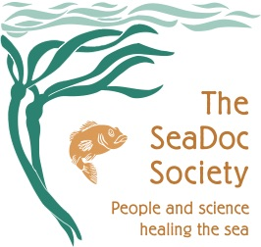
Name_________________________Date_____________Period__________________

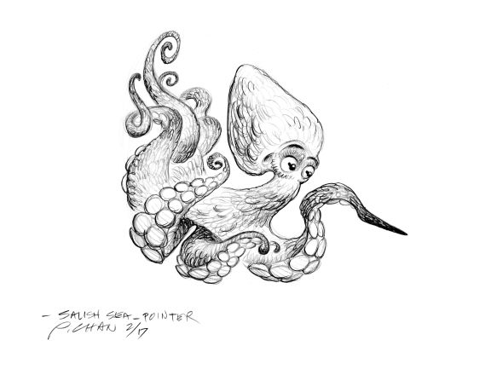
Explore the Salish Sea: Ch 7 Migration Pre-assessment

Instructions: Read each question carefully. Write and/or draw what you know; you will not be graded.

Circle all that apply in questions 1 and 2.
1. Migration improves animals’ ability to
a. find food
b. have a safe place to breed and have young
c. avoid boredom
d. stay warm

2. The Salish Sea is an important rest stop during a long migration because
a. it is a giant estuary with many habitats, including river deltas, mud flats, tidal marshes, eelgrass meadows, kelp forests, and deep waters.
b. it has free washrooms, coffee, and cookies for travelers.
c. upwelling currents and tumbling rivers deliver nutrient-rich waters for an abundant and diverse food web buffet.

3. Write 3 types of wildlife that depend on the Salish Sea during their migrations and the main reason for stopping here: Answers will vary

Animal  1. salmon  2. humpback whales, gray whales  3. seabirds and shorebirds (dozens of kinds, accept all answers) | Reason for coming to the Salish Sea  Travelling to their home streams to spawn  Feeding on fish (humpbacks) and shrimp (grays) on their way to Alaskan waters  Feeding on fish (seabirds) and worms and biofilm (shorebirds) on their way to nesting grounds

4. Draw a Pacific salmon lifecycle as best as you can.
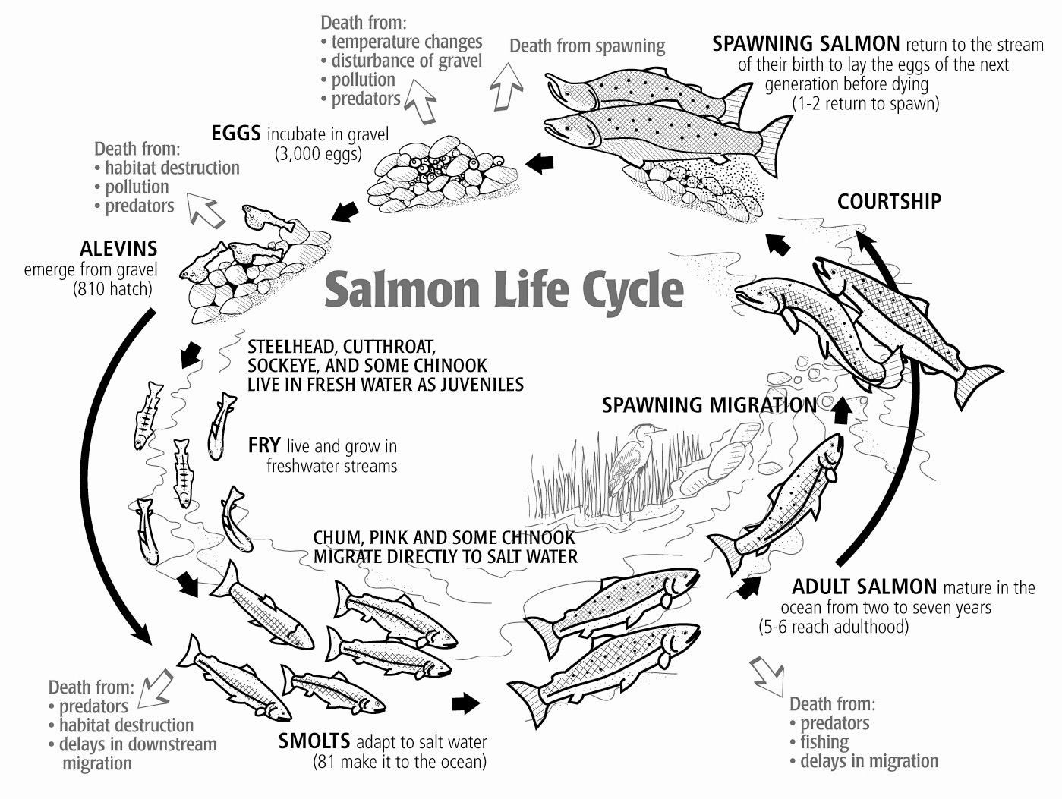

5. In the lifecycle diagram above, draw or write the habitat type they depend on next to each lifecycle stage. See diagram

6. What are three ways to test whether a stream is healthy for salmon?
1. Water quality testing for Clean, Cool, Clear water– through sensors like thermometers, chemical test strips and by which macroinvertebrates live there
2. Riparian plant survey – measuring shade, erosion protection, and insect habitat provided by native plants and trees.
3. Stream complexity survey – measuring water depth, flow rate, and observing for pools and riffles, logs, and culverts.

7. How are salmon important to a Coast Salish tribe or First Nation near you?
Salmon are honored as relatives from the sea who sacrifice themselves for the people. They are honored with a First Salmon Ceremony, where intact remains of the first salmon caught are returned to the sea to show respect for their gift. (This is shown in the Through Salmon Eyes video or shared personally by a visiting tribal knowledge keeper.)

