
Name_________________________Date_____________Period__________________

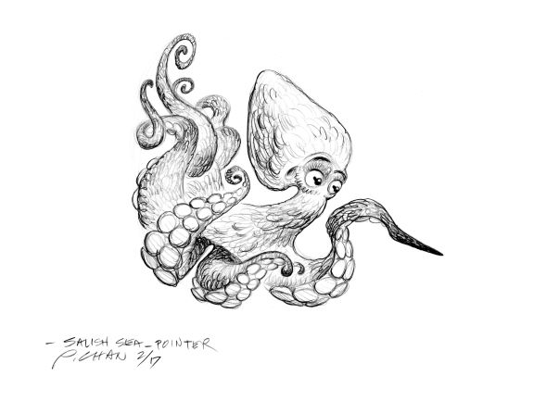
Explore the Salish Sea: Ch 7 Migration Pre-assessment

Instructions: Read each question carefully. Write and/or draw what you know; you will not be graded.

Circle all that apply in questions 1 and 2.
1. Migration improves animals’ ability to
a. find food
b. have a safe place to breed and have young
c. avoid boredom
d. stay warm

2. The Salish Sea is an important rest stop during a long migration because
a. it is a giant estuary with many habitats, including river deltas, mud flats, tidal marshes, eelgrass meadows, kelp forests, and deep waters.
b. it has free washrooms, coffee, and cookies for travelers.
c. upwelling currents and tumbling rivers deliver nutrient-rich waters for an abundant and diverse food web buffet.

3. Write 3 types of wildlife that depend on the Salish Sea during their migrations and the main reason for stopping here:
Animal  1.  2.  3. | Reason for coming to the Salish Sea
4. Draw a Pacific salmon lifecycle as best as you can.

5. In the lifecycle diagram above, draw or write the habitat type they depend on next to each lifecycle stage.

6. What are three ways to test whether a stream is healthy for salmon?

