
Name_________________________Date_____________Period__________________

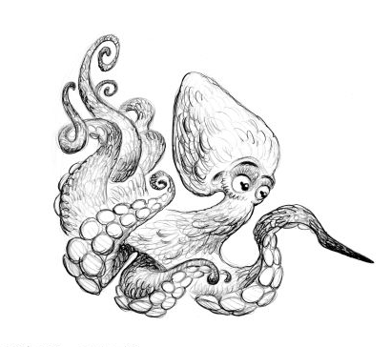
Explore the Salish Sea: Task Force Pre-assessment

Instructions: Read each question carefully. Do your best; you will not be graded.

1. What are four essential needs of every living thing?
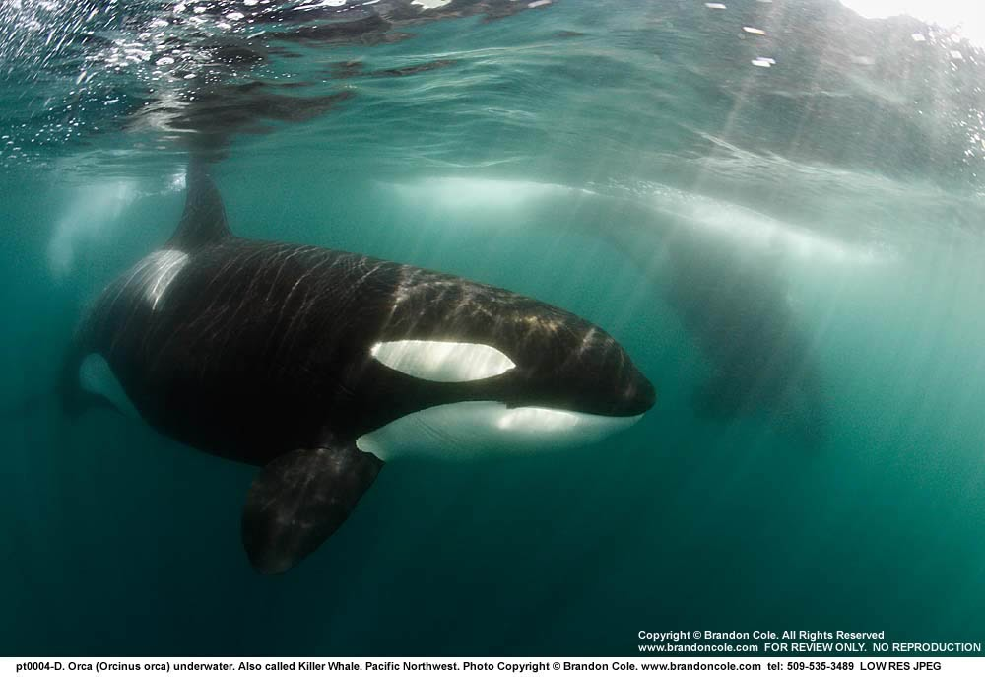
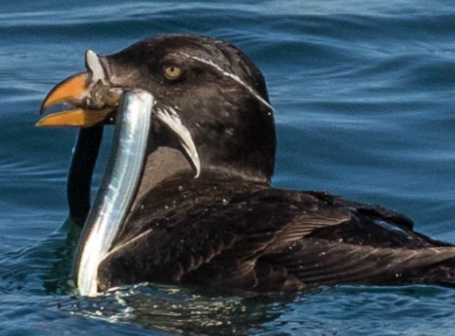

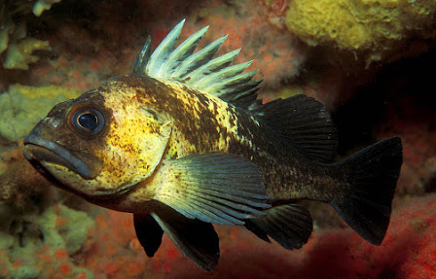
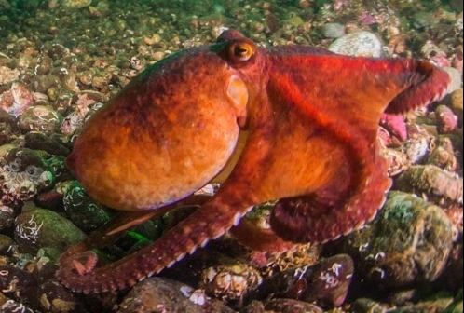

2. At what part of the Salish Sea food web are orcas (circle the best answer)
a. The bottom (they produce their own food) c. The middle (they have some predators)
b. The top (they have no predators)

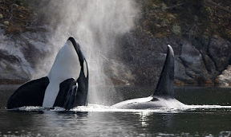
3. What are three challenges that the southern resident killer
whales face in the Salish Sea? Circle Three:

a) noise c) getting mistaken for pandas e) toxic pollution
b) lack of salmon d) lack of seals f) too many salmon

4. Who has the most experience with taking care of the Salish Sea healthy for people and wildlife?
Circle one:

a) college professors b) government officials c) the Coast Salish peoples d) your teacher

5. How can scientists, tribal leaders, fishers, and whale watch and shipping business owners work together to save an endangered species?

_________________________________________________________________________________

_________________________________________________________________________________

_________________________________________________________________________________

