May the Forces Be With You
Exploration Stations

BACKGROUND FOR EDUCATORS
At this point, your students’ ROVs may have had failure points, such as sinking or floating too much or not moving forward smoothly. Figuring out the effects of Newton’s Laws may help them figure out how to revise their designs to correct the failure points. You may already have introduced your students to Newton’s Laws of Motion, for which there are many lesson plans or online animations available, so you may draw on this previous knowledge here. But if not, don’t worry; they can jump right into discovery.
Teams will apply their discoveries to improve their ROV design to reach balance, neutral buoyancy, and three dimensional movement through the water with the least resistance, given the onboard equipment required to complete their mission. Explore Stations each offer discovery of pairs of opposite forces at play on their ROVs: gravity and buoyant force, thrust and friction (resistance), and air compression and expansion, as well as the interplay of mass and volume on displacement, or the mass of water moved out of the way by an object.

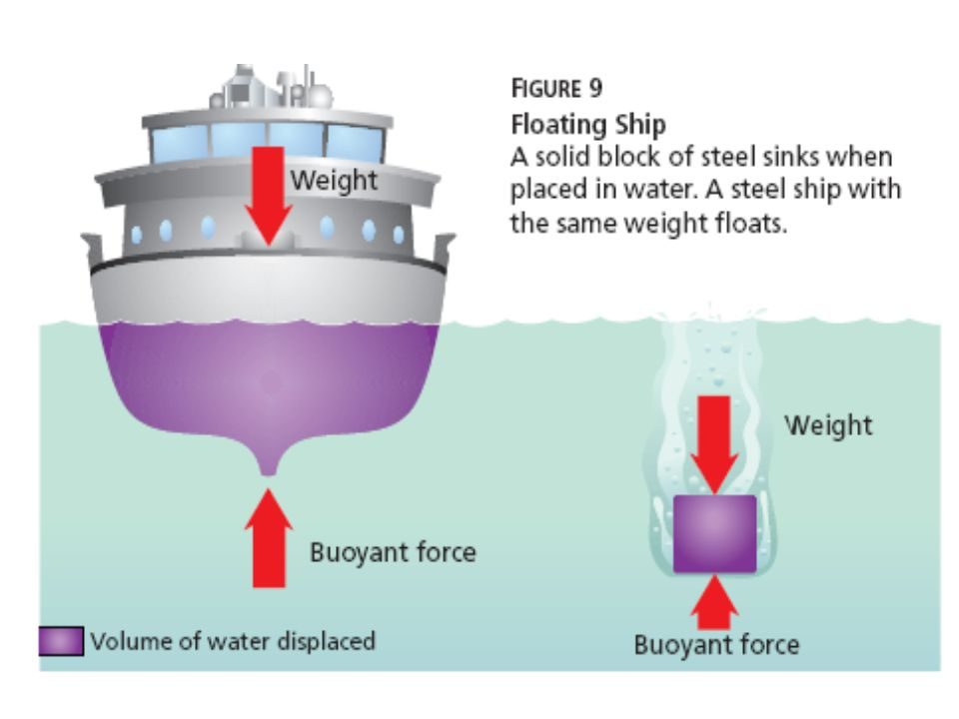
GRAVITY AND BUOYANT FORCE – Matter has an attractive force, called gravity. The more mass the matter contains, the greater its gravitational force. The closer an object is to a mass, the greater the force of gravity on that object. Earth is the greatest and closest mass to us! An object in water pushes down on the column of water beneath it. Water pushes on an object in the opposite direction of gravity. The amount of upward (buoyant) force depends on the volume of water displaced by the object. An object floats when it displaces a volume of water that has a mass equal to the mass of the object. If steel is shaped into a boat (Figure 1), it will displace more water than the same mass of steel shaped into a cube. The more water displaced, the greater the buoyant force. The wider and longer the boat, the more water it displaces and the higher it floats. Note that in the figure, the size of the arrow indicates the relative strength of the force.
1
Cut the instructions on the following pages by station and place 1 at each station.
STATION 1 Equal and Opposite Forces are just Ducky
Materials:
One rubber duck per student at the station
One container to hold enough water to fit 4-5 rubber ducks
Water to fill the container and a rag to mop up any drips

Explore: What directions are forces pushing on the duck to make it stay where it is in the water?
1. Draw your duck on journal p. 14 in the space for station 1.
2. Draw arrows to show the direction of the forces pushing on the duck. If the forces are unequal draw a bigger arrow for the greater force. If they are equal, draw equal sized arrows. (Hint: unequal forces cause motion)

STATION 2 Displacement Moves an Equal Mass of Water
Materials: One or two rags for setting wet objects on
One balance (triple beam balance or electric balance) to measure mass
500 mL plastic or glass beaker with volume measurements, 1 per student at station
Two approx.10 - 15 cm square pieces of aluminum foil and 8 pennies per pair of students at the station (these should have roughly equal masses)
10 or 20 mL graduated cylinder for pouring out the displaced water, 1 per student at station
Long forceps (tweezers) to remove aluminum from beaker.

Explore: What happens to the water level when different shapes of aluminum are placed in it?
1. Find the mass of each of each piece of aluminum foil plus 4 pennies. Record on journal p. 23.
2. Record the water level in your beaker on journal p23.
3. Wrap one piece of foil tightly around 4 pennies and place this into the beaker of water. What did that do to the water level? Record the new water level.
4. Remove the ball of aluminum and pennies and set on a towel.
5. Record the water level in the beaker
7. Set the cup- or boat-shaped aluminum and pennies in the beaker. Record new water level.
8. Did the water level change? By how much for each object?
* Challenge exploration: compare the mass of the aluminum objects with the mass of the water they displaced.
a. Find and record the mass of your graduated cylinder.
b. Remove and record the mass of the amount of water that was displaced by each aluminum object by pouring it into the graduated cylinder (if the water level changed from 100 mL to 105 mL, pour 5 mL of water into the graduated cylinder).
c. Find the mass of the graduated cylinder with the water.
d. Subtract the mass of the empty graduated cylinder from this. This is the mass of the displaced water alone.
e. Find and record the mass of the aluminum ball and boat and compare these to the mass of the water each displaced. What did you find?
STATION 3 Pressure and Compression
Materials: Per pair of students at station:
One 1-L or smaller, clear, squeezable plastic water bottle
One glass eye dropper 2 empty balloons
Source of water triple beam or electric balance to measure mass

Explore: Water pressure increases the deeper you go because more and more water is above, being acted upon by gravity. What happens to an air-filled object in water when water pressure increases?
1. Blow up one balloon, leave the other unfilled. Weigh and record the mass of each balloon. What do you notice? Does air have mass?
2. Fill your plastic bottle nearly to the top with water
3. Fill your eye dropper about ¼ full of water, ¾ full of air
4. Place your eye dropper into your bottle of water, rubber end up and put the cap on tight.
5. Increase the water pressure to simulate deeper water in the bottle by squeezing it.
6. What happens to the eye dropper in the bottle?
7. What could this mean for your air-filled ROV?

STATION 4 Propulsion and Friction
Materials: For each pair of students at station:
Some open space for flying toy airplanes
Rubber band-powered, propeller airplane

Explore: What forces act on an airplane, moving through the air?
1. Set up your rubber band-powered airplane and let it fly!
2. Draw arrows indicating each of the forces acting upon your plane on journal p. 14, Station 4. If forces are unbalanced, draw a larger arrow to indicate the greater force/s.

STATION 5 Center of Gravity and Balance Point
Materials: One card stock triangle, at least 20 cm on one side
One card stock paper airplane
One toy boat, any material
Each team’s ROV

Explore: Find the balance point
1. Find the balance point of each object by balancing it on only the eraser end of a pencil.
2. Finish by putting your ROV in water to see if it is balanced. What might you add to straighten it out if one side is lower than the other?

