Name_________________________Date_____________Period__________________

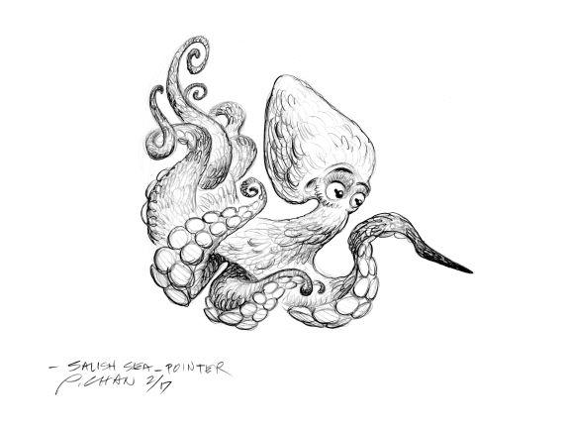

Explore the Salish Sea: **Stormwater** **Post-assessment**

Instructions: Read each question carefully.

1. Fill in the missing step of the water cycle:

**C-_______________________________**

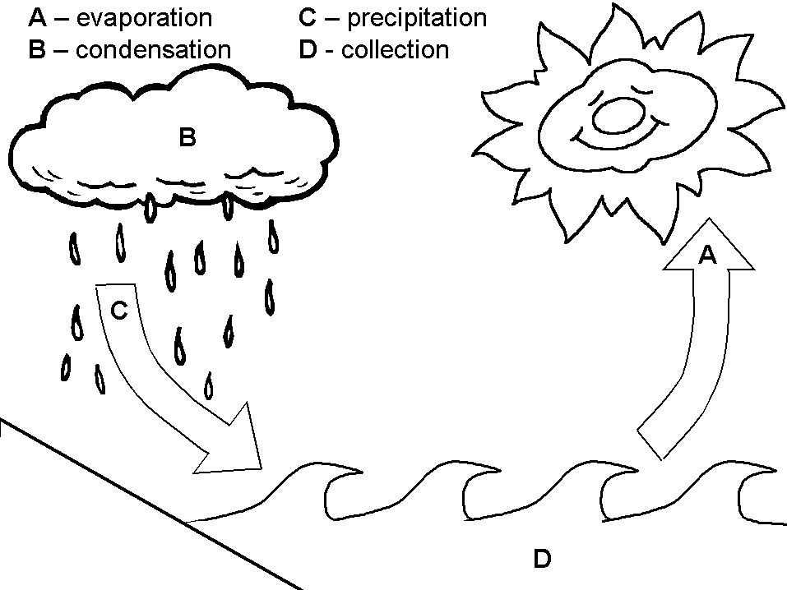

2. Draw and label a diagram of a watershed. Include the

* watershed boundary
* headwaters
* Floodplain
* Estuary



3. Where does the water that you drink come from and where does it go afterward? Write or draw a labeled diagram.

4. List at least 3 substances that this water might carry with it through your community.

5. Identify the manipulated (independent) and responding (dependent) variables in the following question:

“Does the river contain more pollutants after it passes through the city than before?”

Manipulated variable______________________ Responding variable __________________________

6. Write your hypothesis to the question in number 5 above.

7. What actions would you recommend to improve the water quality in your watershed?