
Name_________________________Date_____________Period__________________

Explore the Salish Sea: Ch 3 Salish Sea Rocks Post-assessment

Instructions: Read each question carefully. Write what you know; you will not be graded.
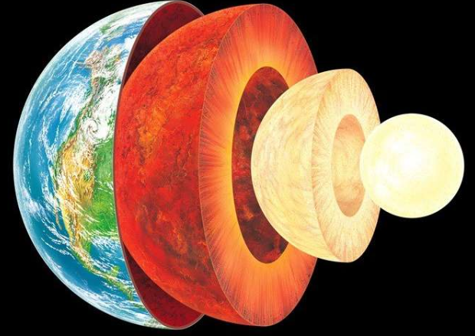
1. The outer crust of the Earth is made of _________________ that
floats and moves on a squishy, moving layer called the mantle.

2. Describe 3 ways rocks can form
- ______________________________________________________________________________
- ______________________________________________________________________________
- ______________________________________________________________________________

3. What characteristics help us tell different types of rocks apart? Circle all that apply:
a color. d. personality
b minerals. e. size
c. texture f. hardness

4. Any kind of rock can melt to form magma
a. True
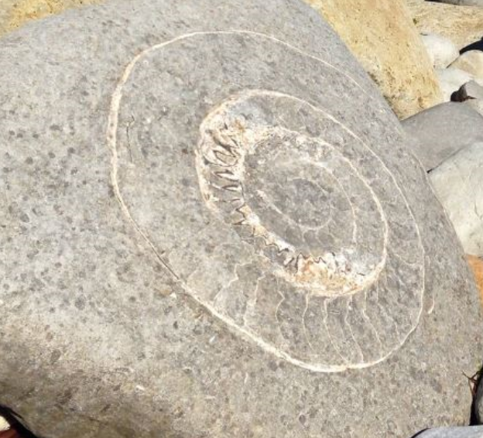
b. False

Shale

Marble

Magma and Basalt
a. igneous

b. sedimentary

c. metamorphic

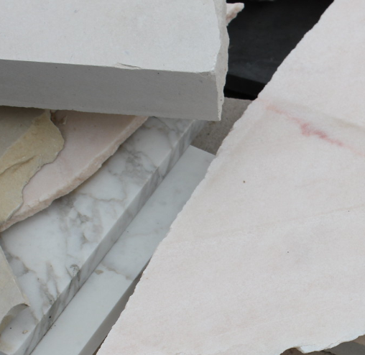
5. Draw a line from the rock type to its photo.

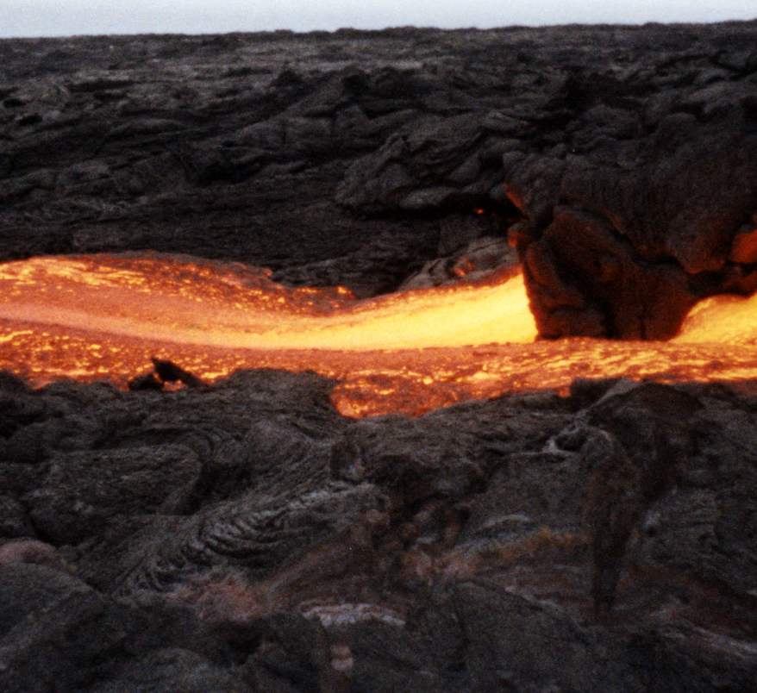

6. What mysteries of Earth’s past can a rock reveal? ____________________________________________________________________________________ ____________________________________________________________________________________
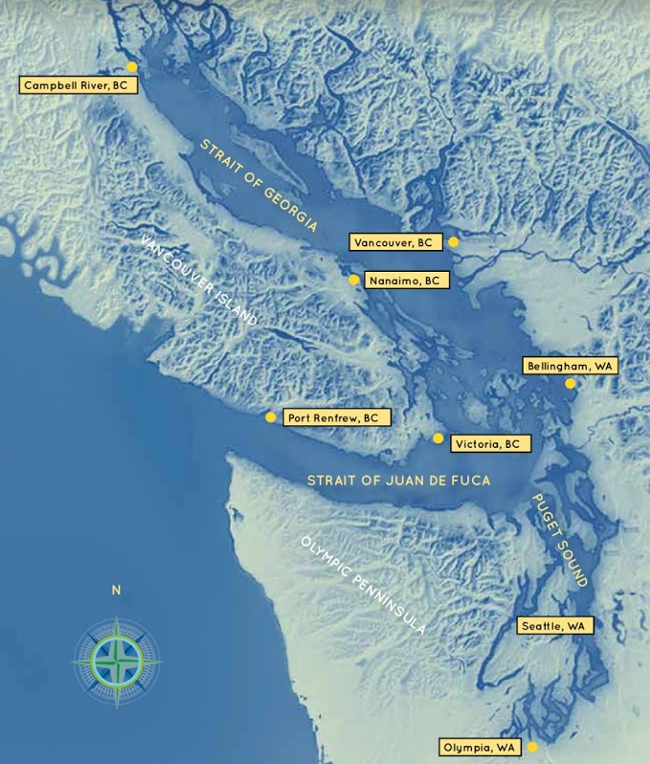

7. What Earth process carved out the basins of the Salish Sea?
a. volcanoes
b. earthquakes
c. moving ice, called glaciers
d. dinosaur footsteps

Bonus: My pet rock is named _________________________.
It is a ____________________________ rock. 😊

