
Name_________________________Date_____________Period__________________

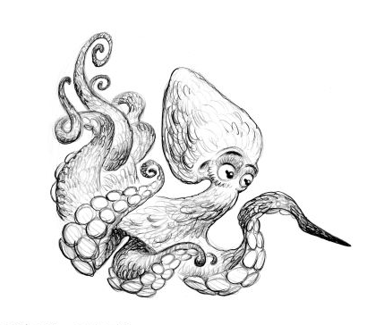
Explore the Salish Sea: Ocean Motion Post-assessment

Instructions: Read each question carefully.

1. True or false: Nearly ¾ of the Earth is covered by ocean _________

2. The Salish Sea is shared by______________ and _______________ (list two countries)

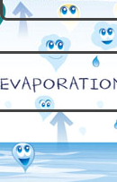
and was named to honor the ___________ ____________ peoples.

3. Water is always changing states (solid→liquid→gas/vapor and vice versa).
What must water gain to change from a liquid to a gas? _____________________

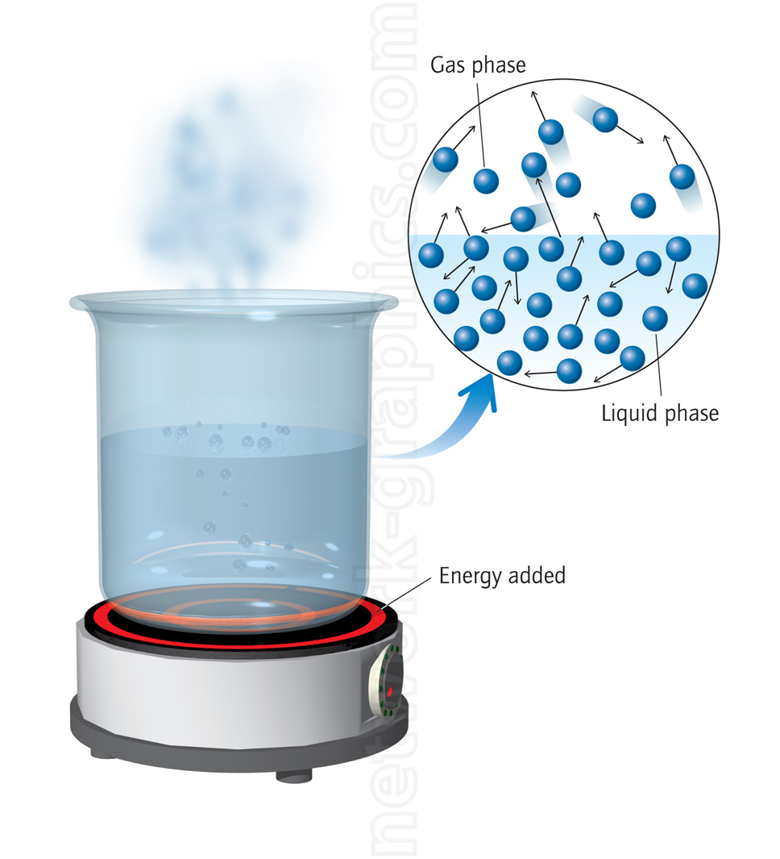

4. a. Adding heat to a liquid would increase / decrease (circle one) its density.

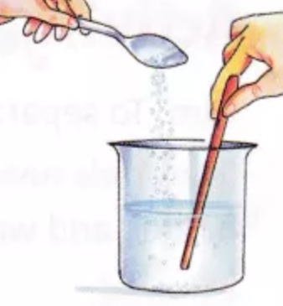
b. Adding a solute, like salt, to a liquid would increase / decrease (circle one)
its density.

5. Which of the following cause ocean water to circulate? (circle all causes that apply)
a. wind
b. gravitational pull of the moon and sun
c. whales swimming
d. heat
e. salinity (saltiness)

6. True or False: Buoyancy is an object’s tendency to float, sink, or remain stable in liquid. __________

7. ______________________ are tiny organisms that drift in the ocean and make over half of Earth’s oxygen. They need ______________________ to photosynthesize so they need to float near the surface of the water.

8. Draw one diagram showing the process of science and one showing how traditional knowledge is shared.
The Process of Science | Traditional Knowledge

