
Name_________________________Date_____________Period__________________

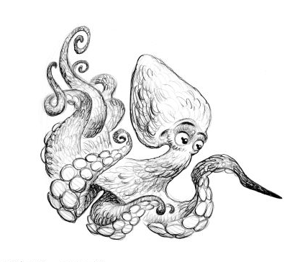
Explore the Salish Sea: Ocean Tech Post-assessment

Instructions: Read the scenario carefully and consider how you would define the problem then solve it.

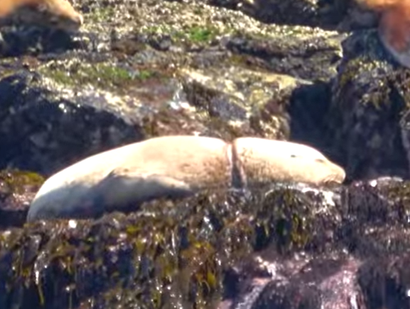
You see a sea lion suffering with a plastic packing strap around its neck. Plastic packing straps secure boxes for shipping goods around the world. These straps are loops that are neutrally buoyant and sea lions find them great fun to play with. The fun and games end when one gets stuck and the sea lion continues to grow. They can choke and die.

After you alert SeaDoc Society to activate the marine mammal rescue team you decide to tackle the problem where it began and save many more sea lions.
Don’t worry, SeaDoc Society and a team of wildlife vets and supporters saved this sea lion and he is now swimming free in the Salish Sea.

- Define the problem you see here.

- Design a solution to the problem you have defined. You may use words and diagrams to model your solution.

- Given the materials you would need, what steps would you take next?

