
Name_________________________Date_____________Period__________________

Explore the Salish Sea: Task Force Post-assessment

Instructions: Read each question carefully and write and/or draw your best answer.

1. What are four essential needs of every living thing?
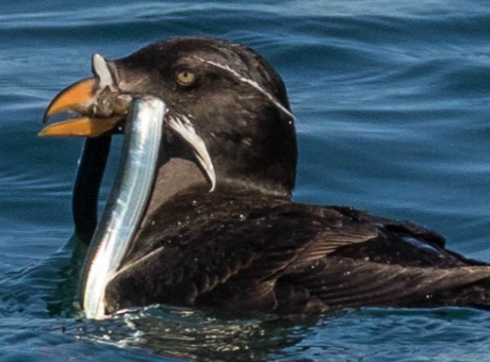

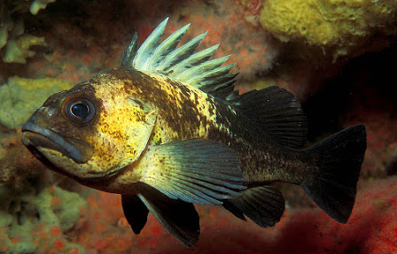
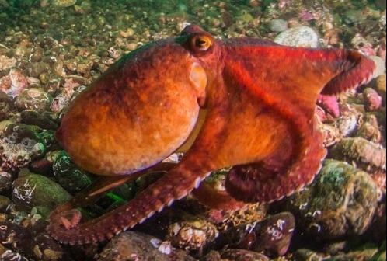

2. Where in the world can you find killer whales? (circle the best answer)
a. The Salish Sea c. Antarctica
b. New Zealand d. All of the above; killer whales live all over the world

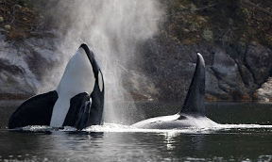
3. What are three challenges that the southern resident killer
whales face in the Salish Sea? Circle Three:

a) noise c) getting mistaken for pandas e) toxic pollution
b) lack of salmon d) lack of seals f) too many salmon

4. How can science and knowledge from Indigenous elders help to save an endangered species?

_________________________________________________________________________________

_________________________________________________________________________________

_________________________________________________________________________________

7. Who has the longest-standing knowledge of how to keep the Salish Sea healthy for people and wildlife?
Circle one:

a) college professors b) government officials c) the Coast Salish peoples d) your teacher

8. What did you recommend that leaders do to help the southern resident killer whales recover?

______________________________________________________________________________________

______________________________________________________________________________________

