**Aquatic Macroinvertebrate Survey**

Aquatic macroinvertebrates are animals without backbones that live in the water and you can see them without a microscope. They include insect larvae, snails, crustaceans, and worms, all important organisms to the food web (bigger animals like to eat them). They have another cool feature for *Nature Detectives*; the type you find can tell you how clean the water is that it’s in!

All you need is a key to identify the species and a key that tells you which species are tolerant (can handle) pollution, which are sensitive to it, and which are intolerant to (can’t stand) pollution. You’ll find all you need in this packet. -Introduction by SeaDoc Society

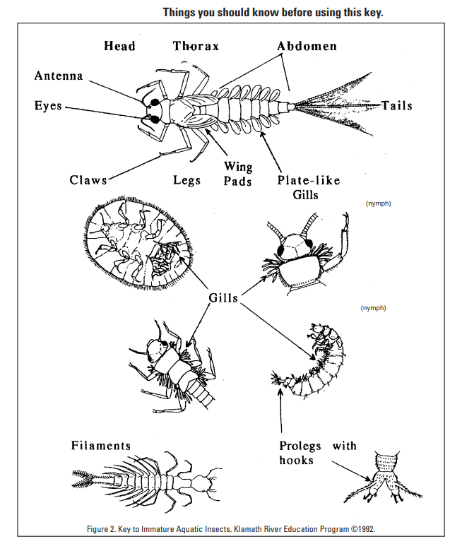

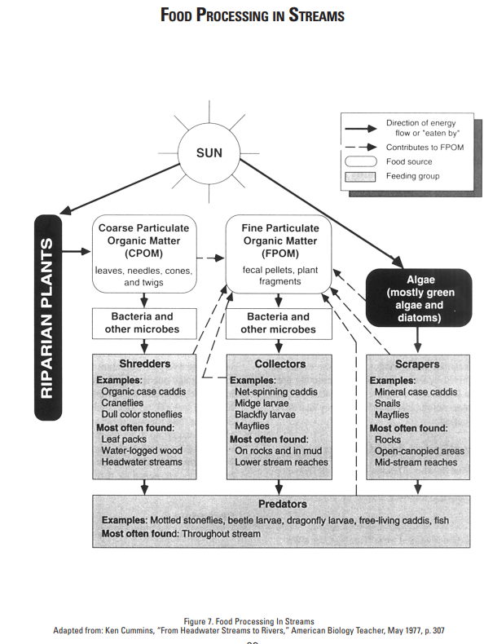

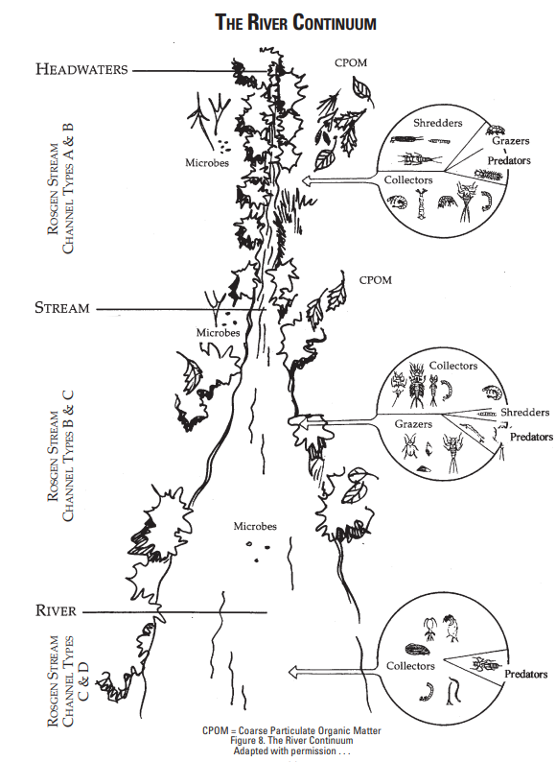

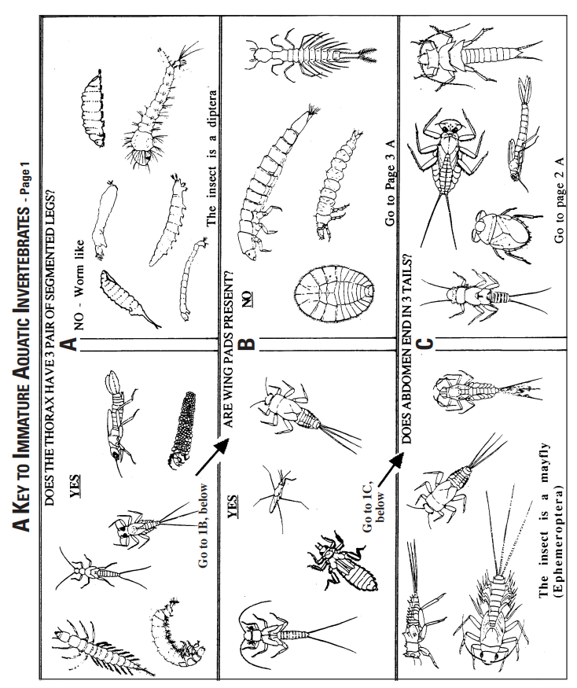

Figure 2., Continued / Klamath River Educational Program ©1992

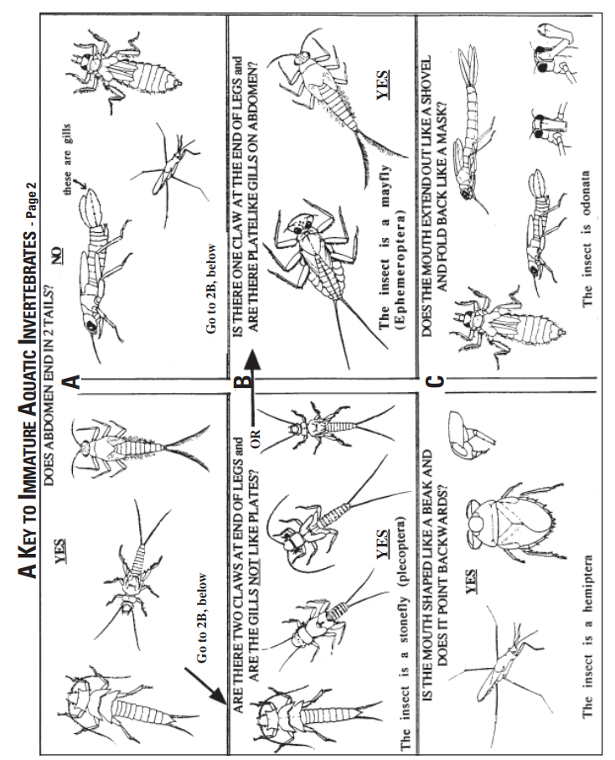

Figure 2., Continued / Klamath River Educational Program ©1992

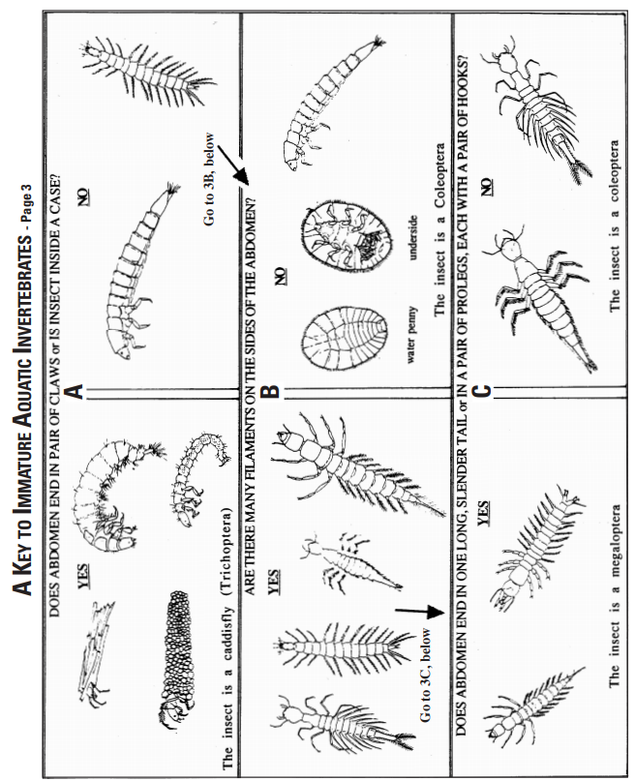

Figure 2., Continued / Klamath River Educational Program ©1992

