Link to the IMO Noise Reduction Guidelines:

<https://cetsound.noaa.gov/Assets/cetsound/documents/MEPC.1-Circ%20883%20Noise%20Guidelines%20April%202014.pdf>

# Ways to reduce ship noise from IMO Guidelines [1]:

## Design new ships to effectively reduce noise

* The best time to address underwater noise is when designing a ship. This is the only time in a ships life where it’s noise signature can be considered looking at the whole ship at once.
* Machinery can be chosen to be quiet and be mounted properly
* The hull of the ship can be designed to reduce the underwater noise radiated from it at the ships design speed (noise from a ship will change as a ship goes faster or slower)
* The propeller of the ship can be chosen to not cavitate at the ships design speed.

## Design and operate propellers at a speed that reduces cavitation

* Propeller cavitation is the number one source of underwater radiated noise from ships
* Cavitation is caused by steam bubbles forming and then collapsing at a quick rate (see definitions).
* Cavitation is directly affected by the changes in pressure around the propeller. The speed of the propeller changes the pressure around it.

## Design the hulls to have an even wake field

* An even wake field means that the water is flowing evenly over the propeller
* Ships that have blunt (square or v-shaped) ends (sterns) tend to have uneven flows
* Ships with a more bulbous, or round stern tend to have a more even wake field
* To visualise this concept, think of two rocks in a stream. One is round and smooth, the other is triangular and rough, Observing the water flowing around the two rocks demonstrates *laminar* (smooth) and *turbulent* (rough) flow. The water flowing around the back of a ship should be as smooth as possible.

## Select machinery to be quiet

* Machinery like the engine, motor, generators, pumps, fans, etc all make noise when running.
* Selecting machinery to be quieter right from the beginning is very effective at keeping ships quiet.
* Replacing noisy machinery can also be effective (depending on how big the machinery is and how hard it is to remove/replace)

## Vibration isolation of shipboard equipment

* The second most effective way to stop machinery noise is to properly isolate the machinery from the ships hull.
* Machinery noise is made even louder if it is allowed to transfer to the hull. The transfer of vibration means that not only is the machinery making noise, but now the hull itself is making noise from vibration. This vibration can also be transferred through the hull to other pieces of machinery causing them to run even louder than they would on their own.
* Isolating machinery from the hull reduces vibration. To reduce air-borne noise (noise that isn’t caused by the transmission of vibrations) insulating materials can be used in machinery spaces to muffle the noise before it passes outside the ships hull.
* Isolation mounting usually uses springs to isolate machinery. These springs work the same way as bike forks with a hydraulic-shock, the hydraulic-shocks absorb the vibration from the tire over the trail. You would feel all of that vibration if you were riding a bike with hard forks.
* To demonstrate the use of insulation to muffle noise, experiment with various materials like: foam, paper or tin foil, placed over a speaker and compare how loud the noise becomes.

## Consider diesel-electric propulsion configurations

* Many ships are powered by diesel engines. However, in today’s day and age there are many different options to chose from for a propulsion configuration. Diesel-Electric systems use diesel engines to produce electricity by using a generator. The electrical power is then transferred to an electric motor which is attached to the propeller. If the generator produces more power than the electric motor can use, the extra power can be stored in batteries.
* Diesel-electric propulsion configurations are quieter because electric motors are much quieter than diesel engines. By de-coupling the diesel engine from the propeller shaft (the long shaft that turns to connect the motor to the propeller) there is less noise transmitted from inside the ship to the outside, (since the propeller shaft will always transfer noise from the motor and the diesel engine can be properly vibration and noise isolated).

## Regularly clean the propeller and keep the hull clean

* Keeping the hull and propeller clean and regularly painted, prevents fouling (the build up of marine critters like barnacles, and rust prevention) that creates an uneven flow of water back to the propeller

## Reroute ship traffic away from important areas for noise sensitive marine wildlife

* This is the most effective way to stop underwater radiated noise from affecting marine wildlife.
* If a new route all together can’t be found, routes that allow the ships to change course more easily if whales are spotted in the area are better (choosing wider channels, instead of narrow ones. The number of ships in an area also affects noise levels

# Definitions

## Cavitation:

Cavitation happens when bubbles of steam form and then collapse quickly giving off a burst of energy. The bubbles form in areas of low pressure where water boils at lower temperatures. We know that water at 100oC and atmospheric pressure (normal pressure at sea level) starts to boil. But water will also boil at lower temperatures, if the pressure is also low enough. When a propeller turns the areas facing the flow of water have a higher pressure, those on the other side have a lower pressure, this pressure at certain propeller speeds is low enough that water starts to boil and steam bubbles are formed. As the bubbles move to areas of higher pressure, the water turns back into a liquid causing the bubbles to collapse (burst). The bubbles burst because steam (gas) takes up ~50,000 times more space than liquid water. When the bubbles burst they release a lot of energy in a very small space, these bursts of energy over time can have really big effects on a propeller, slowly creating micro (tiny) cracks in the metal that eventually can leave a propeller with no propeller blades! [2]

A good video to watch that explains why cavitation is important to control for submarines can be found here [3]: <https://www.youtube.com/watch?v=ON_irzFAU9c>

## Pressure:

Temperature, pressure and volume are all related to each other. In order to understand how water can boil at room temperature, we need to understand how the three interact with each other. They are related through the ideal gas law:

Pressure (P) x Volume (V) = number of moles (n) x the universal gas constant (R) x Temperature (T)

The universal gas constant is always the same, it’s a constant. The number of moles, refers to the amount of substance.

[*the relationship between temperature and pressure can be demonstrated by placing a balloon in a freezer and watching the balloon deflate. Same pressure inside the balloon but the temperature difference causes the pressure to decrease and thus volume to shrink]*.

## Hull:

A ship’s body is called its hull. The hull is the watertight part of the ship.

## Hull Drag:

Hull drag refers to the resistance created as a ship moves through the water. It reflects the amount of energy required to push the water away to make space for the ship. The more of the ship’s hull that is underwater, typically the more hull drag or resistance a ship has. [4]

A ship that has a clean, smooth hull will move more easily through the water, compared to a dirty, or barnacle covered ship. This is because a dirty ship has more surface area. The clean hull is also smoother, this helps to reduce the *friction* between the water and the hull. This is the same reason we wear shoes with rough surfaces on ice not smooth soles.

# How to design a propeller:

## Propeller Design Parameters:

Propeller design depends on many factors (NOTE, I don’t have permission to use any of these photos, they just help to illustrate the different dimensions):

* Number of blades

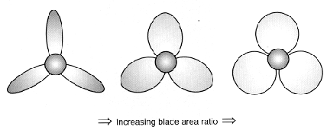

* Propeller Diameter

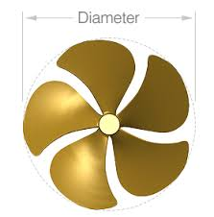

* Pitch Ratio (the curvature of the propeller blade)

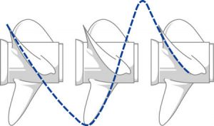 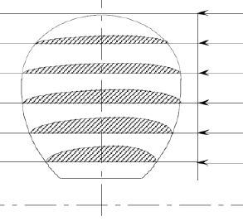

* Shape of the stern (back) of the ship
* Power delivered from the engine
* Design speed of the ship
* Speed of the propeller shaft (rpm or rotations per minute)

## Design Strategy:

1. There are no formulas to calculate the dimensions of a propeller exclusively from theory. The process is iterative and requires some parameters to be fixed in order to figure out the others.
2. Main dimensions for propellers are verified by the results of model tests. A model test is a scaled down version of the propeller that is towed behind a model ship in a controlled environment where measurements can be taken.
3. The model tests produce results that are displayed in graphs. These graphs are used to create formulas with mathematical constants that propeller designs can be compared against.
4. 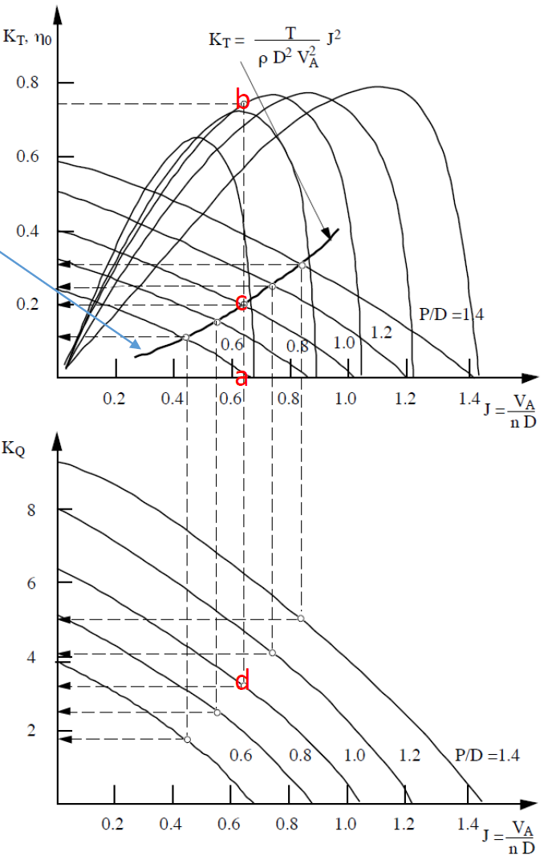These constants are the torque coefficient, thrust coefficient, efficiency and a constant called the advance number. These four coefficients can all be calculated using the propeller design parameters mentioned above. Sample graphs are shown on the left.

## Rules of thumb:

* The larger a propeller the more efficient it is, however a propeller is limited in size usually by the draft of a ship. The draft is the distance between the bottom of the ship and the waterline. Propellers must stay under water to avoid cavitation
* The speed at which the propeller shaft turns must be at a frequency different from the resonant frequencies of the shaft, hull and other propulsion machinery in order to prevent excessive noise and vibration.

# References

|  |  |
| --- | --- |
| [1] | M. E. P. Committee, "GUIDELINES FOR THE REDUCTION OF UNDERWATER NOISE FROM COMMERCIAL SHIPPING TO ADDRESS ADVERSE IMPACTS ON MARINE LIFE," in *International Maritime Organization*, London, 2014. |
| [2] | IET Institute for Energy Technology, "Cavitation - Easily explained!," IET Institute for Energy Technology, 15 2 2016. [Online]. Available: https://www.youtube.com/watch?v=U-uUYCFDTrc. [Accessed 30 1 2019]. |
| [3] | D. Stefanescu, "Cavitation! explained HD," 19 10 2014. [Online]. Available: https://www.youtube.com/watch?v=ON_irzFAU9c. [Accessed 30 1 2019]. |
| [4] | Wikipedia, "Wave-making resistanve," [Online]. Available: https://en.wikipedia.org/wiki/Wave-making_resistance. [Accessed 30 1 2019]. |