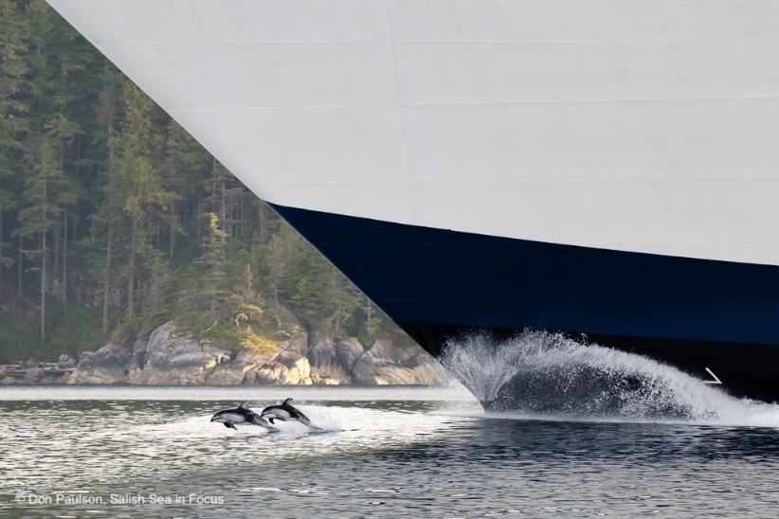

**Hungry Hungry Porpoise**

Okay, so these are Pacific white-sided dolphins, not porpoise, but the photo really shows one of the challenges acoustic animals face in a noisy sea. Play this game to find out just how hard it would be to find food using our ears alone.

**Materials**

One harbor porpoise hat to act as a blindfold (a black balaclava or beanie works great)

Herring hat or something else a student could wear to represent forage fish.

**Objective**

Students will experience the challenges of finding prey in an acoustic world as one harbor porpoise uses echolocation to hunt for forage fish in the Salish Sea.

**Set-up**

Have class form a fairly tight circle representing island and mainland shores of the Salish Sea.

Select one student to be a porpoise and one student to be a herring

Blindfold the student who is the porpoise using the hat and have the forage fish student don the herring hat or other forage fish symbol.

**How to play**

The porpoise has to make noise to echolocate, in this case clapping one time.

The herring must clap twice in immediate reply each time the porpoise claps.

The porpoises will attempt to find then tag the herring using sound alone.

The herring may not leave the “Salish Sea,” staying within the circle of student “islands.”

When/if the herring is caught, select two more students to play the roles.

If the herring is not caught, set a time-limit on hunting sessions.

**Added challenges to make it more realistic**

1. Have the porpoise attempt to hold his/her breath while hunting

2. Have some of the students acting as islands switch to being ships and make engine sounds during the hunt. Discuss challenges afterward **Have fun!**