OCEAN NETWORKS CANADA

June 2020

[[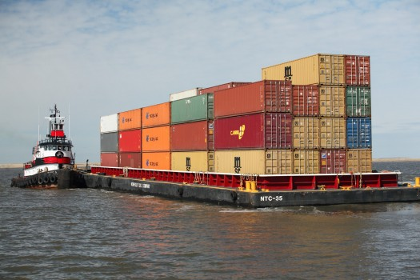](https://dosits.org/wp-content/uploads/2020/05/barge-and-tug_MaritimeAdministrationDOT.png)](https://dosits.org/wp-content/uploads/2020/05/barge-and-tug_MaritimeAdministrationDOT.png)

***Underwater Acoustic Impacts of COVID-19***

The novel coronavirus (COVID-19) has had a major impact on society around the globe. Shelter-in-place orders and non-essential travel bans have had significant effects at all levels, from local to national economies. There have been unexpected, wide-ranging, trickle-down effects from these changes, including shifts in local and regional [soundscapes](https://dosits.org/glossary/soundscape/). Unprecedented slowdowns in industrial, transportation, and recreational activities have led to less [anthropogenic](https://dosits.org/glossary/anthropogenic/) [noise](https://dosits.org/glossary/noise/) from sources such as construction, buses, cars, [ships](https://dosits.org/galleries/audio-gallery/anthropogenic-sounds/ship/), and aircraft. The decrease in human activities have even led to noticeable reductions in the vibrations ([seismic](https://dosits.org/glossary/seismic/) noise) of the Earth’s upper crust in and around cities [1]. This has been measured by existing land-based [seismometers](https://dosits.org/glossary/seismometer/) that allow geologists to spot and monitor earthquakes and other seismic events.

Soundscape changes associated with COVID-19 have also been detected underwater. As part of health and safety measures related to the pandemic, commercial, research, and other types of vessel traffic have been reduced or completely halted. With a global reduction in vessel traffic, there has been a corresponding reduction in the underwater noise caused by human activities. Barclay and Thomson (2020)[2] reviewed underwater acoustics data recorded by four, bottom-mounted, [hydrophone](https://dosits.org/glossary/hydrophone/) stations, which are part of the VENUS and NEPTUNE [underwater observatories](https://dosits.org/galleries/technology-gallery/basic-technology/ocean-observatories/). The [hydrophone](https://dosits.org/galleries/technology-gallery/basic-technology/hydrophonereceiver/) stations have been recording since at least October of 2018 and have at least a year of pre-pandemic baseline data for comparison. One station is on the Endeavor node of the NEPTUNE observatory, a deeper water hydrophone station located near the Juan de Fuca Ridge (#1 in figure below). The second station (#2 in the figure below) is on the Pacific continental slope, associated with the Clayoquot Slope node of the NEPTUNE observatory. Two stations, associated with the Central and East nodes of the VENUS observatory (#3 and #4 in the figure below), are located in the Strait of Georgia, between Vancouver Island and the British Columbia mainland. The scientists’ analysis of the hydrophone data focused on low [frequency](https://dosits.org/glossary/frequency/) signals (100 Hz) to isolate underwater sound produced by shipping. [Automatic identification system (AIS)](https://dosits.org/glossary/automatic-identification-system-ais/) data and shipping and trade [statistics](https://dosits.org/glossary/statistics/) were also used to assess shipping activity.

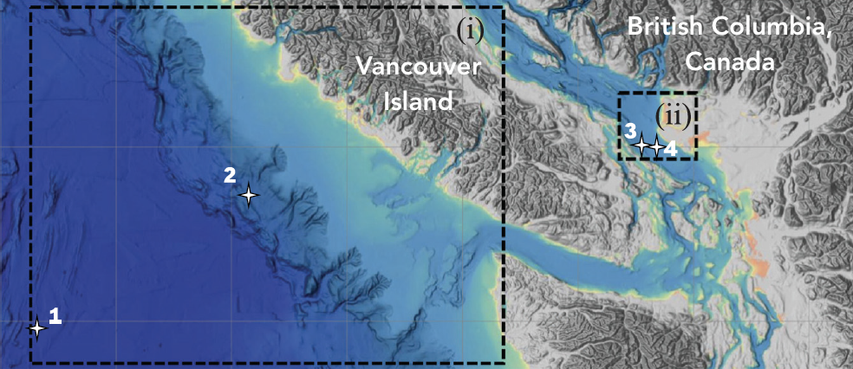

Bathymetric map displaying the British Columbia mainland, Vancouver Island, and the locations of the four Ocean Networks Canada ocean observatory hydrophone stations: Central and East nodes of the VENUS observatory (3, 4) Clayoquot Slope node of the NEPTUNE observatory (2), and the Endeavor node of the NEPTUNE observatory (1). Reproduced from – Thomson, D.J.M. and D.R. Barclay. (2020)[3], with the permission of the Acoustical Society of America

Comparing the weekly rate of change in 2020 to the last quarter of 2018 and all four quarters of 2019, the authors found that the [median](https://dosits.org/glossary/median/) acoustic [power](https://dosits.org/glossary/power/) at 100 Hz was lower in 2020 for three of the four hydrophone stations. Data from the two VENUS observatory hydrophones near the shipping channels off Vancouver Island showed a 4 to 5 [decibel](https://dosits.org/glossary/decibel/) (dB) reduction during the first three months of 2020, which they attributed to early coronavirus impacts on trade between Asia and the Port of Vancouver. At the Endeavor node of the NEPTUNE observatory, an average reduction of 1.5 dB between 2019 and 2020 in [mean](https://dosits.org/glossary/mean/) weekly noise power spectral [density](https://dosits.org/glossary/density/) at 100 Hz was also observed [4].

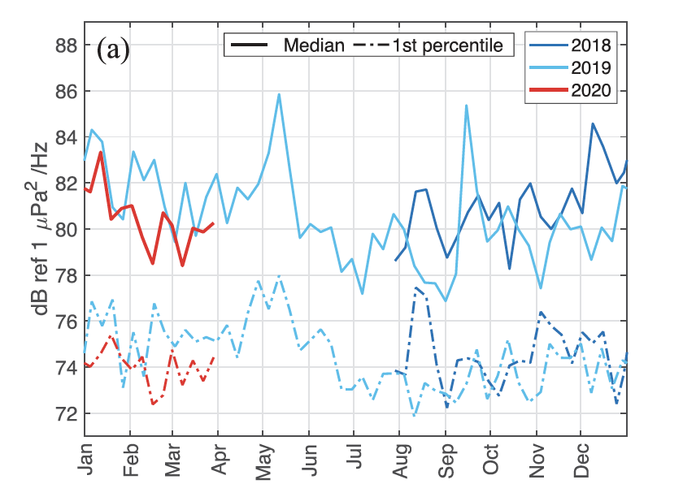

Yearly time-series of median (solid line) and 1st percentile (dashed-dotted line) weekly power spectral density at 100 Hz recorded at the Endeavor node hydrophone station for 2017 (black), 2018 (navy), 2019 (blue), and 2020 (red). Yearly time-series of median (solid line) and 1st percentile (dashed-dotted line) weekly power spectral density at 100 Hz recorded at the Endeavor node hydrophone station for 2017 (black), 2018 (navy), 2019 (blue), and 2020 (red). Reproduced from – Thomson, D.J.M. and D.R. Barclay. (2020)[5], with the permission of the Acoustical Society of America.

Scientists are preparing to study what effect this reduction in [vessel traffic noise](https://dosits.org/animals/effects-of-sound/anthropogenic-sources/commercial-vessel-traffic/) might have on local marine life, including various [cetacean](https://dosits.org/glossary/cetacean/) species at risk, such as the [critically endangered](https://dosits.org/glossary/critically-endangered/) [population](https://dosits.org/glossary/population/) of southern resident [killer whales](https://dosits.org/glossary/killer-whale/) (SRKW). [Underwater sound associated with commercial vessel traffic is a recognized threat to the SRKW population’s survival.](https://dosits.org/hot-topic-killer-whales-and-vessel-noise/) In the summer months, these whales concentrate in the coastal waters off the southern end of Vancouver Island in Canada and northern Washington State in the U.S. In Canada, all commercial marine vessels with the capacity of 12 or more passengers have ceased non-essential activities. Moreover, measures enacted to prevent cruise ships from [mooring](https://dosits.org/glossary/mooring/), navigating, or transiting in Canadian Arctic waters will remain in place until October 31, 2020. Given these vessel restrictions in Canadian waters, scientists and managers may have a rare opportunity this summer to observe the activities of this [endangered](https://dosits.org/glossary/endangered/) population if underwater noise levels continue to be reduced. Other scientists are also interested in the impacts to marine life as it responds to increased anthropogenic sound as activity levels return to normal.

This is not the first time underwater sound associated with vessel traffic has reduced suddenly. Following the September 11th terrorist attacks in New York City, all non-essential vessel traffic was halted along many North American shipping routes. This temporary pause in shipping provided a unique and unplanned opportunity for scientists studying [North Atlantic right whales](https://dosits.org/glossary/north-atlantic-right-whale/) in the Bay of Fundy, Canada. They noted a 6 dB decrease in underwater noise with a significant reduction below 150 Hz. It was concluded that these acoustic changes were a consequence of reduced large vessel traffic in the Bay of Fundy[6].

Barclay and Thomson will continue to review the VENUS and NEPTUNE [ocean observatory](https://dosits.org/glossary/ocean-observatory/) hydrophone data in detail over the entirety of the pandemic. Once at-sea oceanographic research resumes, other scientists will work to retrieve additional instruments, and further data on the potential underwater acoustic effects of COVID-19 will be compiled.

**DOSITS Links:**

* Science of Sound > [How does shipping affect ocean sound levels?](https://dosits.org/science/sounds-in-the-sea/how-does-shipping-affect-ocean-sound-levels/)
* Animals and Sound > Anthropogenic Sound Sources > [Commercial Vessel Traffic](https://dosits.org/animals/effects-of-sound/anthropogenic-sources/commercial-vessel-traffic/)
* People and Sound > [How is sound used to study undersea earthquakes?](https://dosits.org/people-and-sound/examine-the-earth/earthquakes/)
* Hot Topic > [Killer Whales and Vessel Noise](https://dosits.org/hot-topic-killer-whales-and-vessel-noise/)
* Technology Gallery > [Hydrophone](https://dosits.org/galleries/technology-gallery/basic-technology/hydrophonereceiver/)
* Technology Gallery > [Hydrophone Array](https://dosits.org/galleries/technology-gallery/basic-technology/hydrophone-arrays/)
* Technology Gallery > [Ocean Observatories](https://dosits.org/galleries/technology-gallery/basic-technology/ocean-observatories/)
* Audio Gallery > [Ship](https://dosits.org/galleries/audio-gallery/anthropogenic-sounds/ship/)

**Additional Resources:**

* Ocean Networks Canada, [Hushed seas: monitoring underwater noise during COVID-19](https://www.oceannetworks.ca/hushed-seas-monitoring-underwater-noise-during-covid-19)
* Ocean Wise, [Quiet oceans: Has the COVID-19 crisis reduced noise in whale habitats?](https://www.aquablog.ca/2020/04/quiet-oceans-has-the-covid-19-crisis-reduced-noise-in-whale-habitats/)
* NOAA Research News, [Exploring the impact of coronavirus response on the environment](https://research.noaa.gov/article/ArtMID/587/ArticleID/2617/NOAA-exploring-impact-of-coronavirus-response-on-the-environment)

**Cited References**

|  |  |  |
| --- | --- | --- |
| 1. | ↑ | Gibney, E. (2020). Coronavirus lockdowns have changed the way Earth moves. *Nature*, *580*(7802), 176–177. <https://doi.org/10.1038/d41586-020-00965-x>. |
| 2, 3, 4, 5. | ↑ | Thomson, D. J. M., & Barclay, D. R. (2020). Real-time observations of the impact of COVID-19 on underwater noise. *The Journal of the Acoustical Society of America*, *147*(5), 3390–3396. <https://doi.org/10.1121/10.0001271>. |
| 6. | ↑ | Rolland, R. M., Parks, S. E., Hunt, K. E., Castellote, M., Corkeron, P. J., Nowacek, D. P., Wasser, S. K., & Kraus, S. D. (2012). Evidence that ship noise increases stress in right whales. *Proceedings of the Royal Society B: Biological Sciences*, *279*(1737), 2363–2368. [https://doi.org/10.1098/rspb.2011.2429.](https://doi.org/10.1098/rspb.2011.2429) |