**Remotely Operated Vehicle (ROV) Explore Indigenous First Foods**

**Elena Buscher, Darcy L. Mathews, Cheryl Bryce, Kathleen Bryce, Darlene Joseph, and Natalie C. Ban**

**August 2020**

**Adapted by Amy Keiper, PEI, 7/24/24**

Marine ecosystems are facing threats to their health. Baseline information about ecosystems is needed to address these problems. It is the same idea as if you were sick: you need to know your baseline, or what you normally feel like when you’re healthy, to figure out what changed before you can begin a treatment.

In this experiment, the researchers wanted to do two things:

1) they wanted to see how effective it would be to use a mini *remotely operated vehicle* (ROV) to collect marine data where it is difficult for people to be in the water, and

2) they wanted to document seafloor (or *benthic*) species, similar to taking attendance to see who is present in class. They focused particularly on seaweed and animals that are culturally important as First Foods to the Songhees Nation.

The scientists used a Trident ROV to *survey* (gather information) on the deep seafloor of the Tl’ches *archipelago,* which is a group of islands just southeast of the point of Vancouver Island, Canada in the Salish Sea. The islands specifically focused on were Discovery and Chatham Islands. The location is part of the Songhees Nation, an indigenous tribe to the Vancouver, Canada region.

The mini Trident ROV is an inexpensive ROV. The researchers wanted to test the mini Trident ROV for effectiveness to make sure that it could be considered a good and low-cost technology for future projects.

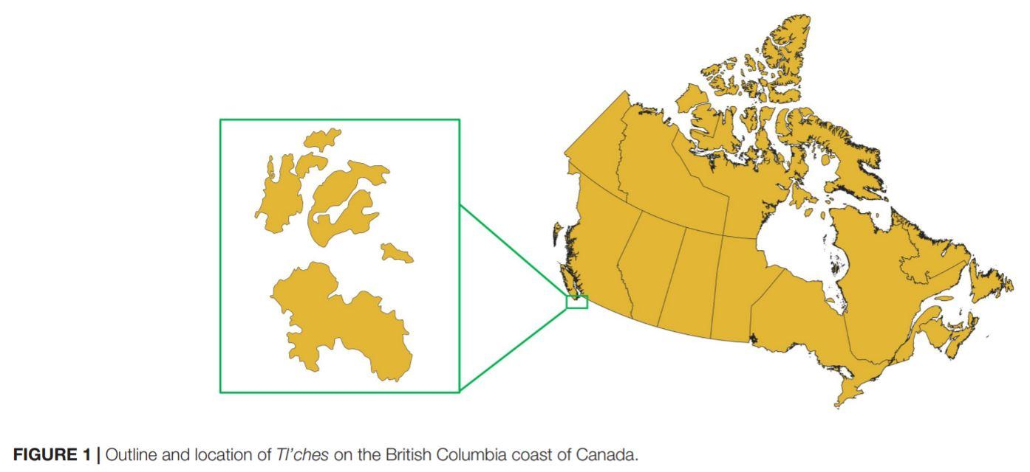

The Songhees have been worried about the health of their traditional territory. The Victoria region has seen more housing and cities from European settlers since the 1800’s. They decided to take stewardship into their own hands to maintain cultural and ecological health. They worked with researchers in this project to establish some baseline knowledge of what the marine ecosystem is looking like so that they can then take the necessary steps to steward it and monitor it over future generations.

**Steps of the Experiment**

There were four primary steps that the research team followed for this experiment:

1) From working with and interviewing the Songhee tribal members, and by performing background research, the scientists identified culturally significant species to be tracked during underwater ROV surveys.

2) The scientists did practice trials to become familiar with the mini Trident ROV

3) The scientists got underwater video footage of the seabed and organisms and counted the plants and animals they found. They did this by completing underwater surveys on over 45 *transects.* A transect is a line across a habitat that a scientist follows and counts the number of species they find.

4) The scientists looked at the photos and videos, identified organisms present using ID guides, and counted the species that were culturally important to tribe the best they could. Overall, the researchers found 14 culturally important species to be present! There were 24 culturally-important species listed before beginning the experiment, so the researchers found about 58% of them during their study.

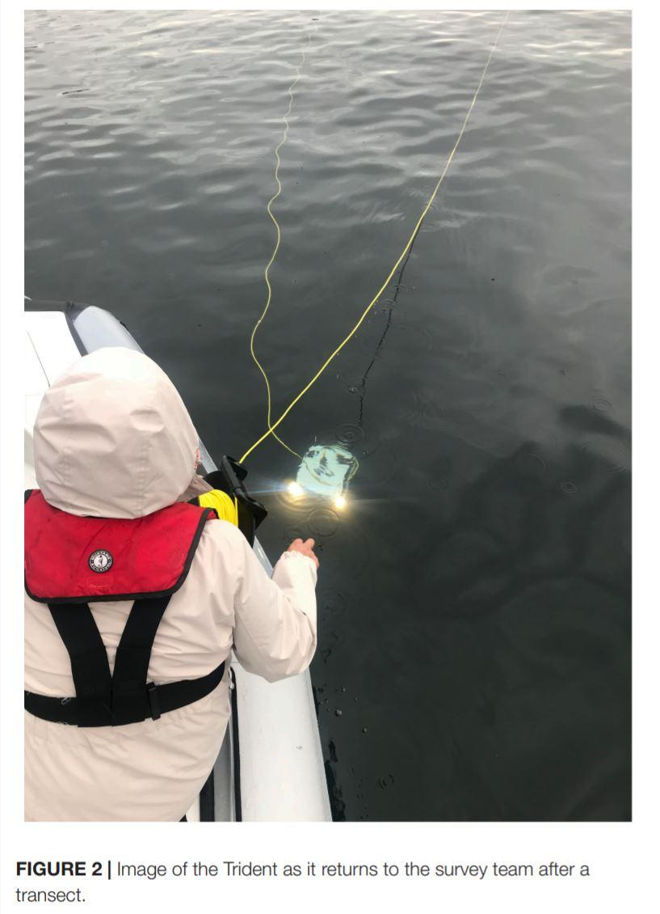

**Challenges**

The researchers said there were some problems with their study. First, the mini Trident ROV was a little unstable in the very strong currents. It also had difficulty seeing through the very cloudy water. Some places were unable to be surveyed using the mini Trident ROV. This could have led to missed species, especially some that may live in those harder to get to areas.

Strong currents are also a challenge that many ROV’s face. The scientists suggested that in the future, studies should be done using not just ROV’s, but also SCUBA and a drop camera to observe and document all life present.

**Conclusions**

The scientists said that although they tried to report the number of species present, they did not collect enough data to make conclusions about the health of the ecosystem. Further data collection over time while using a variety of methods needs to be done. The scientists believed that although the mini Trident ROV worked in this experiment, it would be best suited for use in species counts that take place in environments that are calmer and where the water is clearer (such as tropical environments).

The scientists also said that the mini Trident ROV has a lot of advantages in field research. It provides a relatively cheap option and it does not take a lot of people to work with it (this study only had 3-4 people). The ROV can also safely stay working underwater (up to 100 meters!) for about three hours at a time, whereas SCUBA divers can only take three short dives per day and risk their safety.

The Songhees Nation used the information from this experiment to speak up for the protection of the archipelago. They said that 14 of the 24 culturally important species were present underwater to at least 20m in depth. They helped people understand that protecting this archipelago around to a depth of at least 20m would protect cultural, social, and ceremonial practices for current and future generations within the Songhees Nation. Future studies need to be performed to gain a better representation of wildlife species present and to better understand the health of the whole ecosystem.

**Resources**:

Article: <https://www.frontiersin.org/articles/10.3389/fmars.2020.00669/full>

Songhees Nation: <https://www.songheesnation.ca/>

Transect description: <https://www.bbc.co.uk/bitesize/guides/zmxbkqt/revision/5>