**Applying a Low Cost, Mini Remotely Operated Vehicle (ROC) to Assess an Ecological Baseline of an Indigenous Seascape in Canada**

**Elena Buscher, Darcy L. Mathews, Cheryl Bryce, Kathleen Bryce, Darlene Joseph, and Natalie C. Ban**

**August 2020**

Marine ecosystems are facing unprecedented threats to their health. Baseline information about the state of ecosystems is needed to address these threats. It is the same idea as if you were sick: you need to know your baseline (what you are like when you are healthy) to figure out what changed before you can begin a treatment. In this experiment, the researchers had two main objectives: 1) they wanted to use a mini *remotely operated vehicle* (ROV) and evaluate its effectiveness and capabilities to collect marine data where it is difficult for people to be in the water, and 2) they wanted to perform surveys with the mini ROV and use the data collected to document seafloor (or *benthic*) species, similar to taking attendance to see who is present in class. They focused particularly on seaweed and animals that are culturally important as First Foods to the Songhees Nation.

In this experiment, scientists used a Trident ROV to survey the deep seafloor of the Tl’ches archipelago, which is a small cluster of islands just southeast of the point of Vancouver Island, Canada (near Victoria) in the Salish Sea. The islands specifically focused on were Discovery and Chatham Islands. The location is part of the Songhees Nation, an indigenous tribe to the Vancouver, Canada region. The mini Trident ROV is an inexpensive ROV, which means that projects with limited resources may be able to rely on mini Trident ROV’s to perform research in the future. The researchers wanted to test the mini Trident ROV for effectiveness to make sure that it could be considered a reliable source of technology for future projects.

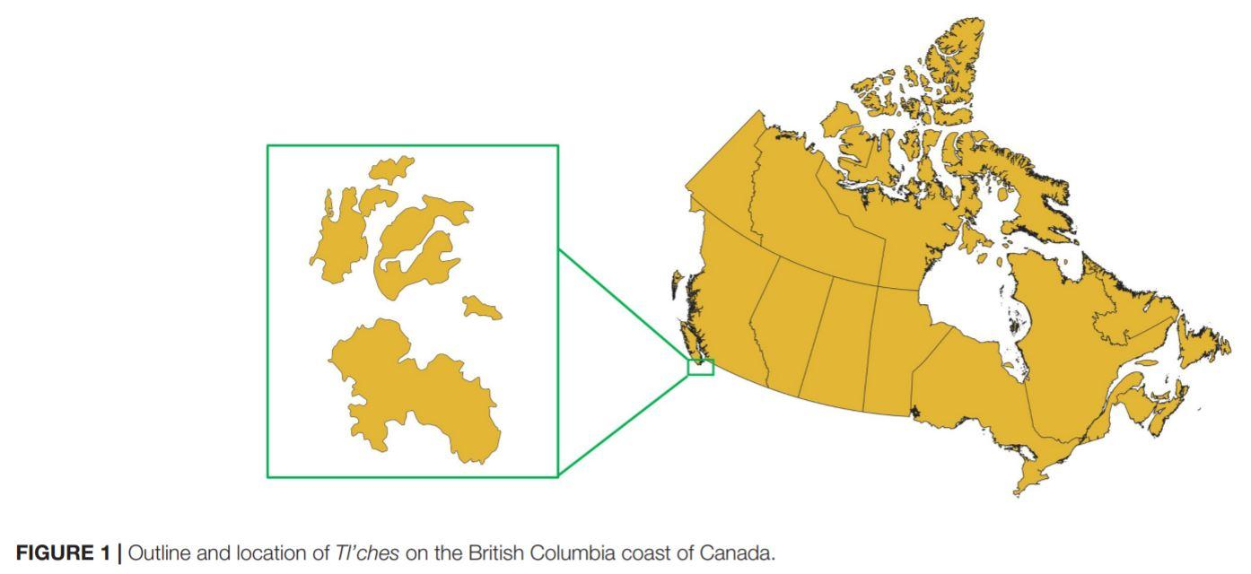

The Songhees have been worried about the health of their traditional territory. The Victoria region has seen major urban development from European settlers since the 1800’s. They have desired to take ecological monitoring and stewardship into their own hands to maintain cultural and ecological health. They worked with researchers in this project to establish some baseline knowledge of what the marine ecosystem is looking like so that they can then take the necessary steps to steward it and monitor it over future generations.

There were four primary steps that the research team followed for this experiment. 1) From working with and interviewing the Songhee tribal members, and by performing background research, the scientists identified culturally significant species to be tracked during underwater ROV surveys. 2) The scientists conducted practice trials to gain working familiarity with the mini Trident ROV and test anticipated methods while the ROV performed from 0-30m deep. 3) The scientists conducted underwater surveys over 45 *transects* (a section or line across a habitat that gets followed for species along it to count) to get underwater footage of the seabed and organisms. 4) The scientists analyzed the footage, identified organisms present using ID guides, and counted the culturally significant species the best they could. Overall, the researchers found 14 culturally important species to be present, including 9 in the most species-rich transect. There were 24 culturally-important species listed before beginning the experiment, so the researchers found about 58% of them during their study.

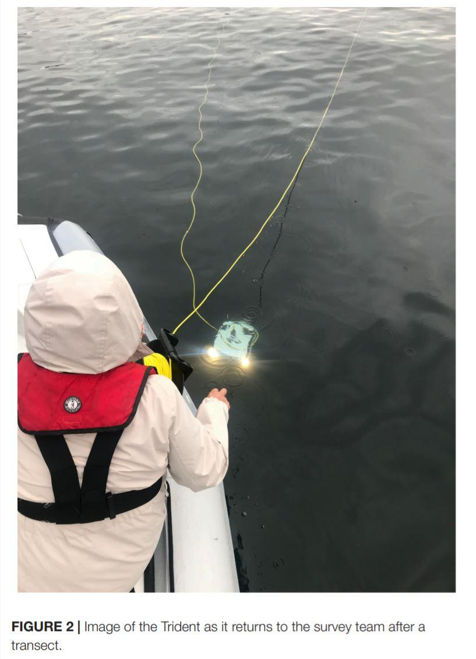

The researchers acknowledged some experimental errors in their study. First, the mini Trident ROV was a little unstable in the very turbulent, high-current environment that was being studied. It also had difficulty seeing through the *high-turbidity* (or very cloudy) water. For example, the entire tidal volume of seawater in the Strait of Georgia (part of the Salish Sea) drains over the archipelago twice a day, and wave exposure on some island sides is amongst the highest in the Salish Sea. Some places were unable to be surveyed using the mini Trident ROV due to accessibility. This could have led to missed species, especially some that may specialize in living in those turbulent areas. High-current conditions are a challenge that many ROV’s face in functioning well underwater. The scientists suggested that in the future, studies are performed in a variety of formats (such as SCUBA, or a drop camera) to observe and document all life present. The researchers also acknowledged that although they set out to report the number of species present, they did not collect enough data to draw conclusions about the health of the ecosystem. Further monitoring over time while using a variety of techniques and methods needs to be performed. The scientists believed that although the mini Trident ROV functioned in this experiment, it would be best suited for use in species counts that take place in environments that are more calm and with more visibility (such as tropical environments).

The scientists concluded that the mini Trident ROV has a lot of advantages in field research. It provides a relatively cheap option for groups who are financially limited and are trying to perform some underwater research. It also does not take a lot of people to work with it (this study only had 3-4 people). The ROV can also safely stay working underwater (up to 100m!) for about three hours at a time, whereas SCUBA divers can only take three limited dives per day and risk safety.

The Songhees Nation utilized the information from this experiment to advocate for protection of the archipelago by stating that 14 of the 24 culturally important species were present underwater to at least 20m in depth. Protecting this archipelago around to a depth of at least 20m would protect cultural, social, and ceremonial practices for current and future generations within the Songhees Nation. Future studies need to be performed to gain a more accurate representation of species present and to accurately assess the health of the whole ecosystem.

**Resources**:

Article: <https://www.frontiersin.org/articles/10.3389/fmars.2020.00669/full>

Songhees Nation: <https://www.songheesnation.ca/>

Transect description: <https://www.bbc.co.uk/bitesize/guides/zmxbkqt/revision/5>