Build a Webmap of your Watershed and more
Thanks to GIS Specialist, Suzanne Shull of Padilla Bay National Estuarine Research Reserve and ArcGIS
In this lesson, you'll create a map that watershed boundaries from the USGS Hydrologic Unit Code delineations. First, you'll create a map and locate La Conner, Washington. Then, you'll add a map layer that shows the watershed boundaries. Lastly, you'll change the way your map and layers look to better display the data. Adapted from https://learn.arcgis.com/en/projects/get-started-with-arcgis-online/

Begin a map
You'll begin your map by signing in to ArcGIS Online or using ArcGIS Online without a login (note: without a login, you will not be able to save your work, but you can create a printscreen of it) and navigating to your area of interest: (Your Town, Your State or Province).
- Use Web Browser to access arcgis.com (or Sign in to ArcGIS Online Note: If you don't have an ArcGIS account, you can sign up for a free public account or an ArcGIS free trial).
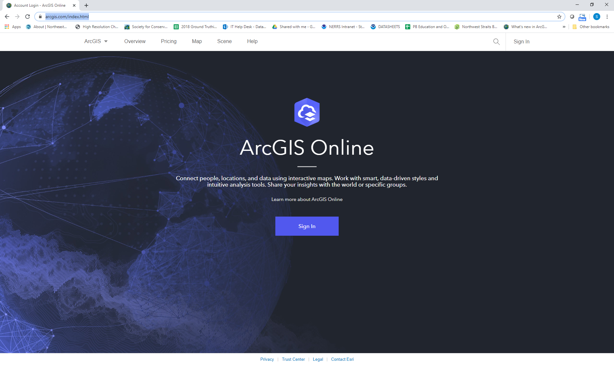

- On the ribbon, click Map.
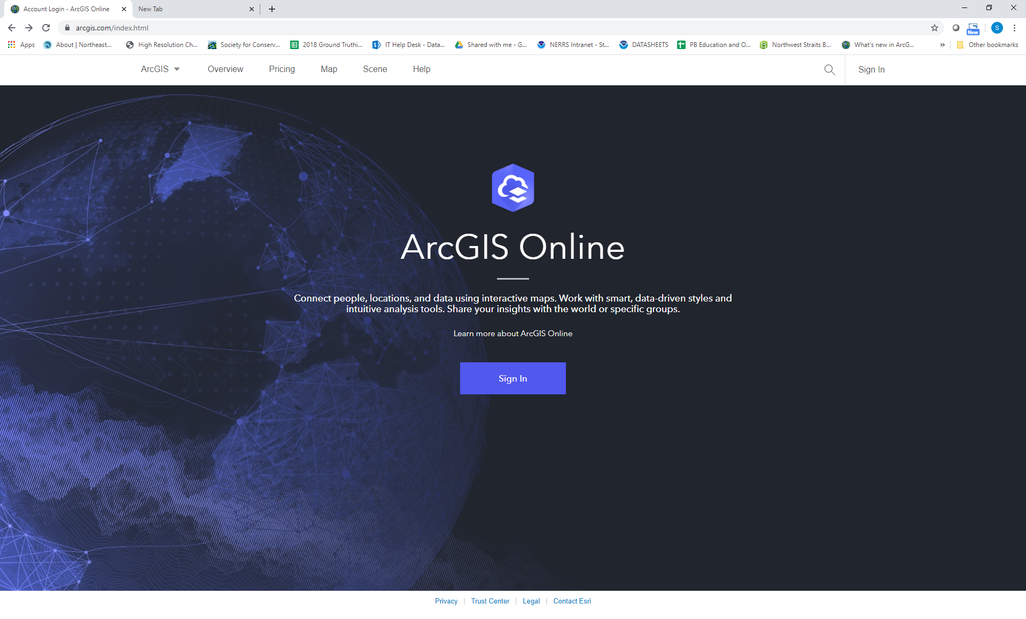
A new map opens.
.
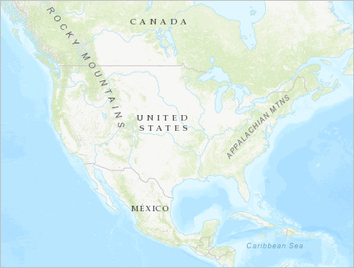
The only layer on the map is the basemap, which provides geographic context such as water bodies and political boundaries.
Above the map is the ribbon. To the left side of the map is the Details pane, which provides information about the map and its layers. Next, you'll navigate to your area of interest.
- On the ribbon, in the search box, type the name of your town. The map should automatically zoom to that location.
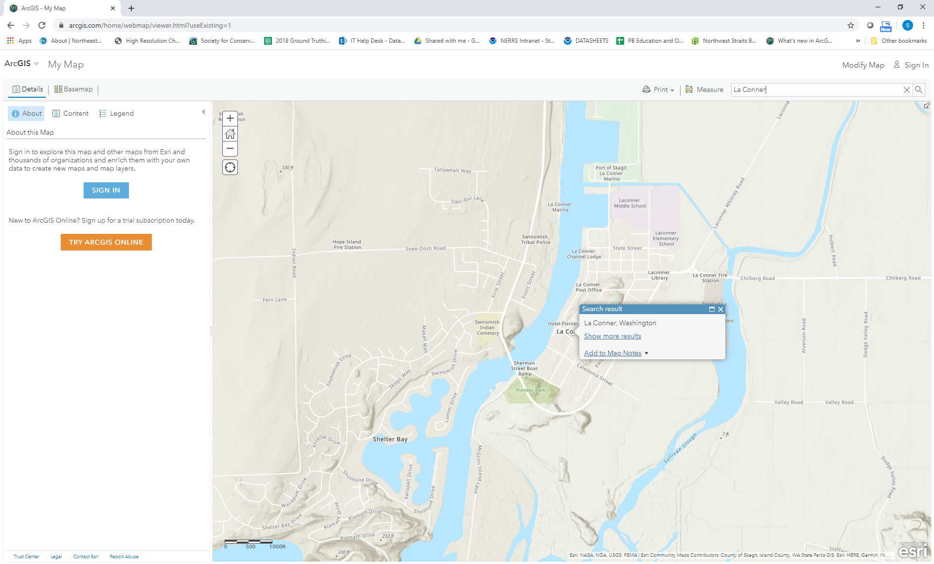
A Search result pop-up confirms the location.
- Close the Search result pop-up by clicking on the X in the upper right corner of the popup.

Add a layer
Next, you'll add a layer to your map that shows watershed boundaries for the US. You'll add this layer from ArcGIS Living Atlas of the World, a collection of curated geographic data from around the globe.
- On the ribbon, click Modify Map
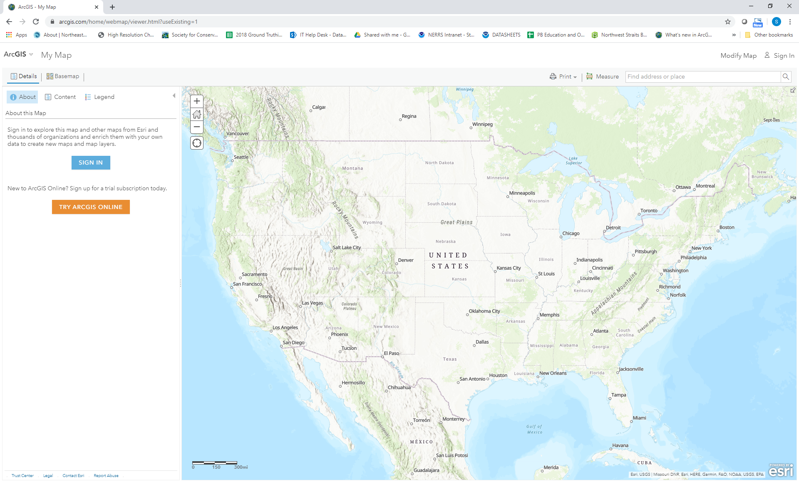
- This will display a new drop down menu on the left side of the ribbon (see screenshot below). Click Add and choose Browse Living Atlas Layers.
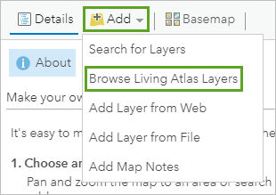
The search pane appears. The layer you want to add is owned by the Federal User Community, an ArcGIS account that contains United States governmental data. You can find the layer more easily by adding the name of the layer's owner to the search terms or just type ‘watershed boundaries’.

- Press Enter.
The search returns a several results. 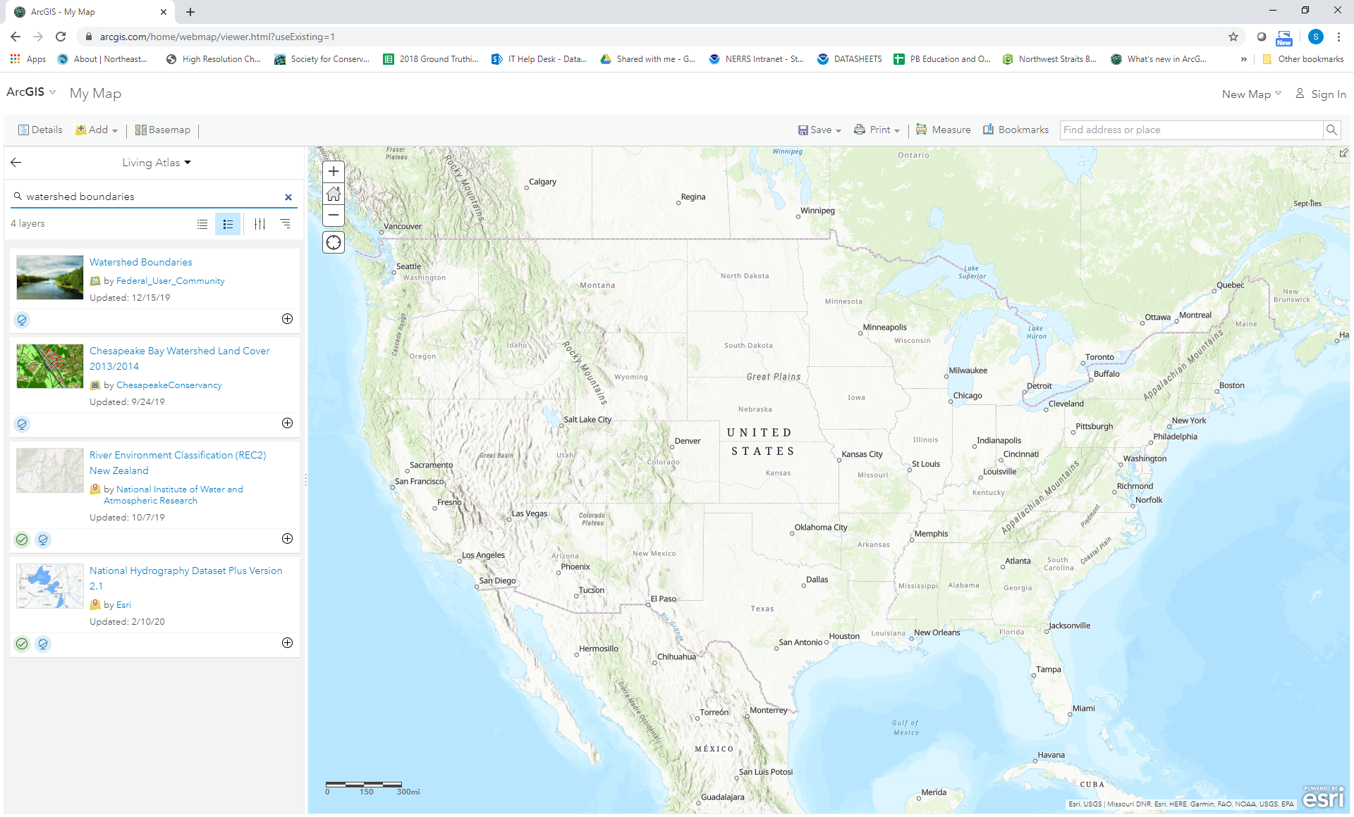
- On the Watershed Boundaries layer from Federal User Community, click the Plus Sign button.
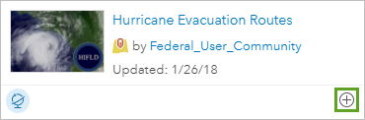
The layer is added to the map. Click on the words Watershed Boundaries to learn more about the data:
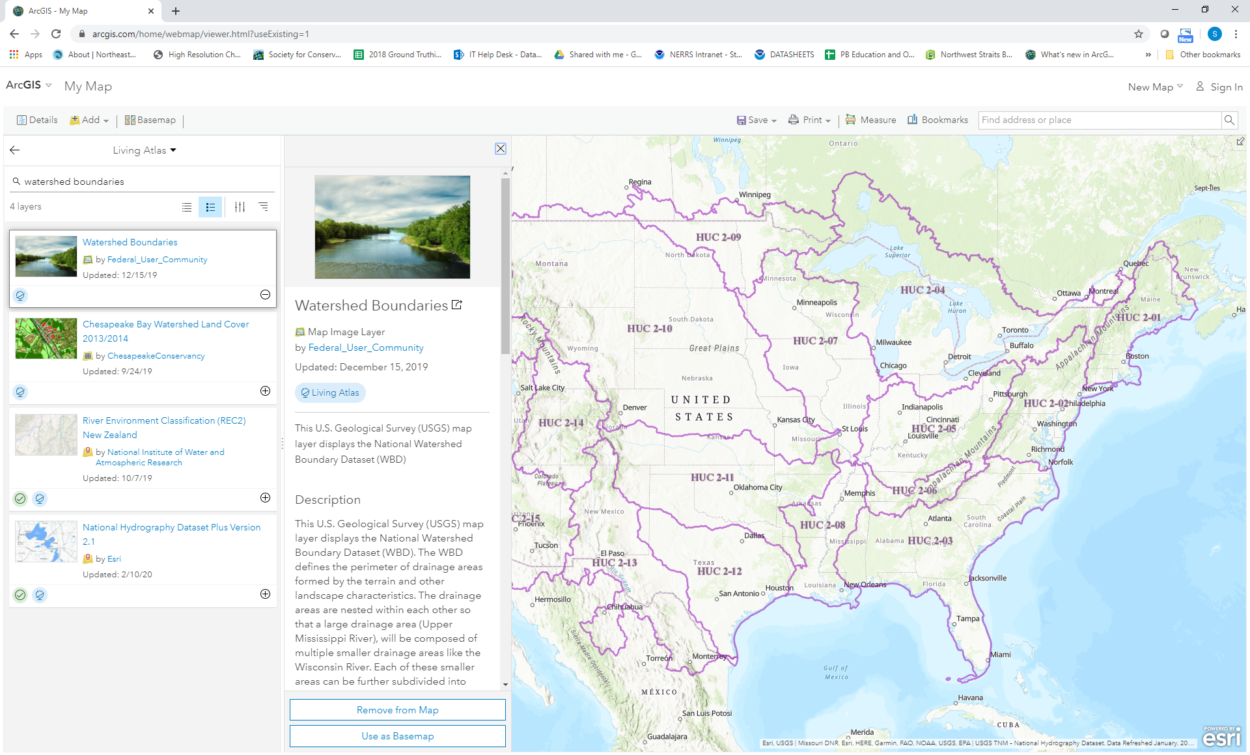
The boundaries are displayed as purple polygons that delineate drainage areas. Now you'll change the basemap to one with a lighter color scheme.
- In the search pane, click the Back button. Click the Show Contents of Map button.
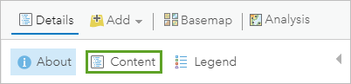
The Contents pane appears. It lists all layers on the map, including the basemap.
- On the ribbon, click Basemap and choose your background. Compare Light Gray Canvas with other basemaps to see which makes the watershed boundary stand out best.
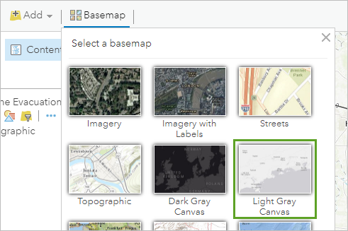

Note:
The basemap changes.
- Zoom to your area of interest and the boundaries will redraw at finer delineation, according to scale (i.e. 2-digit Hydrologic Unit for a Region such as the US or 12-digit Hydrologic Unit for Subwatersheds within a state). This example is from La Conner, WA.
- Click on Legend to see the legend
