**You are my Density Game**

**Background**

***Density*** is the mass of matter in a given volume (space). Warm particles of matter, called atoms vibrate. When energy is added to them, such as in the form of heat, they vibrate faster, collide harder, and bounce further away from one another. This makes them spread apart and take up more space. Therefore, warm matter is less dense (lighter because there are fewer atoms per unit volume) than cool matter and will rise up through cool matter, which will sink down through less dense matter. This creates currents in air (which we call wind) or water. Air is referred to as a fluid in physical science because of this property.

**Question**  What makes high density fluids heavier than low density fluids?

**Materials**

Masking tape

Cleared classroom space, gym, or play area

Slow, medium, and fast music (optional)

1 stone per student

**Set-up**

Outline the perimeter of a square about 10-15 feet or 3-5 meters in diameter on the floor.

Come up with signals for cold, warm, and hot fluids (ie. slow, medium, and fast song).

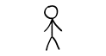

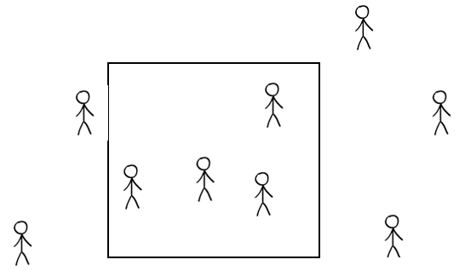 Cold Warm Hot











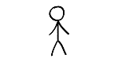



Tell the students they have just turned into atoms. Atoms are particles that make up matter. The matter they make up is fluid, such as water or even air. And atoms dance. They dance very slowly when they are cold, like to the blues, so slowly you can barely tell they are dancing. They dance a little more quickly when they are warm, like to R&B. When they get hot they dance fast, like hip-hop or mariachi or a fancy dance at a powwow.

**How to play**

1. Give the signal for cold (play a slow song or just, plain tell ‘em they’re cold). Ask what they would do when cold. They may huddle together (amidst giggling). Have them all huddle into the square, hugging themselves and each other. (Not a socially-distanced game!)

2. Ask what they would do if they started warming up. They can now move and groove with their arms apart, requiring them to move away from one another. This should push (gently) some students outside of the square, which is good.

3. Ask what they would do if they got hot. They will need to spread out as far as possible from their friends, so they have room to hip-hop and jump around.

4. Have students pause. Now ask them to imagine that the taped square is a container on a scale to measure weight. Ask when did the fluid of which they were a part weigh the most on the scale? When they were cold and all inside the container, the density was the greatest and their mass increased.

5. Repeat the process but tell them they are now water particles (molecules) and that we’re going to add salt to the water. The stones represent salt. When salt dissolves in water, it holds hands with the water (hand out one stone to each student).

6. Have students return the stones and return to their seats.

**Debrief**

Ask what effect the salt in the fluid did to the weight and therefore the density inside the container. What was the density of the salty fluid compared to that without salt? How does this relate to or explain their observations in the Density and Motion activity?