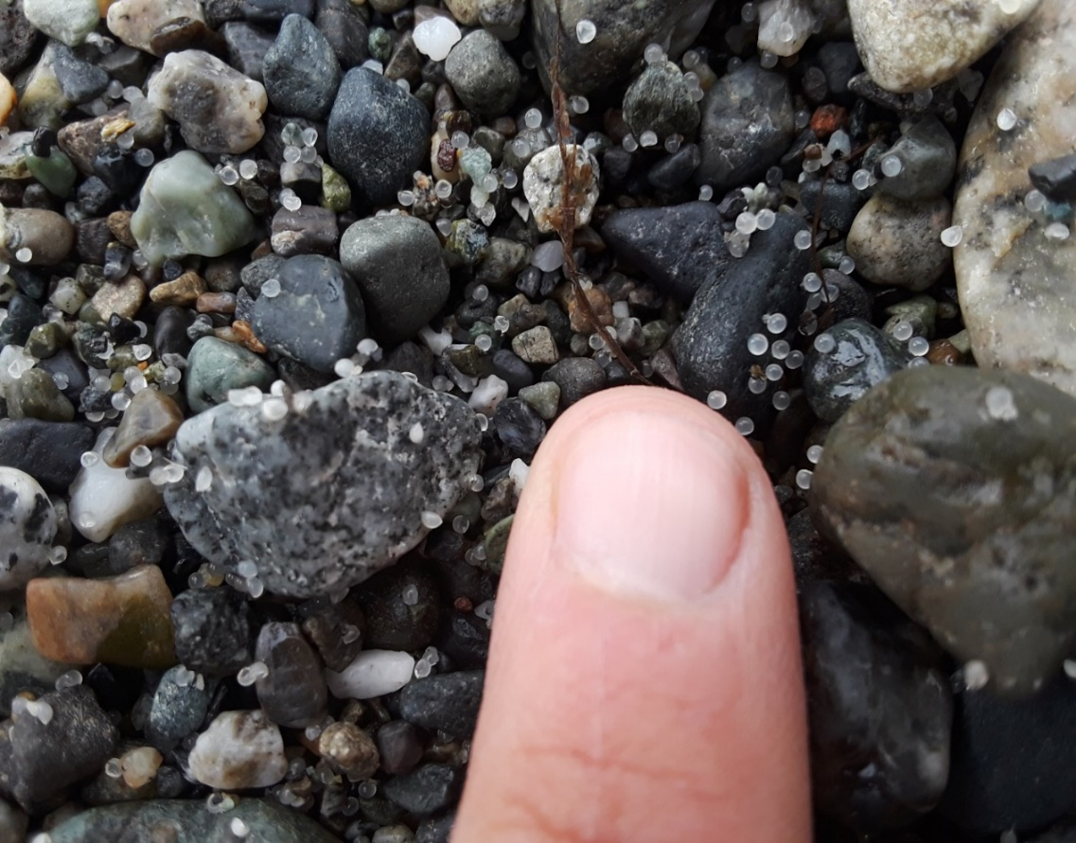

UNIT 3

THE SALISH SEA ROCKS!

Teacher Guide
Earth Materials and Systems, System models, Human Activity

Surf smelt fish eggs stuck to beach sand and gravel. Photo by Matt Castle, Samish Tribe DNR

Explore Chapter: 3 The Salish Sea Rocks
Time Required: 8 50-minute sessions in 3 lessons
Standards based on grade: 5




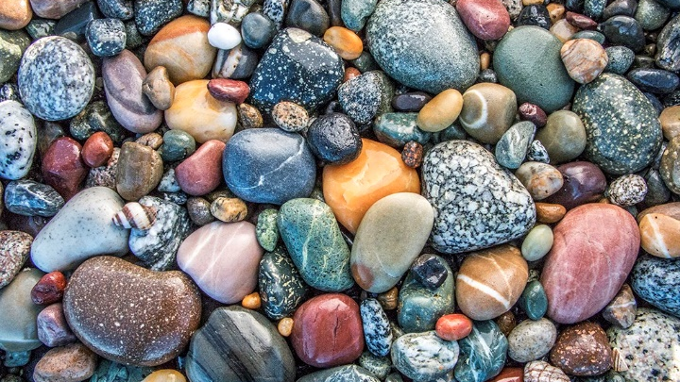

Table of Contents

Background for the Teacher 2

Sources and Further Learning 4

Unit Overview 5

Storyline and Standards 6

Lesson 1 – How does surf smelt biology interact with geology? 7
Learning Targets and Terms for the Teacher 7
Teacher Prep Lesson 1 8
Materials and Weblinks for Lesson 1 10
Class Session Guide Lesson 1 11

Lesson 2 - How does hydrology interact with geology to form a beach? 12
Learning Targets and Terms for the Teacher 12
Teacher Prep Lesson 2 13
Materials and Weblinks for Lesson 2 14
Class Session Guide Lesson 2 15

Lesson 3 - How can we design a scientific investigation to gather and 18
communicate evidence that the geosphere, biosphere, and
hydrosphere interact?
Learning Targets and Terms for the Teacher 18
Teacher Prep Lesson 3 19
Materials and Weblinks for Lesson 3 20
Class Session Guide Lesson 3 21

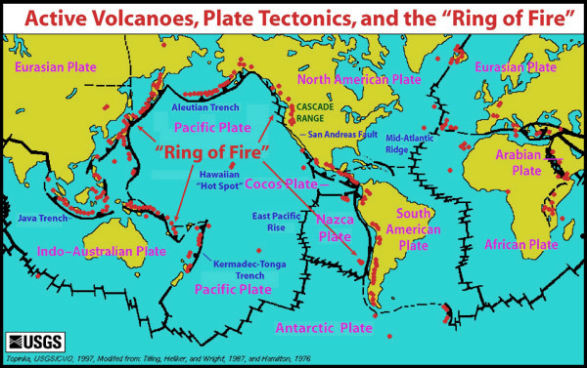
Background for the Teacher
________________________________

In Unit 3, corresponding to chapter 3 of Explore the Salish Sea: A Nature Guide for Kids, you and your students will explore Earth’s processes that create the perfect spawning habitat for a few species of small but mighty fish. Because so many life forms, including humans, forage for these species and they support much of the Salish Sea food web, they are called forage fish. Some forage fish, like surf smelt and sand lance, spawn on beach rocks at high tide. But not just any beach rocks - just the right size of beach rocks.
Forage fish numbers have been dropping and we need to understand why. In an investigation of how the right sized beach rocks are supplied to spawning beaches, clues will be revealed to the earth processes that formed the Salish Sea from snow caps to white caps. Students will use these clues to solve a mystery: how to ensure safe spawning habitat for a little fish which iconic species, from sea birds to salmon and seals to killer whales, depend on.

You will consider Western and Indigenous science perspectives as you support your students’ research, but you do not need to be a geology wiz or traditional knowledge holder to teach this unit. Rather you need only to explore and discover alongside your students. The overall goal is to help students understand how the geosphere (Earth’s rock), atmosphere (the envelope of gases/air around a planet), and hydrosphere (Earth’s waters) interact with the biosphere (life). Following is some background to support your own content knowledge.

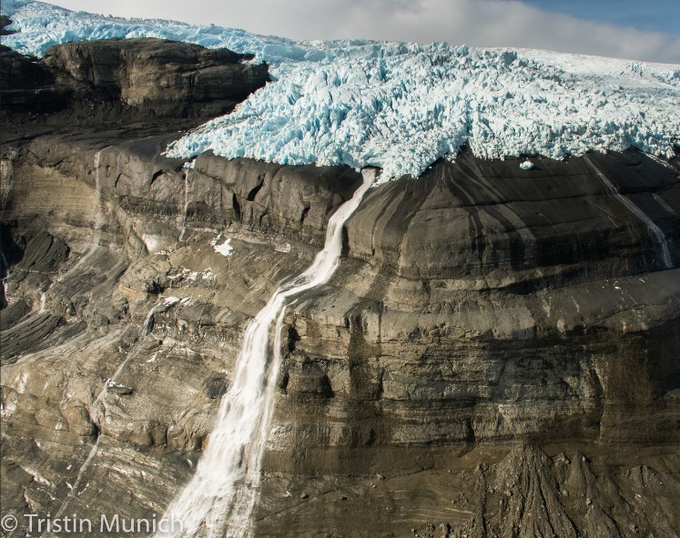
Ways the geosphere, biosphere hydrosphere, and/or atmosphere interact
A glacier recedes from a mountainside it previously covered, scouring rock edges smooth, Note the piles of sediment at cliff bases, remnants of the carving power of ice.
Photo by Tristin Skye Munich

The geology of the Salish Sea is responsible for its shape, influences its unique climate, provides habitat for wildlife, and keeps things exciting and even dangerous at times. The Salish Sea is located in the “Ring of Fire.” This
is the boundary area of the Pacific Plate characterized by volcanic and earthquake activity. These activities are caused by the constant movement of plates that make up Earth’s crust, the solid layer of rock floating on the thick liquid of the mantle.

As the Pacific and Juan de Fuca plates push eastward, they collide with and dive beneath the North America Plate, causing a lot of friction, building heat (think of the heat from rubbing your hands together fast), which melts rock and expands gases, building pressure that pushes up mountains (the Cascades), and even causes them to blow off steam once in a while (Mounts Meager, Cayley, and Garibaldi in BC
and Mounts Rainier and Baker in WA, among others, are all volcanoes).

The mountains and lands around them are constantly exposed to physical and chemical forces. Terms such as weathering: the breaking apart from rain, snow, glacial ice, wind, landslides, flowing waters, chemical reactions, and even by plants and animals, sediments: pieces of rock, from boulders to powdery silt, and erosion: the carrying of sediments downhill and into waterways, and all the way to estuary beaches, where waves and currents join the fray, are all used to describe the bio-geo-hydro-atmospheric interactions that shape habitat for Salish Sea life, including us!

As you can see, sediments that end up here travelled from far and wide, not just by rivers of water, but also by rivers of ice.
. Glaciers to Beaches

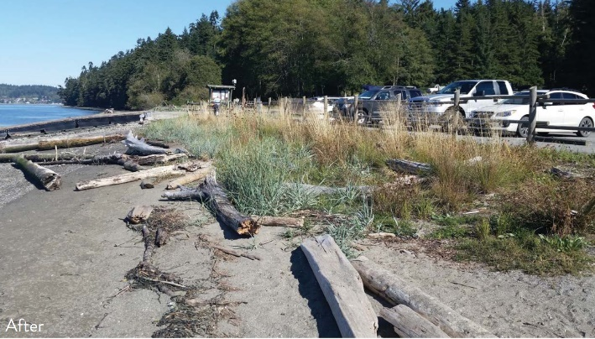
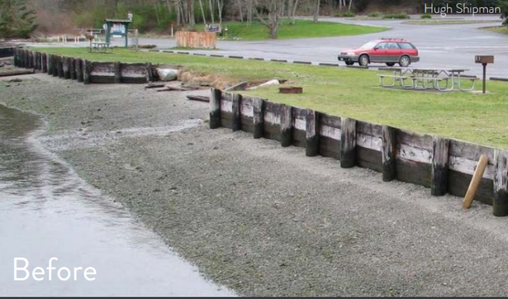
Evidence reveals that glaciers in this region formed in the Pleistocene era, 1.8 million years ago, grew
The replacement of a retaining wall with logs and native plants resulted in less erosion, more habitat, and more beach enjoyment by visitors at Cornet Bay, Deception Pass State Park, WA. Images by WDFW

and merged into the great Cordilleron ice sheet, which sheered away shorter mountain tops and slopes and carved out deep valleys and the fjords that are now the Salish Sea. As the climate warmed and glaciers retreated, the sediments they carved off and carried with them fell off with the meltwaters, leaving boulders, cobble, gravel, sand, and silt behind. These are the ingredients to many Salish Sea beaches, which are either solid rock, which itself got scoured and smoothed by the glaciers, or sediments deposited by them, called glacial till. The same goes for the lands above beaches, upon which humans like to build structures. In a constantly shifting physical environment, building on glacial till is risky and waterfront landowners have gone to great lengths to stack the odds in favor of not losing their homes and businesses to erosion. But, at what cost?

Communities using science ideas to protect Earth’s resources and the environment

Protecting waterfront lands from erosion using retaining walls of concrete, pilings, or piled up boulders or “riprap” (chunks of old concrete and/or asphalt) has been common practice since settlers moved onto these shores. These structures, however, change natural dynamics in several ways.

First, they can increase the power of waves to wash away finer sediments from beaches, leaving coarser rocks and cobble behind. Waves that hit walls retain much of their energy, instead of dissipating it on sand and gravel before the wave recedes. Second, they withhold upland soils that would otherwise erode over time and replenish those lost to wave action, slowly starving the beach of sediments. This loss of sediment can undercut the very walls meant to retain the sediments above. Third, they often require the removal and prevent regrowth of beachfront trees and shrubs which provide natural erosion control and protective shade for forage fish eggs.

Forage fish, such as surf smelt, sand lance, and herring, are small fish that are critical to ocean food webs because so many bigger species eat them, including salmon, sea birds, and subsistence fishers from many local cultures.

Washington and British Columbia and dozens of Coast Salish nations recognize this loss of habitat and have been spending millions of dollars to return lost sediments to beaches and restore critical habitat, for the forage fish that star in this unit, and countless other species. It is a scientific and engineering and social and civic and even spiritual challenge, which is bringing together Western and Indigenous experts from many fields to find solutions.

You and your students will soon join the problem-solving team, as you explore the earth-water-air interactions that support life on our beaches. You’ll compile clues, join experts in your community to conduct an authentic research project, and determine the best beach composition to ensure forage fish survival.

Save student journals with students’ evidence-based recommendations for beach improvement (see the Get CERIAs journal page) for Unit 8, Salish Sea Heroes. This is when they will review all of their Western and Indigenous science-based recommendations to select their favorite/most feasible one and put it to action to improve the ecosystem near you in a Salish Sea Heroes project

Sources

DeLella Benedict, Audrey, and Joseph K. Gaydos, 2015. The Salish Sea, Jewel of the Pacific Northwest. Sasquatch Books. Seattle, WA.

Ma, Michelle. Cumulative effects of shoreline armoring: First Salish Sea-wide shoreline armoring study shows cumulative effects on ecosystem. Last accessed online August 11,2022 at https://www.ocean.washington.edu/story/Cumulative_Effects_of_Shoreline_Armoring_
Penttila, Dan, 2001. Effects of shading upland vegetation on egg survival for summer-spawning surf smelt on upper intertidal beaches in Puget Sound. WDFW report for Salish Sea Restoration.

Penttila, Dan, 2007. Marine Forage Fishes in Puget Sound. Technical Report, WA Dept of Fish & Wildlife.

Townsend, Catherine L. and John T. Figge. 2002. Northwest Origins An Introduction to the Geologic History of Washington State. Burke Museum. Last accessed online July 13, 2022 at https://www.burkemuseum.org/geo_history_wa/

Washington Department of Fish and Wildlife. 2016. Your Marine Waterfront Enjoy the beach. Protect your home. Improve shoreline habitat. A guide to protecting your property while promoting healthy shorelines. Washington Department of Fish and Wildlife. Last accessed online July 11, 2022 at https://wdfw.wa.gov/sites/default/files/publications/01791/wdfw01791.pdf

Zelo et al. 2000. Alternative bank protection methods for Puget Sound Shorelines. Shorelands and Environmental Assistance Program. Washington Department of Ecology. Olympia, Washington. Publication # 00-06-012. Accessed online at https://www.salishsearestoration.org/images/d/d2/Zelo_et_al_2000_alternative_shoreline_protection.pdf

Further Learning and Classroom Resources

CGEN RCEG. Geoscapes of Canada. Canadian Geoscience Education Network. Last accessed online July 13, 2022 at https://www.cgenarchive.org/vancouver-volcano.html

Hruby, Kate. 2020. Salish Sea Geology. Deep Green Wilderness video short for SeaDoc Society. Last accessed online July 13, 2022 at https://vimeo.com/405046798

Pacific Museum of Earth 2020. Geology of British Columbia. University of British Columbia. Last accessed online July 13, 2022 at https://pme.ubc.ca/exhibits/geology-of-british-columbia/

Vancouver Island University Earth Science. Printable Classroom Resources. Last accessed online July 13, 2022 at https://scitech.viu.ca/earth-science/printables

Unit Overview

How can we gather and communicate evidence about how the geosphere, biosphere, and hydrosphere interact?

Anchoring Phenomenon: Critical forage fish lay their eggs on just the right size of rocks at high tide

Design Challenge: How can we design a beach that enables a natural supply of the right size of rocks for forage fish spawning habitat?

Lesson 1 - 3 days  How does forage fish biology interact with geology? | Lesson 2 – 5 days  How does hydrology interact with geology to form a beach? | Lesson 3 – 8 days  How can we gather and communicate evidence that the geosphere, biosphere, and hydrosphere interact?
Session 1  What do we wonder about the just-the-right-size rocks supporting tiny fish eggs?  Session 2  What patterns do we notice in forage fish spawning beaches? – list characteristics of spawning beaches.  Session 3  How does beach geology interact with surf smelt spawning? Revise the spawning beach model design.  Session 4  What do surf smelt need to spawn successfully? Build a physical spawning beach model, based on the design. | Session 1  Have beach stones always been there?  Session 2  How do waves and currents interact with beach stones?  Session 3  What stories can beach stones tell us about how they got there?  Session 4  How do glaciers interact with rock? – revise model of a smelt beach using new understanding of sediment supply | Session 1  Design an investigation that compares surf smelt eggs on beaches with and without the factors we’ve determined support surf smelt spawning success. Include information from tribal and First Nations knowledge  Session 2  Carry out the investigation.  Session 3  Analyze the smelt egg data  Session 4  Argue using evidence with fellow scientists and make evidence-based recommendations for surf smelt spawning beach restoration and protection  Session 5  Make final spawning beach model revisions

UNIT 3: SALISH SEA ROCKS STORYLINE  Students will figure out how to ensure safe spawning habitat for a culturally- and ecologically-essential fish. To figure out this phenomenon, students will work in Explore Teams to develop and refine a model of a forage fish spawning beach and upland area. They will first wonder at forage fish eggs on beach gravel and discover with a visiting expert just what kinds of eggs these are. Learning the cultural and ecological importance of smelt to the Salish Sea people and food web will build a sense of urgency for their goal.  Next, they will visit a forage fish spawning beach (if possible) and observe provided photos of known spawning beaches to look for patterns among them. While there or in class, they will receive prompts to wonder: how did these just-the-right-size beach stones get here and how do we make sure they stay?  This question will guide them to plan and conduct investigations into the earth processes that build, change, and move rock from its place of origin all the way to spawning beaches. On school grounds, they will model the processes of erosion by glaciers, weather, waves, and currents. At the beach, they will conduct their own surf smelt survey with a community partner, if feasible. Crosscutting Concepts of Cause and Effect, Patterns, and Systems and System Models will be reinforced.  Observations from these experiences will inform students’ revisions of their forage fish spawning beach models as they go. Finally, they will make evidence-based recommendations for ensuring forage fish-safe spawning habitat and keep these for Unit 8, Salish Sea Heroes, when it comes time to select and conduct an environmental improvement project. Keep journals from each unit you choose to implement until after Unit 8, the culminating unit, is complete.  Icons in this curriculum are from  <a href="https://www.flaticon.com/free-icons/chemistry" title="chemistry icons">Chemistry icons created by Freepik - Flaticon</a> | TERMS FOR THE TEACHER    Assessment- a chance to measure overall growth through a pre- and post-assessment for each unit.    Background research- includes the Explore the Salish Sea book, articles, videos, games, songs, and expert guests.    Essential question – The overarching question that drives the background research, games, activities, and authentic inquiry for each unit.    Formative Assessment – opportunity to check for student understanding and misconceptions.    Games- games are used to introduce and reinforce concepts through play. Instructions are included.  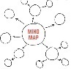  Mind Map – Draw a model with the problem in the center circle and clues to solving it connected to it, grouped by related ideas.    Model – A physical, mathematical, or conceptual representation of an object, process, or event    Team Read – The equitable division of a large piece of literature among teammates, each getting summarized individually, and then synthesized into one summary. This allows each student to feel that they have contributed an important piece of background research, while accommodating individual reading levels.    Team Talk –Each student shares ideas with their Explore Team for 1 uninterrupted minute to ensure equitable sharing and give a voice to students who may not speak out in a full-class discussion. The Science Communicator reports a summary to the class. This symbol is also used when students communicate their science with the class or greater community.    Tribal Knowledge - Work with your district’s Tribal or First Nations Liaison, if you have one, to invite a cultural outreach or natural resources employee from a local tribe or First Nation to meet with your class and share what they deem appropriate about the topic.    Wonder – a phenomenon, problem, or discrepant event that sparks curiosity in students and initiates exploration
LEARNING TARGETS LESSON 1  Wonder about the survival of forage fish eggs on Salish Sea beaches.  Identify patterns in beach composition in several known surf smelt spawning beaches.  Determine the size of rocks that surf smelt need for spawning.  - Define geologist, geosphere, sediment  - Design and build a model of an ideal surf smelt spawning beach.  - Explain each beach model component to an audience for its purpose in keeping forage fish eggs alive.  TEACHING WITH THE 5 E’s FOR A COHERENT STORYLINE – LESSON 1  ENGAGE activity: Students wonder, discuss, and form a question about the image of fish eggs on beach rocks, only knowing that the fish inside need this size of rocks to survive.  Practice: Asking questions  EXPLORE activities: Compare photos or beaches in-person to identify patterns across known surf smelt beaches. Hear from a Coast Salish knowledge holder about how to find surf smelt.  Practice: Obtaining and evaluating information.  EXPLAIN activity: Compare data of surf smelt egg mortality (dead egg) rates between boulders, cobble, and sand-gravel beach sites.  Practice: Analyzing and interpreting data. Engaging in argument from evidence.  EXTEND activity: Model an ideal surf smelt spawning beach based on current understanding.  Practice: Developing and using models  EVALUATE activity: Present models to the class and consider what more we need to know to ensure a healthy beach.  Practice: Communicating and Evaluating Information | NGSS PERFORMANCE EXPECTATIONS  blue=Practice orange=DCI green=Crosscutting Concept  5-ESS2-1 Develop a model using an example to describe the ways the geosphere, biosphere, hydrosphere, and/or atmosphere interact.  5-ESS3-1 Obtain and combine information about ways individual communities use science ideas to protect the Earth’s resources and environment.  BRITISH COLUMBIA SCIENCE CURRICULUM  Grade 5 Content – Earth/space  • First Peoples concepts of interconnectedness in the environment  • the nature of sustainable practices around BC’s resources  • First Peoples knowledge of sustainable practices  If using this content for grades 4 or 6-8:  4-ESS2-1 Make observations and/or measurements to provide evidence of the effects of weathering or the rate of erosion by water, wind, or vegetation.  MS-ESS2-1 Develop a model to describe the cycling of Earth's materials and the flow of energy that drives this process.  MS-ESS2-2 Construct an explanation based on evidence for how geoscience processes have changed Earth’s surface at varying time and spatial scales.  BC Science Curriculum Content  7- Evidence of climate change over geological time and the recent impacts of humans:  - physical records  - local First Peoples knowledge of climate change  8- Major geological events of local significance  -First Peoples knowledge of:  - local geological formations  - significant local geological events
TEACHER PREP LESSON 1

- Review unit plan, student journal, and slideshow together. Revise these as desired and appropriate for your community and ecosystem.

- Print student journals on 8.5 x 14” paper, booklet fold, in-color if possible. If you choose to print so each journal page is on a full sheet of 8.5 x 11” paper, change settings in the Word document. It is automatically set to print in booklet fold on 8.5 x 14” paper as is.

- Connect with a community partner who can support a forage fish spawning survey in Lesson 3. Plan ahead for a field trip to conduct the survey.

- Invite a visit by an indigenous knowledge holder from the tribe or First Nation upon whose territory your school resides. This might also be your community partner for the forage fish survey. See suggestions for developing partnerships with local tribes and First Nations in A Note About Indigenous Knowledge here.

- Review unit vocabulary (see student journal pp.5-6) and consider ways you will weave the use of these words naturally through the lessons. Students will return to define them opportunistically as they become familiar through use.

- Print, cut, fold, and place Pearls of Wisdom into a shell or other container for students to draw from, if you choose to include this practice of inspiration.

- Decide on Explore Teams composition. It works best to have mixed ability groups, where students may contribute their individual strengths to the team and support one another where needed. If you haven’t already, label spots at each table with Explore Team titles (see student journal p.5). When switching roles, students can rotate seats within their own team or find their new role in their new team.

- Print Salish Sea Rocks pre-assessment or prepare to administer electronically.

- Gather materials for the forage fish spawning beach models. Set aside space for model storage when not in use. Prepare for water, sand, and gravel spills (keep rags, broom, and maybe a mop on hand!)

MATERIALS LESSON 1  Session 1 ENGAGE  - Printed and cut Pearls of Wisdom and a seashell to hold them (optional)  - Internet connection*  - Audio/Visual equipment and The Salish Sea Rocks! Slide deck *  - Teacher Guide, print a copy if desired, have electronic version available for weblinks*  - 1 printed pre-assessment for each student  - 1 student journal for each student plus 1 for you to mark up and follow along*  *Used in all sessions  Session 2 EXPLORE  - Explore the Salish Sea: A Nature Guide for Kids books – class set  - Colored pencils for designing a beach model  Session 3 EXPLAIN  Grainsize survey  - ¼-meter or 1-meter square quadrats (square frames made from wood, pvc pipes or other material to delineate a survey plot), 1 per Explore Team. Hula hoops will do instead.  - Space in the school yard where sediment (rocks, sand, dirt) is exposed with enough room for each Explore Team to set out their quadrat or hula hoop  - Calipers or a ruler with millimeter markings, 1 per team  Session 4 EXTEND  Beach Model  - Sand – 5 gal bucketfull  - Gravel, assorted sizes – 5 gal bucket full  - Water – 5 gal bucket full  - Large, metal or plastic baking dish-type trays 9 x 13” or larger, 1 per team  - Small watering cans with sprinkle nozzle (to simulate rain), 1 per team  - Twigs or model trees and shrubs  Session 5 EVALUATE  - Whatever students deem necessary to explain their beach models to the class (poster paper, markers, etc.) | WEBLINKS LESSON 1  Salish Sea Rocks Slideshow*  https://pacificeductioninstitute.sharepoint.com/:p:/s/Program/Ef_z-JzwbABLtr-yO68CGtsBYyOO4Y7d-AbhkaZCKHOECA?e=r6CNJm  Salish Sea Rocks Pre-assessment  https://pacificeductioninstitute.sharepoint.com/:w:/s/Program/Efq1R48VM6tNmkGbVQ5liyUB_jvsyvSGQuia-VIDDlLyJg?e=pDxRhB  Student journals*  https://pacificeductioninstitute.sharepoint.com/:w:/s/Program/Eb7zLdlKPqxIps96eNpFKZQBzyYdn3VRR0lLu4Vlz9z-fw?e=bzRYla  Things to Consider for Partnering with Local Tribes (from WA Since Time Immemorial Curriculum, but applicable here*  https://www.k12.wa.us/sites/default/files/public/indianed/tribalsovereignty/partnering/partneringwlocaltribes.pdf  Indigenous Liaison contacts BC School Districts*  http://www.bced.gov.bc.ca/apps/imcl/imclWeb/AB.do  Office of Native Education (ONE) Washington State and nearest tribe by school district list*  https://www.k12.wa.us/student-success/access-opportunity-education/native-education  https://www.k12.wa.us/sites/default/files/public/indianed/tribalsovereignty/partnering/SD-Nearest%20Tribe%20List.pdf  Essential Question description  https://www.scholastic.com/teachers/articles/teaching-content/essential-questions/  *Used for all sessions

TIME  Approx. | TEACHER GUIDE LESSON 1, ROCK DETECTIVES (five 50-min sessions)
Session 1  1 min  5 min  20 min  10 min  8 min  6 min | ENGAGE  - Provide Pearls of Wisdom in a large shell for a student to draw from and read aloud just for inspiration. (Optional)  - Direct Explore Team formation/role changing, following journal p3, slide 8.    - Administer Salish Sea Rocks pre-assessment, slide 9.    - Wonder: Show slide 10. Don’t describe the image, other than to share that these are small, but mighty fish eggs that need just the right size of beach stones to survive. Invite students to write or draw whatever this makes them wonder on journal p6. Student question examples: Are there enough beaches with the right size stones? How do the right size rocks get to the beach? Are there fish eggs on the beach stones at our local beach? What kind of fish lays their eggs on the beach? Remind students of the Team Talk protocol and hold a Team Talk for students to share their wonderings with one another.    - Invite Science Communicators from each team to share their team’s wonderings. Afterward, read the story of the Upside Down People from the Hoh Tribe, slide 11. Ask students how smelt are important to the Hoh Tribe. Invite a popcorn discussion about this new information. Show slides 12-15 Ask how smelt may be important to other smelt fishers, as well.    - Show slide 16 and let them know that smelt are one type of forage fish that spawn on beaches with just the right size of rocks, but those are getting to be hard to come by. In fact, they have been disappearing for the past 160 years.  Guide the formation of an Essential Question, slide 17 structured around the theme of ensuring the right size rocks for beach-spawning forage fish. Have students write the class’ agreed-upon Essential Question on journal p4.
Session 2  15 min  25 min  10 min  Time will vary  Session 3  *1 full hour  5 min  5 min  20 min  10 min  20 min | EXPLORE  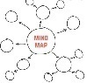  - Show slide 18, Background Research, and let Explore Teams know it’s time to get to work as Nature Detectives and gather some clues to solve the mystery of the disappearing forage fish spawning beaches. Create a Mind Map (or your accustomed equivalent) on a poster paper for the class with the Essential Question in the Center circle. Connect categories of clues to the center circle and connect clues to relevant categories to model the mystery-solving process. Have Science Communicators ready to record clues on the map as discovered.  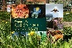  - 1st stop for clues: Explore the Salish Sea chapter 3, slide 19. Read silently or in partners for support. After reading they should write or draw their thoughts, ideas, questions, and clues generated while reading on journal p5. Give them a chance to scan the vocabulary on journal pp6-7, define any they already know, and highlight or circle ones they will learn as they go. Have teams discuss the chapter and add relevant clues to their mind map. Additions will likely be related to the source of beach stones and processes that delivered them to beaches.  - Invite students to look for beach similarities between successful spawning sites in slide 20 then between less successful spawning beaches on slide 21. Ask them to record characteristics on journal p8.    - Invite a visit by a local Indigenous knowledge holder to share what forage fish spawning beaches need. Record notes on journal p8. Have Research Associates record new evidence on the class mind map. Check journal p8 for understanding.  EXPLAIN  - GRAINSIZE Ask students just what are the right size rocks for a spawning beach? Let them know a forage fish biologist researched this very question over 20 years in nearly 200 spawning sites. Show his data in the graphs in slide 22 and ask if they can make sense of (analyze) what the bars tell us. Invite popcorn-style discussion.  - Ask, do you know the difference between clay, silt, sand, gravel/pebbles, cobble, and boulders? Let’s geologize to figure it out with our own grainsize survey! Display the grainsize guide on slide 23 and give time for students to make sense of methods on journal p9.  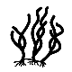  - Remind students of Outdoor Classroom norms. Bring students outside to a place where sediment is exposed in your school yard. Ask Chief Scientists to guide their teams through the Sediment grainsize Survey, with each team member carrying out their role. Field Techs should acquire rulers or calipers and quadrats (hula hoops will work fine if you don’t have ¼-meter or 1-meter squares).  - Back in the classroom and equipped with new geology vocab, show slide 22 again. Ask if the grainsize they found in their practice survey is the right size for either type of fish in the graphs then write responses at the bottom of journal p9.  - SHADE and ARMOR Show the graph in slide 24, a compilation of data from multiple surveys to compare the percentage of dead eggs on 3 types of beaches. Show slide 25 to point out sea walls as armoring. Go back to slide 24 and ask students to analyze what they see and take popcorn-style discussion. Invite students to consider a Claim, Evidence, and Reasoning (CER) for what makes a safe beach for forage fish, journal p11, then ask Research Associates to add these clues to the class Mindmap. Revisit vocab lists on journal pp6-7 and ask if they are equipped to draw or write any more definitions. Check both.
Session 4  10 min  10 min  25 min  5 min | ELABORATE  - Now that students have formed their own ideas of what makes a safe spawning beach, invite them to draw a diagram of a dream beach for forage fish on journal p10, labeling components, including sediment type (sand, gravel, cobble, etc.).  - Hold a Team Talk for students to share their own designs for a forage fish-safe beach with their teammates. After 5 minutes ask that they combine the best aspects of each design into one design per Explore Team. Research Associates should create a diagram of the team design onto a separate sheet of paper, write the team name and “Iteration #1” on it.  - Invite Lab Techs to obtain supplies for the team to build a physical model based on the team’s agreed-upon spawning beach design. Build! Remind the Chief Scientists to ensure that everyone has a task and is on task, the Research Associates to record changes to the design as they build. Suggest that larger sediments (gravel) be placed first and sand last.  - Ask that Lab Techs direct the return of model materials, cleaning of the table, and place the model in a safe storage area. Science Communicators may pin team’s beach model design, Iteration #1, to the wall by the class mind map, leaving space beneath for additional iterations to be added.
Session 5  50 min | EVALUATE  - Ask for Science Communicators to present their team’s physical model to the class with support from their team members, if desired. Class members may ask questions about the models, challenge certain components, and make respectful suggestions for revisions. Research Associates should make notes on these suggested revisions during the presentation on journal p11. Invite students to complete their model and presentation evaluations on journal p12.

LEARNING TARGETS LESSON 2  - Wonder about the problem of beach sand and gravel loss to erosion.  - Determine the forces that remove sediment from beaches.  - Define erosion.  - Determine the sources of new beach sediment  Identify the origin of rock that becomes beach sediment to understand the geologic and hydrologic processes that formed Salish Sea rocks.  - Define erosion, glacier, physical weathering, and rock cycle.  - Revise and present the beach model with this new information in mind.  TEACHING WITH THE 5 E’s FOR A COHERENT STORYLINE – LESSON 2  ENGAGE activity: Students wonder about the problem of beach sediment loss and replacement.  Practice: Asking questions  EXPLORE activities: Observe effects of rain, wind, and waves on model beach sediment composition. Adopt a rock and track it to its origin.  Practice: Obtaining and evaluating information.  EXPLAIN activity: Track the sediment lifecycle by modeling upland erosion, glaciation, and the rock cycle.  Practice: Developing and using models.  EXTEND activities: Adopt a pet rock, identify its type and source, bake rock cycle cookies, and play rock tag. Revise beach models with a source of new sediment using this new information.  Practice: Obtaining and evaluating information, Developing and using models  EVALUATE activity: Present models to the class and consider what more we need to know to ensure a healthy beach.  Practice: Communicating and Evaluating Information | NGSS PERFORMANCE EXPECTATIONS  blue=Practice orange=DCI green=Crosscutting Concept  5-ESS2-1 Develop a model using an example to describe the ways the geosphere, biosphere, hydrosphere, and/or atmosphere interact.  5-ESS3-1 Obtain and combine information about ways individual communities use science ideas to protect the Earth’s resources and environment.  BRITISH COLUMBIA SCIENCE CURRICULUM  Grade 5 Content – Earth/space  • First Peoples concepts of interconnectedness in the environment • the nature of sustainable practices around BC’s resources  • First Peoples knowledge of sustainable practices  If using this content for grades 4 or 6-8:  4-ESS2-1 Make observations and/or measurements to provide evidence of the effects of weathering or the rate of erosion by water, wind, or vegetation.  MS-ESS2-1 Develop a model to describe the cycling of Earth's materials and the flow of energy that drives this process.  MS-ESS2-2 Construct an explanation based on evidence for how geoscience processes have changed Earth’s surface at varying time and spatial scales.  BC Science Curriculum Content  7- Evidence of climate change over geological time and the recent impacts of humans:  - physical records  - local First Peoples knowledge of climate change  8- Major geological events of local significance  -First Peoples knowledge of:  - local geological formations  - significant local geological events

MATERIALS LESSON 2  Session 1 ENGAGE  - Team beach models  - 2-3 gal of water to fill the bottom of the trays holding the models to simulate ocean water, about 1 quart or 1 liter per model  - Rigid, plastic or wooden board, such as a cutting board or plywood, the length of the inside of the baking trays – to be held vertically in the water and moved gently to simulate large, storm waves, 1 per model  - Aluminum foil or wooden tongue depressors to simulate a sea wall  - Small watering cans with sprinkle nozzle (to simulate rain), 1 per team  - Twigs or model trees and shrubs  - Hairdryer – 1 or 2 for the class -to simulate wind and wind-generated, small waves.  - Model/toy houses or other buildings  Session 2 EXPLORE  - Mind maps for adding clues  Rock Detectives For each pair:  - Dichotomous key  - Magnifying glass or dissecting scope, 1 per pair  - Piece of glass (for scratch test)  - Steel nail  - White vinegar in a dropper bottle  - Plastic pipette or eye dropper (if vinegar is not in a dropper bottle)  Rock Tag (optional extension)  - Open space, safe for running  - Cones to mark play area boundaries  - Printed and cut rock stage and process necklaces (see instructions) on cardstock  - Yarn and hole-punch  Rock Cycle Cookies (optional extension)  - Chocolate chip cookie ingredients  - See Rock Cycle Cookies activity link for list of all items  Session 3 EXPLAIN  - ¼-meter or 1-meter square quadrats (square frames made from wood, pvc pipes or other material to delineate a survey plot), 1 per Explore Team. Hula hoops will do instead.  Session 4 EXTEND  - Beach Models  - Additional sand and gravel of varying sizes to replace any lost or add to the model  Session 6 EVALUATE  - Beach model presentation materials | WEBLINKS LESSON 2  Rock Rainbow Nature Detective activity  https://pacificeductioninstitute.sharepoint.com/:w:/s/Program/Eeq1h-Rj3BdHjIlMtuN6bRwBPsS1CMXfC-4D4LEYzrQlBQ?e=xvZRmo  Essential Question description  https://www.scholastic.com/teachers/articles/teaching-content/essential-questions/  Rock Type Video  https://untamedscience.com/blog/rock-types/  Rock Tag Instructions  https://pacificeductioninstitute.sharepoint.com/:w:/s/Program/EUVH5L0ZTWNPpv1u0w_wpEIB7jWWPCUWNEXMw5jyBXoO1g?e=Z0ZRbM  Rock Tag cards  https://pacificeductioninstitute.sharepoint.com/:w:/s/Program/EUVH5L0ZTWNPpv1u0w_wpEIB7jWWPCUWNEXMw5jyBXoO1g?e=PVUrNn  Rock Cycle Cookies instructions  https://pacificeductioninstitute.sharepoint.com/:w:/s/Program/ETT2ELaDr61Ih3SDSIvZLocBTV5QQrc-wpkLRXAzWLgm1w?e=O3Jakn  Density Dance how-to  https://pacificeductioninstitute.sharepoint.com/:v:/s/Program/Eana3IilzlNPkDIV5LZ5jHAB-cWpsUUArbhYgkzm6zkhgg?e=wNOShl  Rock Cycle dance how-to  https://pacificeductioninstitute.sharepoint.com/:v:/s/Program/EeOHxIzMl7JJsM1MMBqHUSABdhjTfNj-iejPHL8SSiMM0w?e=Siq4BH  Rock Cycle dance music: Planet Rock by Afrika Bambaataa  https://www.youtube.com/watch?v=_rlUQsC8ECk  Rock Detective Activity  https://www.juniorseadoctors.com/rock-detective  Rock Detective dichotomous key by Rachel Micander, Nevada Bureau of Mines and Geology  https://pacificeductioninstitute.sharepoint.com/:b:/s/Program/EWv7IlJdtMdIgaa5dEM4y8gBM7KjXr9Lh4nbQMKNlCDYeQ?e=9mVyhF

TEACHER PREP LESSON 2
Sessions 1 and 2
- Touch base with community partner and continue field trip prep for Lesson 3

- Review unit vocabulary (see student journal pp.5-6) and consider ways you will weave the use of these words naturally through the lessons.

- Procure water, extra sand, and other model materials

- Bring in 1 watering can per team, 2 or 3 hairdryers, and the cutting boards or plywood sheets for the class and set up stations for testing effects of rain, wind waves, and storm waves on beach model sediments. Practice on your own test model first so you can advise on how to avoid a sand and water disaster. Hold the hairdryer “offshore” (over the water in the model) and point it at an angle to the beach. Start on low speed and observe the size of wind waves it generates. Observe for beach erosion caused by these waves. Switch to high power and observe again. Next try generating larger “storm” waves using the cutting board or plywood. Hold it vertically and push it gently back and forth only a few centimeters at a time and at even intervals. Observe for erosion.

Session 3
- Collect a variety of rocks from one beach or plan for students to collect them prior to Session 2. Make sure there are several colors and textures included and that there are enough for 1 per student. Take a photo of the beach where the rocks were collected, from the waters’ edge, facing the land. Open the Salish Sea Rocks slide deck and add this photo to slide 26.

- Provide craft supplies for decorating pet rocks, such as googly eyes, yarn, glue, paint, and/or markers

- Print 1 dichotomous rock key for every pair of students. Provide steel nails and small pieces of glass for scratch tests (steps 18 and 20 in the dichotomous key), 1 each per Explore Team. Tape glass edges if sharp. Prepare to provide careful supervision for use of nails and glass.

- Prepare a poster for the rock rainbow to be assembled with students’ adopted beach stones. This will likely lay on a table unless you get creative with a wall hanging that can support 28 or so rocks!

Session 4
- Secure a place outdoors where you can pile up dirt, sand, and rocks into model mountains, 1 per Explore Team.

- Make or purchase ice blocks for modeling glaciation, 1 per Explore Team

Session 5
- Ensure plenty of modeling materials for model revisions, as in Sessions 1 and 2. Add materials for building sea walls or bulk heads, such as popsicle sticks, tongue depressors, or aluminum foil.

 | TEACHER GUIDE LESSON 2, ROCK DETECTIVES (four 50-min sessions)
Session 1  12 min  6 min  22 min  5 min  5 min | ENGAGE  - View the time lapse video of the Elwha River delta transformation from before to after dam removal, slide . Hold a Team Talk to discuss the source of the sand that built up the beach. Pause at 5 minutes and ask what caused the loss of sediment after the dam was built? Allow 2-3 more minutes for discussion. Ask Science Communicators to share out teams’ thoughts on the process of sands returning to the beach after the dam was removed and what forces took the sands away, leaving only cobble and boulders behind after the dam was built.  - Students may have suggested rainstorms, waves, currents, or wind forces taking the sand away. Use the term erosion here frequently to reinforce its meaning. Return to journal p6 when students are able to define it.  - Invite students to simulate the forces they believe are responsible for beach erosion one at a time, using watering cans for rain and streams, hair dryers for wind and wind waves, and the boards for storm waves (gently, like you practiced during prep). Ask Chief Scientists to kindly ensure everyone has a job and is doing it and that all members record their observations on journal p13.  - Ask Lab Techs to supervise the return of materials and cleaning up.  - Conclude this session by asking Science Communicators to share observations then ask them, if all of these forces are taking sand and gravel away, where do beaches get new sediments so forage fish may spawn successfully? Let them know that next session they’ll need to dig into clues and figure out the source.
Session 2  10 min  5 min  3 min  20 min  4 min  8 min | EXPLORE  - Ask students if they uncovered clues the mystery of the disappearing beach sand by modelling erosion. Ask them to recap the forces that removed the sand in their models: rain, wind, and waves, then add this information to the mind map.  - Ask, if those forces are always acting on beaches, where might new sand and gravel come from to replace what was lost and keep the beach safe for forage fish spawning? Take some suggestions through “popcorn” responses (students pop up to share an idea). Ask if their observations in the previous session offered any clues to how the sand and gravel gets replaced. Ask if they are ready to dig into the source of new sand and gravel using their models.  - Lab Techs may bring the models back to their teams and teammates may help get modeling materials that will aid in testing out their ideas of how new sediments are delivered to the beach. They again might want to use watering cans and hairdryers, but maybe not the cutting boards. Allow their creativity to guide their methods and materials.  - Invite students to simulate the forces they believe are responsible for beach deposition. Chief Scientists should kindly ensure everyone has a job and is doing it. Everyone should record observations on journal p14.  - Ask Lab Techs to supervise the return of materials and cleaning up.  - Ask Science Communicators to share out: Were new sediments deposited on their beaches? How? What was their source? What were the differences between model beaches where sediments were successfully deposited (these likely included upland source of new sand) and those where they were only eroded. Ask Research Associates to record new clues on the Mind Map.
Session 3  Note: this session is 1 full hr  15 min  15 min  15 min  5 min  10 min | EXPLORE CONTINUED  - Review Mind Map additions, focusing on beaches eroding and depositing new silt, sand, pebbles, and rocks over time. Suggest that they take a closer look at the beach stones and see if they really do have stories to tell. Invite students to adopt a rock in honor of the important contributions of rocks to our beaches. Have each student select one beach stone from a variety of colors you or they collected. They can name their new friends and decorate them with eyes, etc. Ensure enough rock is showing to see its color and composition. Have them write their initials on the rock in pencil. Next, they should fill in the Rock Rainbow worksheet, except for the final square on journal p16, to which they will return later.  - Show slide 26 and challenge students to be Rock Detectives as in Explore the Salish Sea p14, journal p17. Provide dichotomous keys, magnifying lenses or dissecting scopes, 1 per pair. Show slide 27 to portray how to use dichotomous keys. Allow time for students to observe rock characteristics and work through the key to try to identify their rock friend.  - Show the Untamed Science Rock Type video , slide 28. then talk through each part of the rock cycle in slide 29. Allow about 10 minutes to observe for characteristics in their own rocks that may be clues to whether they are sedimentary, igneous, or metamorphic and complete Clues to the Past, journal p18.  - Show slide 27 and direct students to the rock cycle diagram on journal p19. Again, talk through each step in the diagram then challenge them to find where in this cycle their own rock was “born.” This is a brief foray into the rock cycle, just to bring awareness to its role in forming the Salish Sea. As optional extensions, assign characters and narrate/bake Rock Cycle Cookies (at-home option), slide 30, journal pp19-21 and play Rock Tag., slide 31.  - Show slide 32 and invite students to line up their rocks on a prepared poster in rainbow order and display it during this unit.
Session 4  Note: this session is 55 min+  10 min  5 min  25 min  5 min  5 min  5 min  ELA time | EXPLAIN  - Remind students that the rock cycle showed that rocks change size and form. Show slide 34 and invite students to search for signs that small rocks come from large rock formations or mountains. Show your photo of the beach where the rocks were collected in slide 34. Ask how their little stones may have broken off and gotten to this beach from their rock formations far away. Take a few suggestions. Direct them to pp16-18 in Explore the Salish Sea for a clue search. After 3 or so minutes, ask what they discovered in a popcorn discussion. They will likely share about the work of glaciers.  - Show photos of glaciers in slides 35-40 to look for clues that glaciers have enough force to carve rocks from mountains and push them to the sea. Ask how they could model a glacier in motion to test it out. Offer ice blocks, but support other plans if feasible!  - Model glaciers with ice blocks! Have teams build hills of sand and/or dirt outdoors. Provide each team an ice block. Let them add weight to the ice or increase the hill slope angle enough so the ice block moves downhill on its own. They may also push it with their hands like a bulldozer from mountain top to valley floor. An actual glacier would move downhill by having additional ice weight built up at the top, so note this model imperfection for students. If time allows, leave ice blocks at the bottom with a few rocks on top of them. Let them melt and return to find where those “glacial erratics” landed, (Explore the Salish Sea p15).  - Have students note effects of the glaciers moving on the sand and dirt on journal p22.  - Ask that Field Techs lead their teams in cleaning up glacier modelling supplies.  - Show the Salish Sea Geology Rocks video in slide 41 to support and expand on observations students made while modeling glaciation with their ice blocks.  - Assign students to write the story their beach stone has to tell on journal pp23-24 for ELA
Session 5  10 min  5 min  30 min  or more, if possible  5 min | ELABORATE  - Show slide 42 to bring attention back to beach stones as habitat. Review clues in the class Mind Map to establish the ways new sediments made their way to the forage fish spawning beaches. Ask the class if they know all of the components of safe spawning beaches. Invite students to revise their diagrams of a dream beach for forage fish back on journal p11, labeling components, and now including a source of new sediments to replace those lost to erosion by waves and streams.  - Show slide Hold a Team Talk for students to share their design revisions. After 5 minutes ask that they combine the best aspects of each design into one design per Explore Team, as in Lesson 1. Research Associates should create a diagram of the team design onto a separate sheet of paper, including the team name and “Iteration #2”  - Invite Lab Techs to obtain their physical model and any supplies needed for revisions. Build up an upland source of sediments and again simulate waves and rain on them to see whether they wash new sediments from above and deposit them on the beach below. Remind the Chief Scientists to ensure that everyone has a task and is on task, especially that the Research Associates record observations of new beach sediment deposition.  Interrupt halfway through to throw a curveball: We know beach sediments get washed away. We know spawning beaches need a new source of sediments to replace them. But if these are falling from above the beach, what could happen to waterfront homes and buildings up there? How would you protect them?  Show them additional materials (toy houses, buildings, trees/twigs, popsicle sticks, aluminum foil, etc) with which they may model erosion prevention or avoidance and allow them to build these into their models.  - Ask that Lab Techs direct the return of model materials, cleaning of the table, and place the model in a safe storage area. Science Communicators may pin the team’s beach model design, Iteration #2 to the wall beneath Iteration #1, leaving space beneath for additional iterations to be added.
Session 6  *1 full hr  10 min  10 min  20 min  10 min  10 min | EVALUATE  - Show slide 43 and ask teams to compare these sea walls to structures they built to protect buildings in their models. Hold a Team Talk to discuss observations of the modeling in session 5, including whether sediment deposition occurred and the effects, pros, and cons of adding shoreline armoring to protect waterfront buildings. Have Science Communicators share their observations with the class.  - Allow time to add additional clues to the class Mind Map.  - Have teams prepare a 5 min presentation on their model revisions, using journal p25, including the source of sediments to replace those lost from the beach to waves, streams, and rain, and how they protected upland buildings from erosion.  - Ask for Science Communicators to lead the presentations of their team’s observations from the last modelling session to the class with support from their team members, ~5 min per team. Class members may ask questions about the models, challenge ideas, and make respectful suggestions for revisions. Research Associates should make notes on these suggested revisions during the presentation on journal p26.  - Invite students to complete their model and presentation rubrics on journal p27.

LEARNING TARGETS LESSON 3  - Develop an investigable research question and identify variables in an investigation to determine egg survival rates on a beach with the characteristics that support egg survival vs. one without those characteristics.  - Design a field research project with a community partner.  - Carry out a scientific investigation  - Analyze data in a class graph  - Argue using evidence about the.results, implications, and applications of the new information.  TEACHING WITH THE 5 E’s FOR A COHERENT STORYLINE – LESSON 3  ENGAGE activity: Develop a testable question about the suitability of the real beach/es for egg survival.  Practice: Asking questions and defining problems  EXPLORE activities: Design and conduct an investigation to compare egg survival between two or more beaches of differing sediment, shade, and/or armoring characteristics.  Practice: Planning and carrying out investigations  EXPLAIN activity: Create a class graph of egg survival data and analyze. Compile cultural knowledge into a picture or map.  Practice: Using mathematical and computational thinking. Analyzing and Interpreting Data  EXTEND activity: Compare outcomes of this investigation to similar studies or traditional knowledge of Coast Salish communities. Argue using evidence and suggest implications and applications of this knowledge in a Get CERIAs Forum.  Practice: Constructing Explanations and Designing Solutions. Communicating and Evaluating Information.  EVALUATE activity: Make final revisions to beach models and present final products to an audience in the community. Complete the final model rubric.  Practice: Communicating Information | NGSS ADDRESSED IN LESSON 3  How can we gather and communicate evidence that the geo-, bio-, and hydrospheres interact?  5-ESS3-1 Obtain and combine information about ways individual communities use science ideas to protect the Earth’s resources and environment.  BRITISH COLUMBIA SCIENCE CURRICULUM  Grade 5 Content – Earth/space  •
MATERIALS LESSON 3:  Session 1 ENGAGE  Printed copies of the surf smelt article by Rice, 2006, 1 per team, divided into sections, 1 section per student.  Session 2 EXPLORE  Spawning survey  - Student journals with data tables  - Pencils  - 1 gal Ziploc bags for journals in case of rain  - Field trip letter home with list of outdoor clothing/shoes, permission forms, etc.  - Chaperones  - Community partner! The community partner will supply the survey materials (measuring tape, sediment scoops, swilling bowls, hose, microscopes, and egg development stage ID guides  Session 3 EXPLAIN  Class graph  - Prepared Google Sheet, Excel spreadsheet, or other spreadsheet template  Surf Smelt Team Read  - Surf smelt article  - Surf Smelt Facts and Maps (option for less reading)  - Team Read template drawn onto poster paper  Session 4 ELABORATE  Get CERIAs Forum  - Chairs set up in a large circle or oval  - Spawning survey graph/s displayed on the overhead screen  - Completed Get CERIAs forms (in student journals)  Session 5 EVALUATE  - Beach model supplies (last time!)  - Printed post-assessments, 1 per student  - Presentation materials, if presenting the project to the school or broader community | WEBLINKS LESSON 3  Map of Marine Experts (find one near you to help with your forage fish survey research)  www.juniorseadoctors.org/map  Explore the Salish Sea Training – Guiding the Process of Science lesson  https://www.explorethesalishseatraining.org/lessons/guiding-the-process-of-science/  How Science Works Web Interactive  https://undsci.berkeley.edu/interactive/#/intro/1  Team Read Template and Instructions  https://pacificeductioninstitute.sharepoint.com/:b:/s/Program/EWUMnSLOQRNGimo7TsEnwAkB2yt3dnemmKeSOeSyafWiAg?e=7vADXE  Surf smelt informational text  https://pacificeductioninstitute.sharepoint.com/:b:/s/Program/EWQK8lJlqBJPlE2ixG2dX1ABXTni2PuRUK_thcRUK4v2ew?e=vScbV3  Surf smelt and beach modification article by Rice et al. 2006  https://pacificeductioninstitute.sharepoint.com/:b:/s/Program/ESkVlOyf6a1EniqsTxpHKeABjFQMEhD2B9q94kFA4D5VCA?e=F6ysJK  Forage Fish Spawning Beach Maps  Strait of Georgia  This Link or  https://www.arcgis.com/apps/dashboards/b1323fe4d9034b498c41b1cfc5253e4d  Washington  https://www.arcgis.com/apps/mapviewer/index.html?webmap=19b8f74e2d41470cbd80b1af8dedd6b3  Get CERIAs Forum instructions  https://pacificeductioninstitute.sharepoint.com/:b:/s/Program/ESS_5phZdwVNoJ88dSE6mRcBQYvn0nzZmi4hiJA4loo68A?e=Zk43TD

TEACHER PREP LESSON 3
Session 1
- Review the unit plan, student journal, and slide deck for Lesson 3.
- Practice with your own mock-up of the How Science Works Web Interactive, so you are familiar enough with its workings to guide your students’ process of science.
- Review the Guiding the Process of Science Training in Module 1 of Explore the Salish Sea Training (allow 35 min). You don’t need to have research experience to be a wonderful guide! Rather, you need only to have the curiosity to investigate alongside your students’ Explore Teams and make authentic discoveries together. You got this!
- Obtain large, colored construction paper in a variety of colors. Cut in half lengthwise (hot dog, not hamburger 😊), ensuring one strip of a different color for each Explore Team.
- Obtain small sticky notes in 3 colors. Each team will need one of each color. Choose the terms you will use for each type of variable in the students’ research question. Pre-write “CV” for changed or compared variable (if that is your chosen term) on X number of blue sticky notes, write MV for measured variable on X number of green sticky notes, and, leaving room for a list of at least 3 items, write Controlled variables on X number of yellow sticky notes; X being the number of Explore Teams in your class.

Session 2
- Arrange a meeting time and location for the forage fish egg survey with your community partner. Discuss their spawning survey protocol and share how your class is divided into Explore Teams so they may put the teams to work on the beach in a meaningful, organized way.
- Prepare and arrange all field trip forms, chaperones, and logistics well ahead of time. Prepare an honorarium and/or gift ahead of time with your students.
- Invite a Coast Salish knowledge holder to share what they deem important and appropriate about forage fish needs with your students. Prepare an honorarium and/or gift ahead of time with your students.
- Print out copies of the scientific article on surf smelt spawning beaches (Rice et al. 2006)
- Print out a map of the forage fish sites on beaches near you (find the best map for your school location in the weblinks above) – print 1 per Explore Team

Session 3
- Prepare a Google Sheet, Excel spreadsheet, or other graphing program for each team to enter their forage fish egg survival data. Students will graph their data in their student journals first, then enter it into one class graph that you or a student team has prepared. Generally, the independent (or manipulated or changed) variable will go in column A and the dependent (or responding or measured) variable will go in column B.

Session 4
- Display the class graph on a screen for all students to view
- Ensure space to set up chairs in a large circle or oval for the Get CERIAs forum
- Prepare incentives for students to share (stickers, other small prizes, or points)

Session 5
- Ensure modeling materials are accessible by teams for final model revisions.
- Plan for students to present their project to an audience in your school or broader community in any way you see fit and feasible. This may be in a symposium, brochure, art installation, letter to community leaders or legislators, or anything that captures their imaginations and your feasibility.
- Print out a post-assessment for each student

TIME | TEACHER GUIDE LESSON 3: SURF SMELT SURVEY
Session 1  *full hour  5 min  10 min  5 min  10 min  10 min  10 min  10 min  10 min | ENGAGE  - Show slide 44 and ask students if they feel they have enough expertise to assess their local (nearest) beaches for forage fish spawning habitat suitability. If so, let them know their state/province needs their help! There are a lot of beaches and too few scientists to survey them all.  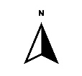  - Show slide 45 or 46 to introduce that spawning beaches have been somewhat mapped by various western and Indigenous scientists working together, and hand out 1 printed forage fish beach map of your area to each team to use to identify a beach or beaches near them to investigate.    - Now return to the Essential Question on journal p4. Review the mind map clues you’ve gathered to figure out the answer to this question in multiple ways. sk if they are ready to use their background knowledge to conduct their very own scientific investigation. Show slide 47 and announce that it’s time to put science to work…at the beach!  - Introduce the How Science Works Web Interactive tool, journal p29, slide 48. Allow time for teams to investigate the various steps and identify which ones they’ve already done. They can circle each step they’ve done and draw their own arrows to connect them in the order in which they did.  INVITE YOUR COMMUNITY PARTNER FOR THE FOLLOWING IF POSSIBLE  - Show slide 49 then slide 50 to introduce that good question development is crucial to an awesome investigation. Click slide 50 again to show the (unrelated) example question. Hold a Team Talk so students may think out loud to develop a testable research question to compare forage fish spawning habitat suitability between at least 2 sites that differ in their characteristics. The actual question will vary depending on the community partner’s goals and resources. Invite Lab Techs to obtain a large strip of colored construction paper then support each Explore Team to write their own research question, as demonstrated in your online training.  - When Explore Teams have written their research questions, introduce variables, or the factors in the investigation being compared, measured, or kept the same, click slide 50 again to reveal the variable ID example. Use slide 51 to further clarify the variables. Have Lab Techs obtain 3 labeled, differently colored sticky notes for their teams. One color should say Compared, Measured, Independent, or Changed Variable, depending on which term your school prefers. This is the factor being compared, i.e., sand and pebble beach site vs. pebble and cobble or boulder beach site or armored beach vs. unarmored beach, etc. One color sticky note should say Measured Variable (the factor being measured, i.e. number of live vs dead eggs or presence vs. absence of eggs, or…?  - Now have Explore Teams list at least 3 controlled variables, which are all the factors that should be held constant to ensure accurate results, i.e., time of year, number of samples from each site, volume of sediment collected, distance from the last high tide line. The list goes on but encourage them to come up with at least 3 factors to keep constant (controlled). Refer to the example in slide 50 again, if needed.  - Invite teams to post their research questions, sticky notes and all, all together up on a wall to display for all to consider. Check question format and sticky note placements for team-level understanding.
Session 2  20 min  15 min  15 min | ENGAGE CONTINUED  - Have the Science Communicators read their team’s question and variables aloud. Assure all that each question is valid, but we will need to select just one so we can take it on with the strengths of all of the Explore Teams collaborating together. Hold a class discussion to consider each question for its importance as well as logistical feasibility (cost, time, community partner support, etc.). Then vote to select one of the team’s questions to investigate as a class or to combine aspects of more than one together into one. Finally, have students each write the final research question into journal p30.  - Ask students what they think the answer to the research question is, based on the clues they have so far. Introduce hypotheses – predictions, supported by evidence, slide 52. Let them know that a good hypothesis is supported by knowing what other researchers have already discovered about their topic, slide 53. Introduce scientific articles as peer-reviewed papers about investigations that have been scrutinized by other scientists to make sure they were valid. Let them know that western science is one way of knowing and gathering evidence, but there are others. Indigenous science includes the oral histories/stories told by Coast Salish knowledge holders about how to take good care of the sea, which is not separate from taking care of our own families.  - Invite students to read a scientific paper about surf smelt habitat needs, one type of forage fish, and their habitat needs using a Team Read. If possible, invite a Coast Salish knowledge holder to speak with your students about surf smelt and/or sand lance spawning needs and recognize that this information is based on thousands of years of observations and teachings.
Session 3  10 min  15 min  15 min | - Have Science Communicators share the information learned from the Team Read article and add these clues, as well as those revealed by the knowledge holder to the class mind map.  - Suggest they are now, finally ready to make their hypotheses. Each student may write their own predictions, supported by evidence, in the If, … then, … because… format, described on slide 52.  - Take some time to document the progress they’ve made using the How Science Works tool. Celebrate their progress!
Session 4  20 min  10 min  ~4 hrs | EXPLORE  INVITE YOUR COMMUNITY PARTNER FOR THE FOLLOWING IF POSSIBLE  - Guide students through designing a forage fish spawning survey, slide 54, journal pp31-32. Invite your community partner to co-lead the survey design, if possible. Their protocol may influence the survey design They may wish to use their data sheets for recording survey data instead of what is on journal p32.  - Discuss field trip logistics and outdoor classroom norms. Students should follow the community partners’ requested order of operations, but students should still carry out their Explore Team roles within teams. And have fun!  - Head to the beach and conduct the survey! Research Associates should record data and turn in journals or data sheets to you for safe keeping. You cannot replace raw data!
Session 5  *1 full hr  5 min  20 min  15 min  20 min | EXPLAIN  Share field trip stories! Then get out that data. It holds our final clues.  Suggest that human minds understand pictures much better than boring lists of numbers. One type of picture in western science is a graph. Invite each student to graph their own Explore Team’s results on journal p33. A bar graph is just great. They may have sampled several sites on the beach or more than one beach for forage fish eggs, so the x-axis labels would be the site numbers or beach names (site 1, site 2, …). The x-axis title would be Sampling Sites. Modify this graph in the way it makes the most sense for the data your students collected. Print separately if needed.  Next ask that Research Associates add their team’s data to the prepared class spreadsheet using your preferred graphing program, such as Google Sheets or Excel. you elect to make a good, old paper graph for the class, that is just fine, too. It just needs to be large enough for all to view it together. Once all the data is in, turn it into a graph, edit the graph to show a title, appropriately-labeled axes, and bars in a color that all students can see. Allow teams with vision-impaired students to build this bar graph out of 3-dimensional math blocks.  - Tell the class it’s time to get serious. Introduce the Get CERIAs Form, journal p35, describe each part using slide 55, and ask them to complete their own with their own thoughts. Support from teammates is encouraged, but they are free to interpret the meaning of their research results in their own, unique way.
Session 6  40 min  10 min | EXTEND  Provide the class graph and site photos on the overhead screen (perhaps on 2 slides) and support a Get CERIAs Forum, journal p35, following the protocol and professionalism described in the guidelines in the link.
Session 7  40 min  10 min | EVALUATE  - Make final beach model revisions and complete the model rubrics.  - Celebrate with a hope fest! Show several photos or a video about successful spawning beach restorations that have brought forage fish back to spawn nearly right after the restoration was done, slides 56-57 (and others you may add).
Session 8  Varies  20 min  5 min | Present the entire project to an audience in your school or broader community.  Administer a post-assessment. slide 59.  Stamp the back of the unit 3 student journals, with any rock-related stamps!

