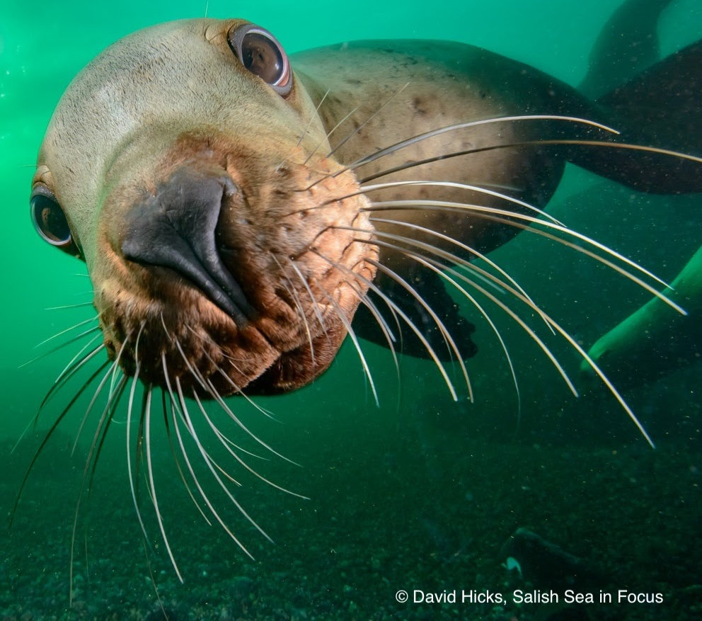
Chapter 6. Life Between Two Worlds
Dive!

Diving Mammal:
____________________________
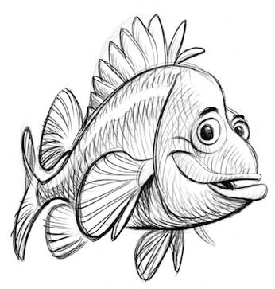
Seashore stewardship pledge
I, ___________________, do hereby solemnly pledge to be a good steward of the marine environment. This means that I will:

- Listen to the instructors both in the classroom and in the field.
- Walk on the shore and docks with care to avoid hurting myself, others, and the sea/river life.
- Treat all life forms with care and respect.
- Use only wet hands to touch gently (using only two fingers) animals that I find.
- Leave creatures attached to rocks and docks because attempting to remove them can hurt them.
- Not hold any marine life out of the water for more than one minute.
- Leave no boulder overturned; I will carefully replace all rocks that I look under and I will only turn over rocks that are smaller than my head.
- Return all organisms to their homes or where I found them.

Signed: ________________________________________________

Dated: _____________________

ORGANIZE YOUR EXPLORE TEAM
Salish Sea Explorers use teamwork to solve mysteries and save the day for sealife. Form a team and select one of these equally valuable roles, then start to explore!
Team Name: ____________________________________________________
Chief Scientist  Research manager  -suggests research projects  -ensures proper scientific protocol  Project manager  -ensures each team member has a job and stays on-task, motivates team with positive encouragement  -Ensures project completion  Assists all other positions as needed | Research Associate  Conducts background research online, in books, interviews, videos, or magazines  Methods manager  -ensures research procedures are legit.  Recorder  -records and enters data in data tables  -records summaries of team’s work  Assists all other positions as needed
Field/Lab Technician  Materials manager  -gets supplies and makes sure they are in  working order  Keeps workstation organized  Infographic artist  -creates graphs from data table content  Assists all other positions as needed | Science Communicator  Reporter  Graphic artist  Presentation manager  -slideshow, poster, video, etc.  Translates complex science into words the general public can understand  Assists all other positions as needed
Cultural Liaison (for 5 person groups)  Researches and records input and perspectives of members of the local Coast Salish Tribe (US) and/or First Nations Band (Canada). Finds Indigenous stories, songs, and/or art that teach us about keeping Salish Sea ecosystems balanced. | For long-term projects, switch roles every 4 weeks  GO TEAM!
Ch. 6 life between two worlds – inspired thoughts
What did this Explore chapter bring to mind? Use this space to free-write and/or draw your thoughts, ideas, imaginings, and questions.
VOCABULARY
Circle or highlight the words you and your classmates found important in this chapter. Come back to define with words or pictures as you learn meanings.
Vocabulary word | Definition
Respiration

Oxygen

Breaching

Adaptation

Anatomy

Physiology

Senses

Echolocation

Acoustics

Amplitude

Frequency

Wavelength

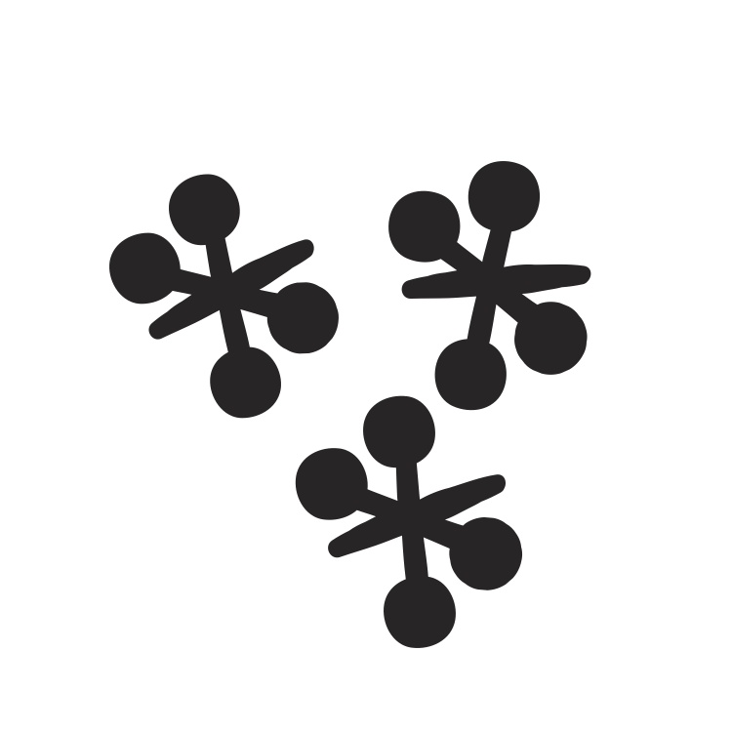
Game time! Hungry Hungry Porpoise

*Did you know: *What to do:
  There is a harbor porpoise in the Salish Sea. It breathes air. It is hungry. Its prey is in deep water where there is no light and no air.  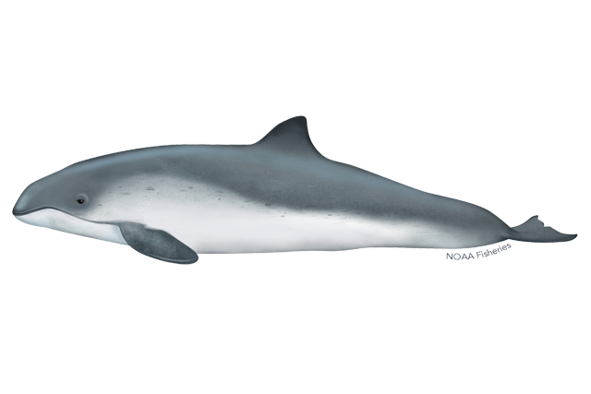 | Be the porpoise! Or its prey, or even an island or ship, all in a game that is kind of like tag… in the dark… without air.  - Select a classmate to be the porpoise.  - Place the porpoise mask on the porpoise so they can’t see.  - Select 1-3 classmates to be its prey. Have them select the type of prey they are representing (smelt, squid, herring, …)  - All other classmates become islands (boundaries) and form a loose circle around the hunting area. Porpoise and prey must stay within the island boundary.  - When the game begins, the porpoise will need to locate its prey. Discuss/look it up: How do porpoises locate prey in the dark?  - When the porpoise claps once, the prey clap twice. The porpoise must locate and catch (tag) them (without peeking!).  - A round ends when at least one prey is caught, meaning the porpoise is full and happy, or 5 minutes goes by with no catch  - Play a few rounds this way, then make it a little more realistic:  The porpoise has to hold its breath while hunting. When they must come up for air (breathe), another porpoise takes its place!  - For another challenge, select several of the “islands” to turn to “ships” and make engine noise while the porpoise is trying to hunt.  What were the biggest challenges to depending on echolocation to find prey in the Salish Sea?  _______________________________________________________  _____________________________________________________________


Wonder

After playing Hungry Hungry Porpoise, what do you wonder about diving animals in a noisy sea? Write or draw your thoughts below.

____________________________________________________________________

____________________________________________________________________

________________________________________________________________
________________________________________________________________
________________________________________________________________


Ready to get to the bottom of it? Let’s explore!

Write our Ch 6. Essential Question Here:
_______________________________________________________________
________________________________________________________________

Team Talk: How to Stay Underwater Longer
If you were a diving animal (maybe you are!), what are ways your body could make your oxygen last as long as possible? List your ideas under each category here:
Behavior | Shape | Physiology


Activity: Model diving animal speed tournament
May the best hydrodynamics win!

*Did you know: *What to do:
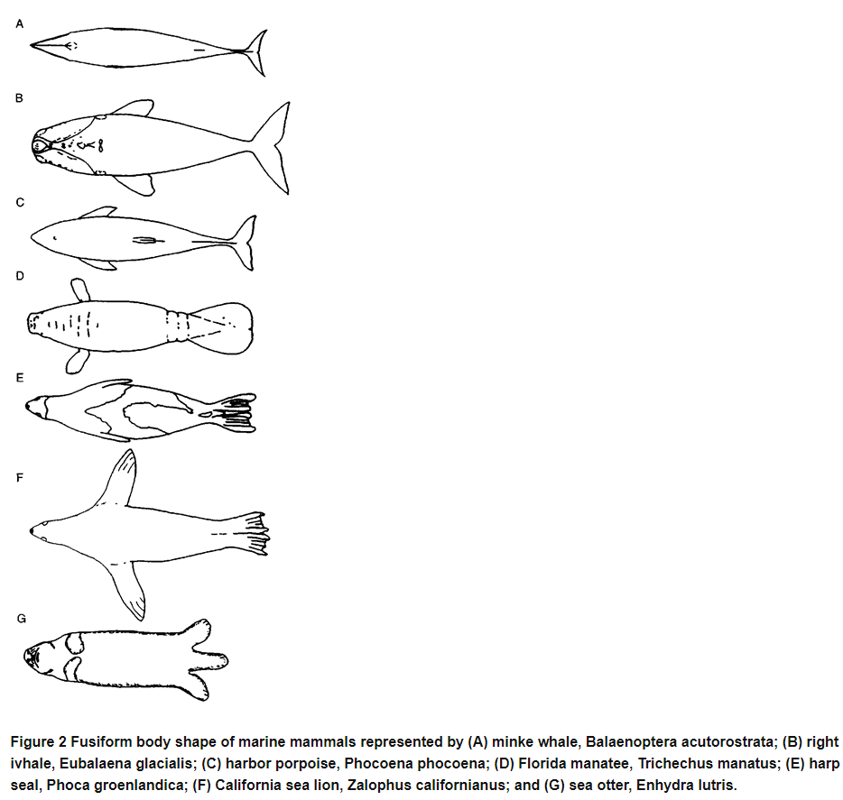  Shapes of diving mammals help them slide through the water. Here are a few (from what-when-how.com ) | - Gather water-resistant modeling clay for each Explore Team member.  - Make a model of a fast-diving marine animal using your clay. Name it 😊  - Add each of your model divers to the speed tournament bracket.  - Race your Explore Team! Time a dive from the surface to the ‘prey’ at the bottom of a tank of water.  - Winners from each Explore Team are placed in the next level in the tournament bracket, then have a dive-off.  - The winner leads the next Research It! experiment (see p. 11 and your teacher for guidelines)

Dive Tournament reflections page
Activity: Team Read: What Happens During a Dive

*Did you know? *What to do:
Diving birds, mammals, and reptiles need to breathe air to get oxygen (O₂).  - The oxygen fuels the breakdown of glucose (sugar) for energy in respiration:  O₂ +C₆H₁₂O₆CO₂+H₂O  (Glucose)  - The glucose comes from plants and algae, which get energy from the sun to fuel the formation of glucose from water and carbon dioxide during photosynthesis:  CO₂+H₂O O₂ + C₆H₁₂O₆ (Glucose)  - Pretty slick set-up between the producers and the consumers!  - But how do diving animals conserve oxygen during a dive?  - And…can WE do that?? | Team Read: How Diving Mammals Stay Underwater So Long  Divide the article into logical parts so each Explore Team member can read and summarize one portion.  Draw this template onto a poster paper:  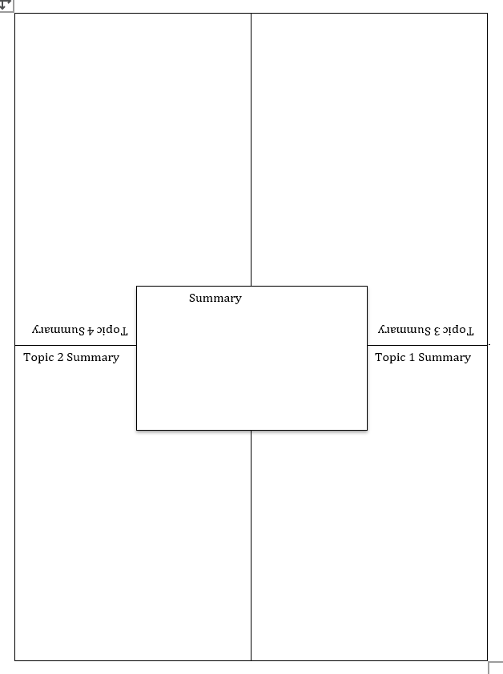  Have each member share their summary in a different color marker, then have the Research Associate write a joint summary of all parts in the center, color coding its parts.
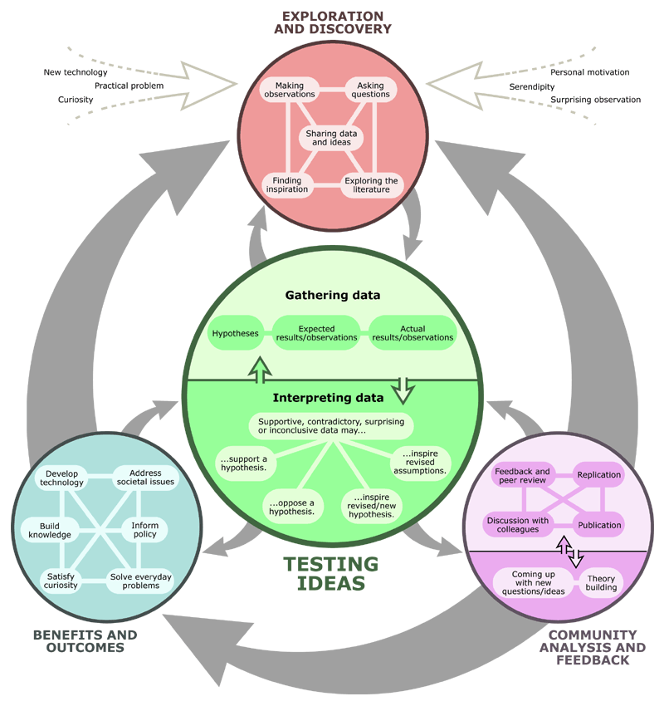


Research it! Human Dive Reflex (Get your Physiologist On!)

Research Title: __________________________________________________________

Choosing Variables: __________________________________________________________
(one compared/changed/manipulated/ variable)
__________________________________________________________
(one measured/responding/dependent variable)
- _______________________________________________________
- _______________________________________________________
- _______________________________________________________
(choose three controlled variables, or things to keep identical for all trials of both treatments)

Research Question: Do humans have a dive reflex?
Hypothesis/Prediction: We predict that if ______________________________________ _____________then__________________________________________________________________________________________________________________________________________
because ______________________________________________________________________

Procedure:

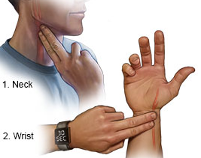
            - Let your partner measure your resting heart rate for 30 seconds by placing the pads of two fingers on the inside of your wrist by the hand or on the carotid artery on your neck. Fit Bits work, too! Record in the table below.

            - Fill a small, paper cup with ice water and submerge your nose in the water. It is okay to let it enter your nose but be careful not to breathe it in!
Again, have your partner measure your resting heart rate, but while your nose is under water. Try to hold your breath with your nose in the water for 30 seconds, if you can. Record in the table below.

Results:

Team Member
Initials
Heart Rate in air (BPM)

Heart Rate with nose submerged

Graph your results: Have your Research Associate add your data to the class graph, then make a graph here or in a spreadsheet on your computer.

- Label the axes:
  - Write what you compared on the horizontal x-axis. This is your changed or manipulated variable.
  - Number your y-axis. Use > half the graph and a scale that fits your whole value range.
Heart Rate (beats per minute)

____________ __________ ___________ _________ __________
Human dive response test subjects (Initials)
Discuss your findings with your class.

Research it! Sound through a gas, liquid, and solid
Remember that: What to do:
*Density is the mass of an object in a given volume:  $$d=\frac{m}{v}$$  *Particles are squished together tight in dense materials and loose in low density materials.  *So:  The density of steel > the density of wood  The density of wood > the density of water  You try it:  The density of water ___  the density of air.  (draw a greater or less than sign) | Team Talk:  If sound is vibrations caused by colliding particles of matter, does sound act the same in materials with different densities?  Try this with a partner:  1. Blow air into a zip-top sandwich bag and seal it in.  2. Hold the bag to one ear and cover the other ear with your hand.  3. Have your partner tap on the bag of air with a pencil.  4. Fill the same bag with water and seal it.  5. Repeat steps 2-3.  6. Place a wooden block into the bag, squeeze out the air, and seal.  7. Repeat steps 2-3.  8. Color in the graph below to show the comparative sound levels.  *Option: If you have a sound measurement app or device, repeat the steps above while holding the bag against the device and record the levels in decibels (db) in your graph.  Sound Level  Air Water Wood
SOUND THROUGH A GAS, LIQUID, and SOLID REFLECTIONs PAGE

CONCLUSIONS

FORMATIVE ASSESSMENT

1. Does sound travel faster through water or air?

2. Does sound travel faster through wood or water?

3. Is there sound on the moon?

4. How are sound vibrations transferred to your brain?

Explore Activity Sketching Sound
Did you know: What to do:
- …that water is matter and matter is made of particles, called atoms?  +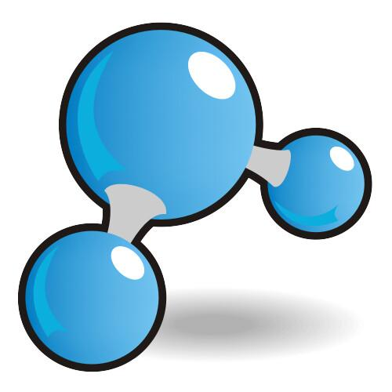+  - …2 atoms of hydrogen and 1 atom of oxygen bond to make a water molecule, H₂O?  +  +-  - …that H₂O is “sticky?” One end has a + charge, the other has a - charge. Opposites attract! The + end of one H₂O sticks to the – end of another.  + + | When your favorite diving mammal makes a sound under water, what does the sound do to the water molecules? Sketch it!  Draw dots to symbolize water molecules:  Sketch a mammal here | Sketch what its sound does to water here here  How fast does its sound travel? ____________________ mph  Stretch the Slinky along the length of your lab table.  Make the sound of your favorite diving mammal as you send a pulse of movement through the Slinky.  Draw a picture of the Slinky in action:  Were your two pictures similar? How? _________________________________________________________  _________________________________________________________

Label the parts of this wave diagram.

Use words from the wave word bank.

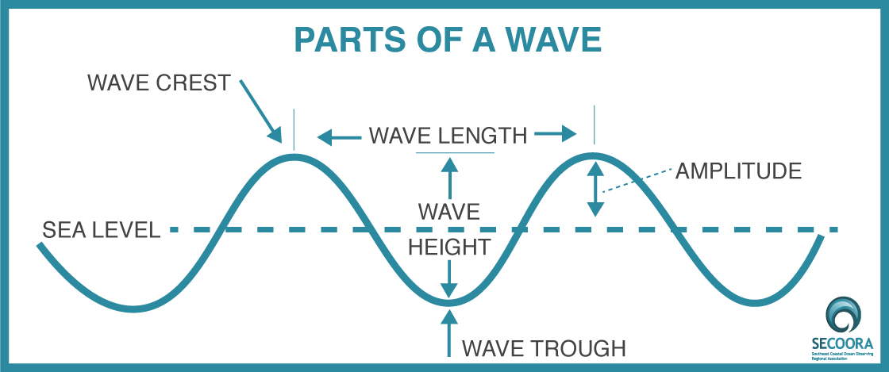
Wave Word Bank
Wave: The repeating and periodic disturbance that travels through a medium (e.g. water) from one location to another location.
Wave Crest: The highest part of a wave.
Wave Trough: The lowest part of a wave.
Wave Height: The vertical distance between the wave trough and the wave crest.
Wave Length: The distance between two consecutive wave crests or between two consecutive wave troughs.
Wave Frequency: The number of waves passing a fixed point in a specified period of time.
Wave Period: The time it takes for two successive crests (one wavelength) to pass a specified point. The wave period is often referenced in seconds, e.g. one wave every 6 seconds.

Can you hear the orcas calling?

You can listen to recorded orca calls or tune in to hydrophones posted at three locations in the central Salish Sea at the Orca Sound website: https://www.orcasound.net/listen/

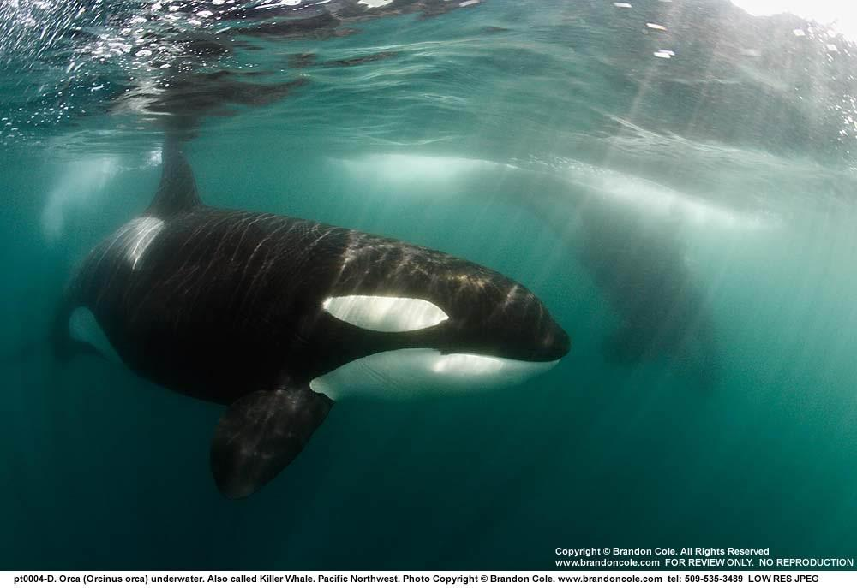

With some additional materials and the engineering skills learned in unit 5, you can build your own hydrophone to add to your ROV or to use on its own.

The University of Connecticut provides instructions. Search for COSEE TEK Simple Hydrophone Design online.

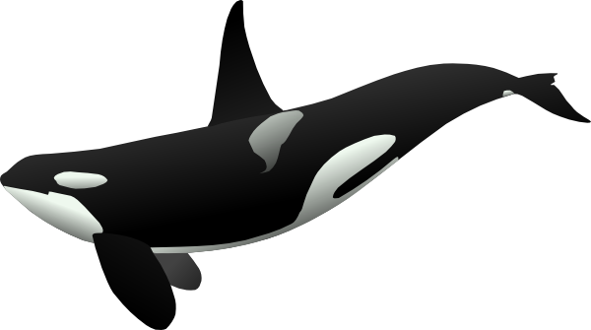

Engineer it! Lowering Sound in the Sound

Have you heard the orcas sing? Let’s help them hear one another and their prey! Gather your materials then design, build, and test your prototype, aiming for the quietest ship hull in the class.

Write and sketch mini diagrams in the circles below to record your engineering process steps.
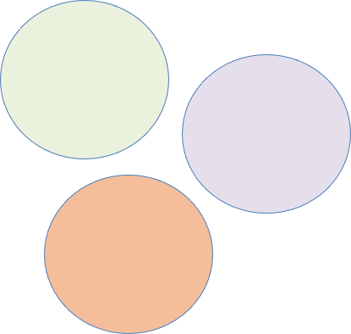
IDENTIFY THE PROBLEM
DESIGN
EXPLORE

CREATE

TRY IT OUT

MAKE IT BETTER

Repeat any steps!
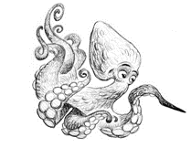

Quieter Ship Design Log Date__________

What did you accomplish today with your Explore Team’s ship design? List positive things under the plus and things that could be changed under the triangle*

*a triangle is a Greek symbol for a delta, where a river enters the sea and forms a triangle shape of sand. A delta is a site of constant change!

+ Δ_______________

Notes - additional thoughts and ideas

Use this page to track your prototype progress. Return to describe the benefits (+) and changes you’d make to each of your designs.
Design 1  Design 2  Design 3 |  |  | Notes  +  Δ  Notes  +  Δ  Notes  +  Δ
 | Engineer Name: | NO |  | SOMEWHAT | YES
 | I and my team designed and built 3 ship hulls
 | Our team designed and built a functioning propeller
 | Our final prototype floated balanced on the water
 | Our final ship prototype produced less noise compared to our initial prototype


Put Science to Work ACOUSTICAL ENGINEERING RESEARCH
Research Title: ____________________________________________________________________
Research Question: What features make a ship quiet? ______________________________________________________________________
____________________________________________________________________________________________________________________________________________
Choosing Variables:
___________________________________________________________
one changed/ manipulated/independent variable (what you will compare) ___________________________________________________________
one measured/responding/dependent variable (what you will count/measure)
1______________________________________________________________
2______________________________________________________________

3______________________________________________________________ (three controlled variables, or things to keep identical for all trials of both treatments)

Hypothesis/Prediction (not all research is hypothesis-driven, so this step may be skipped, if yours is a survey or collection of interviews with elders:
We predict that if __________________________________________________ then_____________________________________________________________ ________________________________because _____________________________________________________ ________________________________________________________________

Diagram: Draw a labeled illustration of the experiment. Show all materials in action.

Procedure: Number step- by-step directions for how to do the experiment.
- Tell how you will set up the experiment.
- Tell how you will change the manipulated variable.
- Tell how you will measure the responding variable.
- Tell how often you will take and record measurements.
- Tell how many times you will repeat each test/observation.

Results: Tables, graphs, and brief description of outcome
- Label columns and rows including units (in parentheses)
- Include a space for the calculated average (mean)
Data table: Sound Levels in ship prototypes
Explore Team | Prototype 1 Sound Level (db) | Prototype 2 Sound Level (db)
1
2
3
4
5
6

Graph your results: Add your data to the class graph then make a graph here or in a spreadsheet on your computer
- Label the axes: Write the items you compared on the horizontal x-axis. This is your manipulated or input variable. Write what you measured on the vertical y-axis. This is your responding or output variable.
- Number your y-axis. Use > half the graph and a scale that fits your whole value range.
- Choose the best graph type to most easily compare between orca types.
y-axis title __________________________

x-axis labels ______________ ____________ ___________ _____________
x-axis title _________________________________________________________

- Get CERIAS Forum Notes
Brief and Concise description of results
Claim | Evidence  • What does the graph show?
Evidence  • Do the math, what are the numerical differences between the two responding/output variables? How much quieter was the quietest ship than the average? | Reasoning  • explain why you think the results turned out that way and any possible errors
Implications  How might this research affect the world? | Applications  • What could/should be done?
These stamps certify achievement of the following:
Sensory Savvy
Diving Adept
Wave Wiz
Research Scientist Superstar
Forensic Fortitude
