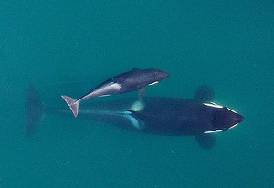
Taskforce!

Resources for becoming whale-wise

Background Research Resources
Use trustworthy sources only when increasing your understanding of a phenomenon. Peer-reviewed scientific articles are the best, but above reading level for most grade 4-8 students. Until we translate scientific articles for kid-access, use popular science magazines, such as Nature, National Geographic, Science, or Popular Mechanics, Popular Science, or Discover, and/or the resources listed below to get Southern Resident Killer Whale-savvy for your Taskforce Working Groups. Peruse the links to the video, preliminary investigation, or article below, or dig up your own background information resources.
Darren Croft, Inside the killer whale matriarchy (5 min Video)
Follow a pod of Southern Resident Killer Whales in their Salish Sea world
https://www.youtube.com/watch?v=sQpGT1BgdX4

Dive Deeper: Center for Whale Research (trusted Website)
Learn nearly everything you could hope to know about Southern Resident Killer Whales with the Center for Whale Research, researching these whales since the 1970s. www.whaleresearch.com

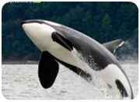
Whales support the economy of the Salish Sea (Report)
Learn how much money that killer whales bring into San Juan County in this SeaDoc Society-sponsored report by Earth Economics.
www.seadocsociety.org/blog/the-economic-impact-of-killer-whales-in-the-salish-sea?rq=Earth%20Economics

