Discovery of Sound in the Sea Hot Topic
May 2019 https://dosits.org/category/hot-topics/
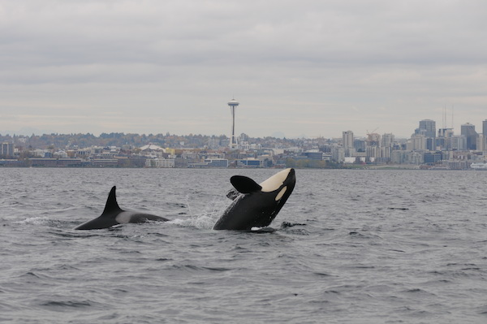

Hot Topic- Killer Whales and Vessel Noise

Measuring and mitigating the potential impacts of vessel noise on endangered killer whales
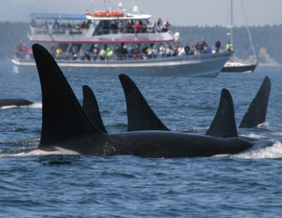
Southern resident killer whales (SRKW) are an endangered marine mammal population found off the Pacific coasts of the United States and Canada. The population is comprised of three pods, whose known range extends from southeastern Alaska to central California. During the summer months, SRKW concentrate in coastal waters off the southern end of Canada’s Vancouver Island and northern Washington State, U.S.A. These inland waters provide critical foraging habitat for the whales. As of January 2019, an estimated 75 individuals remain in the population. Underwater sound associated with commercial vessel traffic is one, recognized threat to the population’s survival. Several new studies look at the potential benefits of ship-quieting activities to help this critically endangered population.
There are three primary threats to the continued survival of the SRKW population:
Underwater sound associated with commercial vessel traffic is one, recognized threat to the southern resident population of killer whales. Image credit: NOAA, NWFSC.

- Reduced availability of preferred prey. Chinook salmon is the primary prey eaten by SRKW, especially in the spring and summer. During the fall and winter, the whales add other salmon species and some demersal fishes to their diet. The abundance of Chinook salmon (and other salmon species in SRKW habitat) has declined due to commercial fishing, habitat destruction, and pollution.
- High chemical contaminate loads. SRKW have been found to carry very high concentrations of persistent organic pollutants (POPs). These high levels can reduce reproduction rates and weaken immune responses in SRKW. Diet is an important contributor to POP accumulation in killer whales. Adult killer whales are primarily exposed to POPs through the ingestion of (contaminated) prey (biomagnification); calves receive POPs via their mother’s milk.
- Physical and acoustic disturbance due to vessel traffic. SRKW critical habitat directly overlaps with major marine traffic routes in the Salish Sea (inland waters of Washington State and British Columbia, including the areas outlined in the yellow oval on the map below), and is bisected by U.S. and Canadian shipping lanes. Whale watching activity has significantly increased in and around the Salish Sea, and several large-scale industrial developments, including the Trans Mountain [Pipeline] Expansion (TMX) Project in Canada, may increase commercial ship traffic in this area.
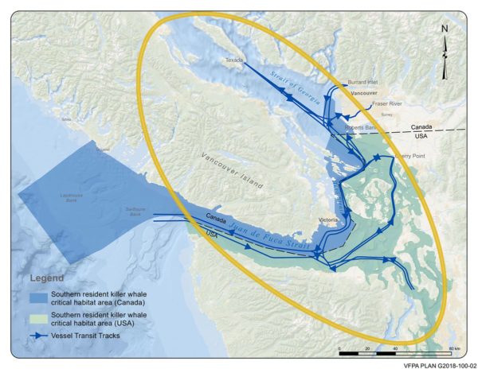
Map of Southern resident killer whale (SRKW) critical habitat (blue- Canada, green- USA) and primary shipping routes (blue arrows). Parts of the Salish Sea (inland waters of Washington State and British Columbia) are outlined in the yellow oval. Image credit, Vancouver Fraser Port Authority.
Killer whales produce echolocation clicks for foraging and navigation, as well as pulsed calls and whistles during social interactions. Resident killer whale calls are stereotyped and population-specific and are thought to be important in maintaining group cohesion and coordination (group-specific vocalizations). Although most sounds associated with commercial vessel traffic are typically below 500 Hz, ship sounds extend to frequencies well above 1 kHz, albeit with lower source levels than the low frequency components. These higher frequencies may overlap with the vocalizations, hearing ranges, and echolocation abilities of odontocetes. Research has found the whales to spend less time foraging and more time traveling in the presence of vessel traffic.^{[1]} Research has also found that as background noise from vessel traffic increases, SRKW adjust their vocal behavior by producing longer calls^{[2]} or increasing their call amplitude by 1 dB for every 1 dB in background noise level.^{[3]} Scientists and managers are concerned that the effects of underwater noise associated with vessel traffic may be masking echolocation and communication signals, amplifying the impact of reduced prey availability on the recovery of the SRKW population.
In the Haro Strait, which runs between Vancouver Island, Canada, and the United States’ San Juan Islands, container ships produce the highest underwater source levels at 178 underwater dB. Other ship types with source levels > 173 underwater dB include vehicle carriers, cargo ships, tankers, and bulk carriers.^{[4]} Current U.S. and Canadian SRKW management plans include measures to reduce disturbance from anthropogenic noise, such as mandatory minimum distances between vessels and killer whales. Scientists have found, however, that vessel speed, not distance, is the most important predictor of noise levels received by the whales.^{[5][6]} For many ships in the Salish Sea, a 1 kt reduction in speed results in a 1 dB reduction in broadband source level.^{[7]} Williams et al. (2019) found a 3 dB noise reduction in Haro Strait could be met by enforcing a speed limit of 11.8 kt on container ships, vehicle carriers, passenger (cruise) and cargo ships, tankers, bulk carriers, and pleasure craft.
Enforcing vessel speed reductions is one method to improve the acoustic environment in SRKW habitat. However, a combination of mitigation measures, including other ship quieting installations and/or modifications, will likely provide the most effective solution. Regulators may revise or expand SRKW critical habitat, while also clarifying key features, functions, and attributes of this habitat. In March 2019, U.S. officials also began considering additional fishing restrictions to help bolster salmon stocks.

DOSITS Links:
- Science of Sound > How does shipping affect ocean sound levels?
- Science of Sound > Advanced Topic > Sound Pressure Levels and Sound Exposure Levels
- Animals > Moderate or Eliminate Effects > Ship Quieting Technologies
- Animals and Sound > Anthropogenic Sound Sources > Commercial Vessel Traffic
- Animals and Sound > MM Communication > Group-specific vocalizations
- Animals and Sound > How do marine mammals use or make sound when feeding?
- Animals and Sound > How do marine mammals use sound to navigate?
- Animals > Potential Effects, Marine Mammals > Masking
- Animals > Potential Effects, Marine Mammals > Behavioral Changes
- Technology Galley > Hydrophone
- Audio Gallery > Killer Whale
- Audio Gallery > Ship

Additional Resources
- NOAA Fisheries: Species in the Spotlight, Southern Resident Killer Whale
- Vancouver Fraser Port Authority, ECHO Program: Voluntary Vessel Slow Down Trial Summary Findings. June 2018.
- Vancouver Fraser Port Authority, Enhancing Cetacean Habitat and Observation (ECHO) Program

References
- Cominelli, S., Devillers, R., Yurk, H., MacGillivray, A., McWhinnie, L., & Canessa, R. (2018). Noise exposure from commercial shipping for the southern resident killer whale population. Marine Pollution Bulletin, 136, 177–200. https://doi.org/10.1016/j.marpolbul.2018.08.050.
- Mongillo, T. M., Ylitalo, G. M., Rhodes, L. D., O’Neill, S. M., & Noren, D. P. (2). Exposure to a mixture of toxic chemicals : implications for the health of endangered southern resident killer whales. U.S. Department of Commerce, National Oceanic and Atmospheric Administration, National Marine Fisheries Service, Northwest Fisheries Science Center. https://doi.org/10.7289/v5/tm-nwfsc-135.
- Williams, R., Veirs, S., Veirs, V., Ashe, E., & Mastick, N. (2019). Approaches to reduce noise from ships operating in important killer whale habitats. Marine Pollution Bulletin, 139, 459–469. https://doi.org/10.1016/j.marpolbul.2018.05.015.
- Williams, R., Clark, C. W., Ponirakis, D., & Ashe, E. (2014). Acoustic quality of critical habitats for three threatened whale populations: Acoustic quality of critical whale habitats. Animal Conservation, 17(2), 174–185. https://doi.org/10.1111/acv.12076.
Cited References
1. |  | Lusseau, D., Bain, D., Williams, R., & Smith, J. (2009). Vessel traffic disrupts the foraging behavior of southern resident killer whales Orcinus orca. Endangered Species Research, 6, 211–221. https://doi.org/10.3354/esr00154.
2. | ↑ | Foote, A. D., Osborne, R. W., & Hoelzel, A. R. (2004). Whale-call response to masking boat noise. Nature, 428(6986), 910–910. https://doi.org/10.1038/428910a.
3. | ↑ | Holt, M. M., Noren, D. P., Veirs, V., Emmons, C. K., & Veirs, S. (2009). Speaking up: Killer whales ( Orcinus orca ) increase their call amplitude in response to vessel noise. The Journal of the Acoustical Society of America, 125(1), EL27–EL32. https://doi.org/10.1121/1.3040028.
4, 7. | ↑ | Veirs, S., Veirs, V., & Wood, J. D. (2016). Ship noise extends to frequencies used for echolocation by endangered killer whales. PeerJ, 4, e1657. https://doi.org/10.7717/peerj.1657.
5. | ↑ | Holt, M., Hanson, M., Giles, D., Emmons, C., & Hogan, J. (2017). Noise levels received by endangered killer whales Orcinus orca before and after implementation of vessel regulations. Endangered Species Research, 34, 15–26. https://doi.org/10.3354/esr00841.
6. | ↑ | Houghton, J., Holt, M. M., Giles, D. A., Hanson, M. B., Emmons, C. K., Hogan, J. T., … VanBlaricom, G. R. (2015). The relationship between vessel traffic and noise levels received by killer whales (Orcinus orca). PLOS ONE, 10(12), e0140119. https://doi.org/10.1371/journal.pone.0140119.

